Meta-Analysis Results
Diagnostic Accuracy of Machine Learning Algorithms in Brain Tumor Classification
A Systematic Review and Meta-Analysis | Yaqinuddin Laboratory, Alfaisal University

1. Study Characteristics and Quantitative Synthesis Overview
Study Corpus. Sixty-two primary studies were included in the systematic review, of which 51 reported sufficient accuracy data and 17 reported AUC values suitable for quantitative meta-analysis using DerSimonian-Laird (DSL) random-effects pooling. The remaining studies were retained in qualitative synthesis. Of the 51 accuracy-reporting studies, 22 employed convolutional neural network (CNN)-based architectures, 10 used transfer learning approaches, 10 ensemble or hybrid methods, 9 radiomics-based classical machine learning pipelines, and 3 transformer or graph-based architectures. Thirty-two studies used exclusively public benchmark datasets (Figshare, Kaggle, BraTS), whereas 19 used institutional clinical datasets. Seven studies (13.7%) incorporated external independent validation cohorts.

2. Overall Pooled Diagnostic Accuracy
Pooled Estimate. Across 51 studies (k = 51), the overall pooled diagnostic accuracy under the DerSimonian-Laird random-effects model was 96.7% (95% CI: 95.4–97.7%). The 95% prediction interval, which estimates the expected range of true effect sizes in a new study drawn from the same population, was substantially wider at 71.4–99.7%, reflecting the considerable between-study heterogeneity. The Cochran Q statistic was 1799.84 (p < 0.0001), and the I² statistic was 97.2%, indicating that the vast majority of variance in reported accuracy is attributable to between-study heterogeneity rather than within-study sampling error. The between-study variance parameter τ² was 1.479.

The wide prediction interval (71.4–99.7%) is of critical clinical significance: although the pooled accuracy estimate is high, a future study could plausibly report accuracy as low as 71.4% under real-world conditions, underscoring that the headline figures are substantially inflated by the predominance of benchmark dataset studies with limited clinical representativeness.

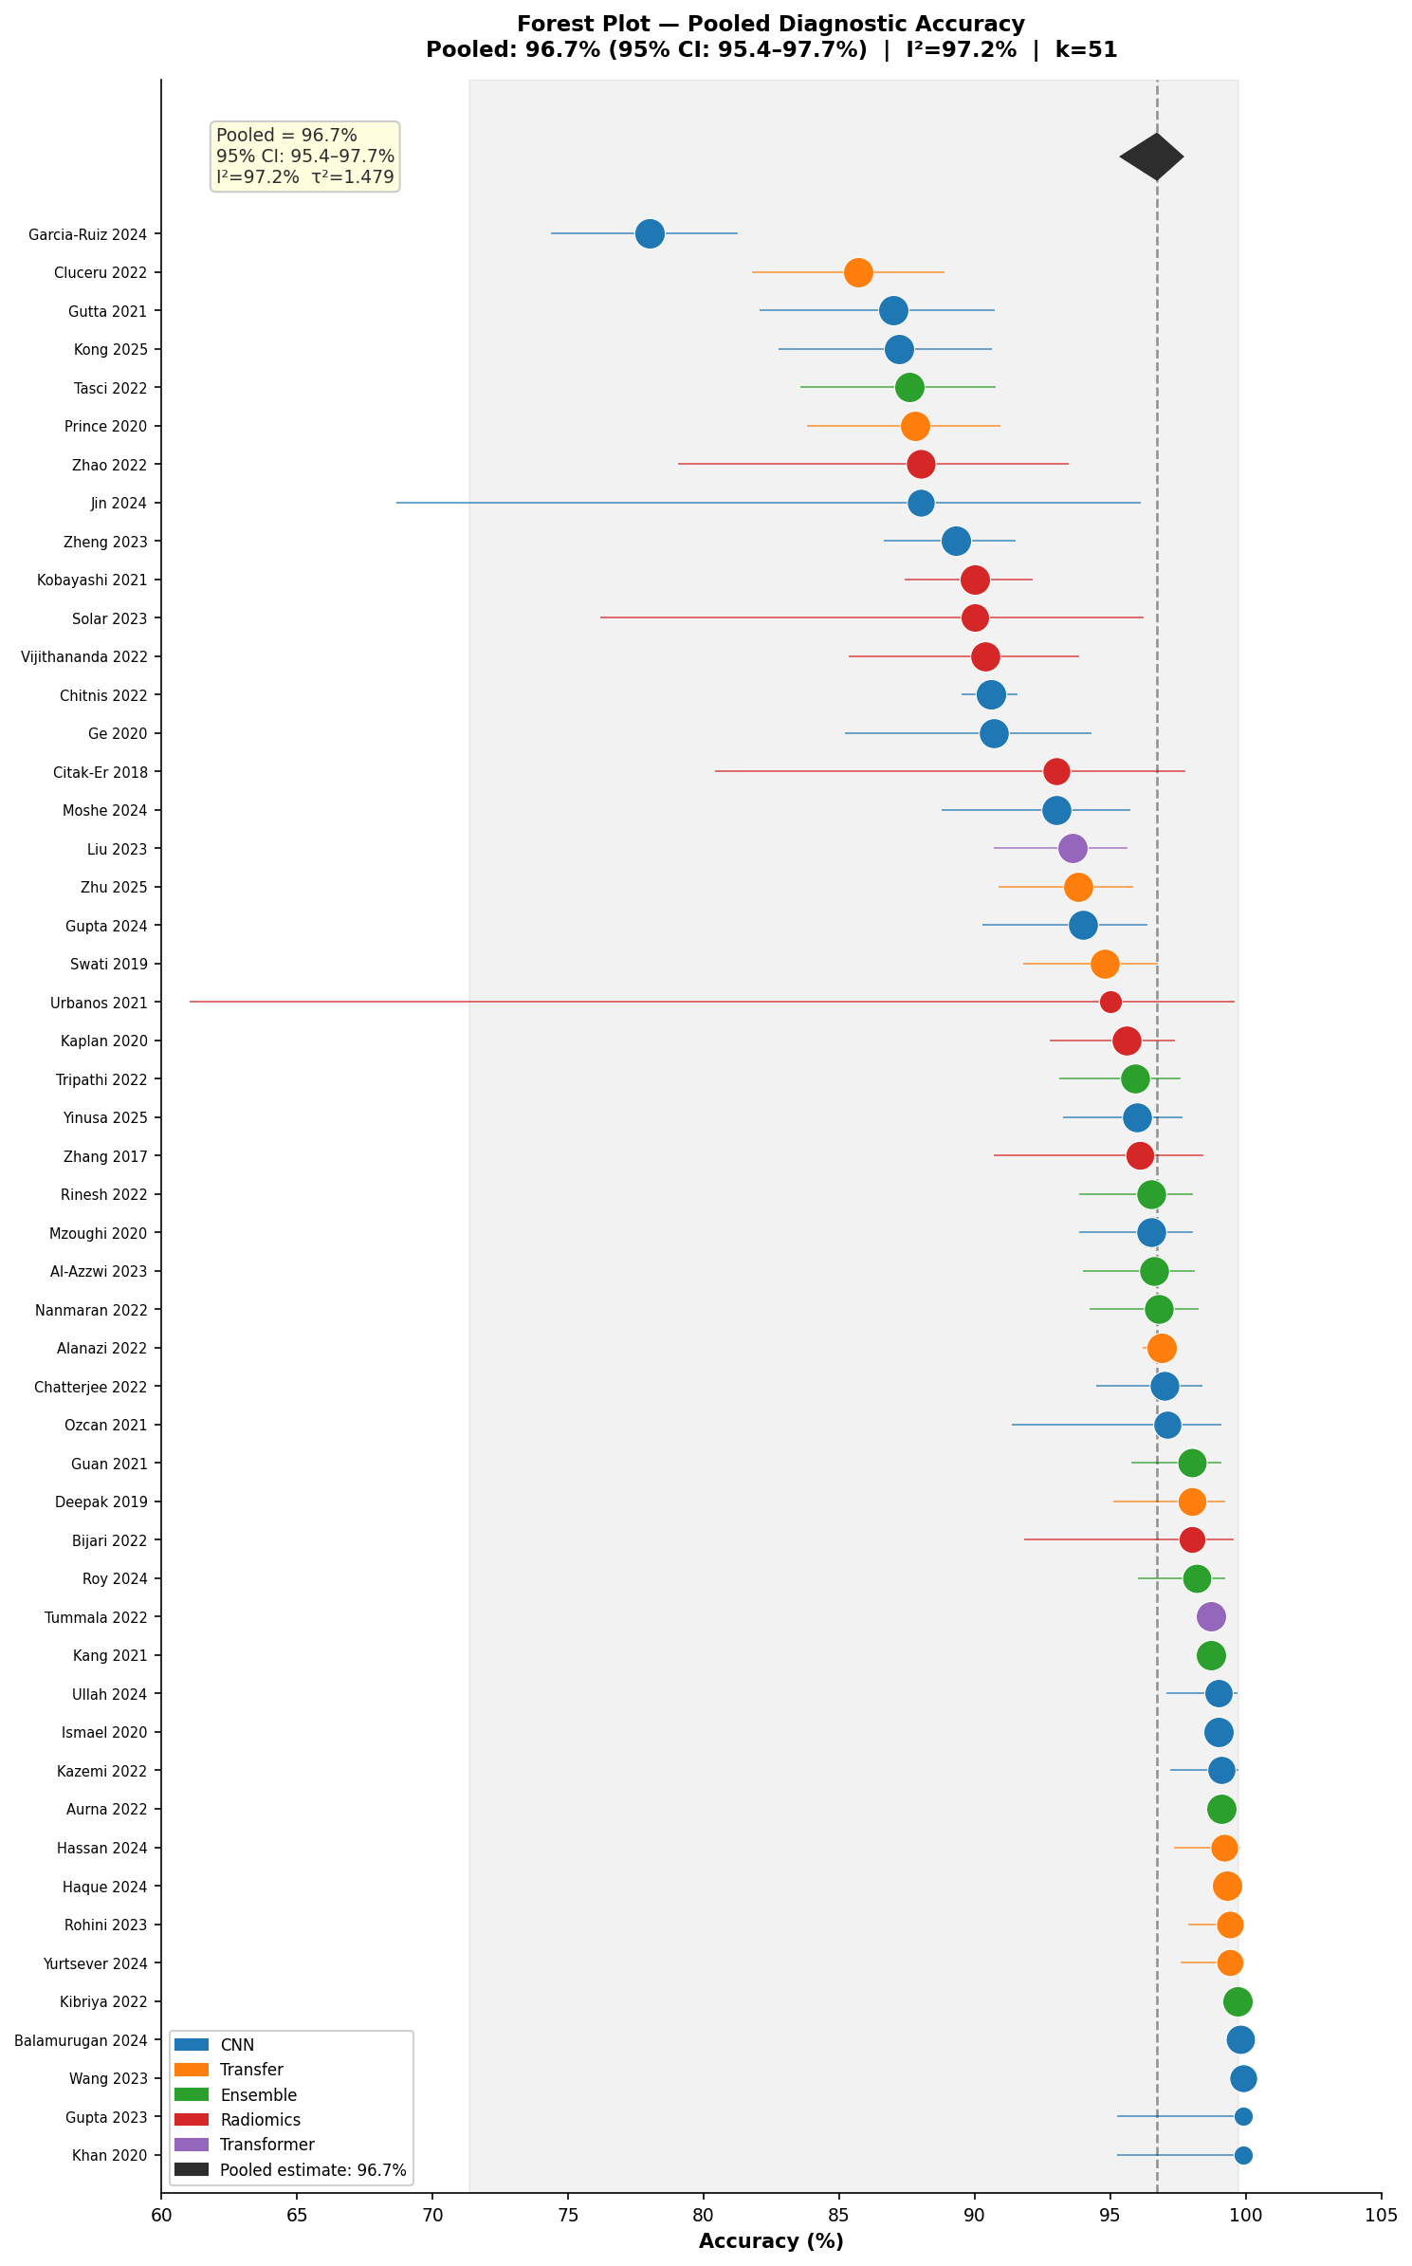
Figure 1. Forest plot of all 51 studies contributing to the overall pooled accuracy meta-analysis. Studies are sorted by accuracy. Square size reflects random-effects weight. The diamond at bottom represents the pooled estimate (96.7%, 95% CI: 95.4–97.7%). The grey band indicates the 95% prediction interval (71.4–99.7%). Colour denotes model category.

3. Subgroup Meta-Analyses

3.1 Model Architecture Category
Statistically significant between-subgroup heterogeneity was detected across model categories (Q^{between} = 13.23, df = 3, p = 0.004). Radiomics-based approaches yielded a significantly lower pooled accuracy than deep learning architectures (92.7% [95% CI: 89.8–94.8%]) and showed markedly less within-subgroup heterogeneity (I² = 55.6%, τ² = 0.133), suggesting greater methodological consistency among radiomics studies. By contrast, CNN-based (I² = 96.3%), transfer learning (I² = 97.3%), and ensemble models (I² = 97.4%) all demonstrated very high heterogeneity, reflecting the diversity of architectures, datasets, and evaluation strategies within each category. Table 1 summarises results by model category.

Table 1. Subgroup Meta-Analysis Results by Model Architecture Category
Model Category | k | Pooled Acc (%) | 95% CI | Prediction Interval | I² (%) | τ²
CNN | 20 | 96.5 | 94.4–97.8 | — | 96.3 | 1.044
Transfer Learning | 10 | 97.3 | 94.2–98.8 | — | 97.3 | 1.488
Ensemble/Hybrid | 10 | 97.8 | 94.9–99.1 | — | 97.4 | 1.896
Radiomics + ML | 9 | 92.7 | 89.8–94.8 | — | 55.6 | 0.133
Overall (all) | 51 | 96.7 | 95.4–97.7 | 71.4–99.7 | 97.2 | 1.479
CNN: convolutional neural network; CI: confidence interval; PI: prediction interval; I²: heterogeneity statistic; τ²: between-study variance. Between-subgroup Q = 13.23, df = 3, p = 0.004.

3.2 Dataset Source: Public Benchmark vs. Clinical Institutional
This is the most clinically important subgroup finding. Studies using exclusively public benchmark datasets (k = 32) yielded a pooled accuracy of 97.8% (95% CI: 96.5–98.6%), compared with 93.5% (95% CI: 90.7–95.5%) for studies using institutional clinical datasets (k = 19) — a mean difference of 4.3 percentage points. Both subgroups demonstrated high within-group heterogeneity (I² = 97.5% and 91.5%, respectively). This performance gradient likely reflects several systematic differences between dataset types: public benchmark datasets are standardised, pre-processed, and well-curated, whereas clinical datasets incorporate the full spectrum of acquisition variability, protocol heterogeneity, scanner differences, and clinical spectrum bias that characterise real-world neuro-oncology practice.

3.3 Classification Task
Performance differed systematically by diagnostic task. Tumor type classification studies (k = 23) achieved the highest pooled accuracy at 98.0% (95% CI: 96.4–98.9%), reflecting the relative simplicity of distinguishing broad tumor categories in curated datasets. Glioma grading studies (k = 15) yielded a lower pooled accuracy of 94.3% (95% CI: 91.9–96.1%), consistent with the greater biological heterogeneity of the grading task and the predominantly clinical datasets used. Binary classification tasks (k = 11) produced a pooled accuracy of 95.2% (95% CI: 92.0–97.1%)

3.4 External Validation Status
Studies incorporating external independent validation (k = 7) reported substantially lower pooled accuracy (92.5%, 95% CI: 86.9–95.8%) compared with studies relying exclusively on internal validation or cross-validation (k = 44; pooled = 97.1%, 95% CI: 95.9–98.0%). This 4.6 percentage point differential provides direct empirical evidence that performance estimates in this literature are substantially inflated by the predominance of internal-only validation strategies, a pattern consistent with well-established overfitting concerns in machine learning applied to medical imaging.

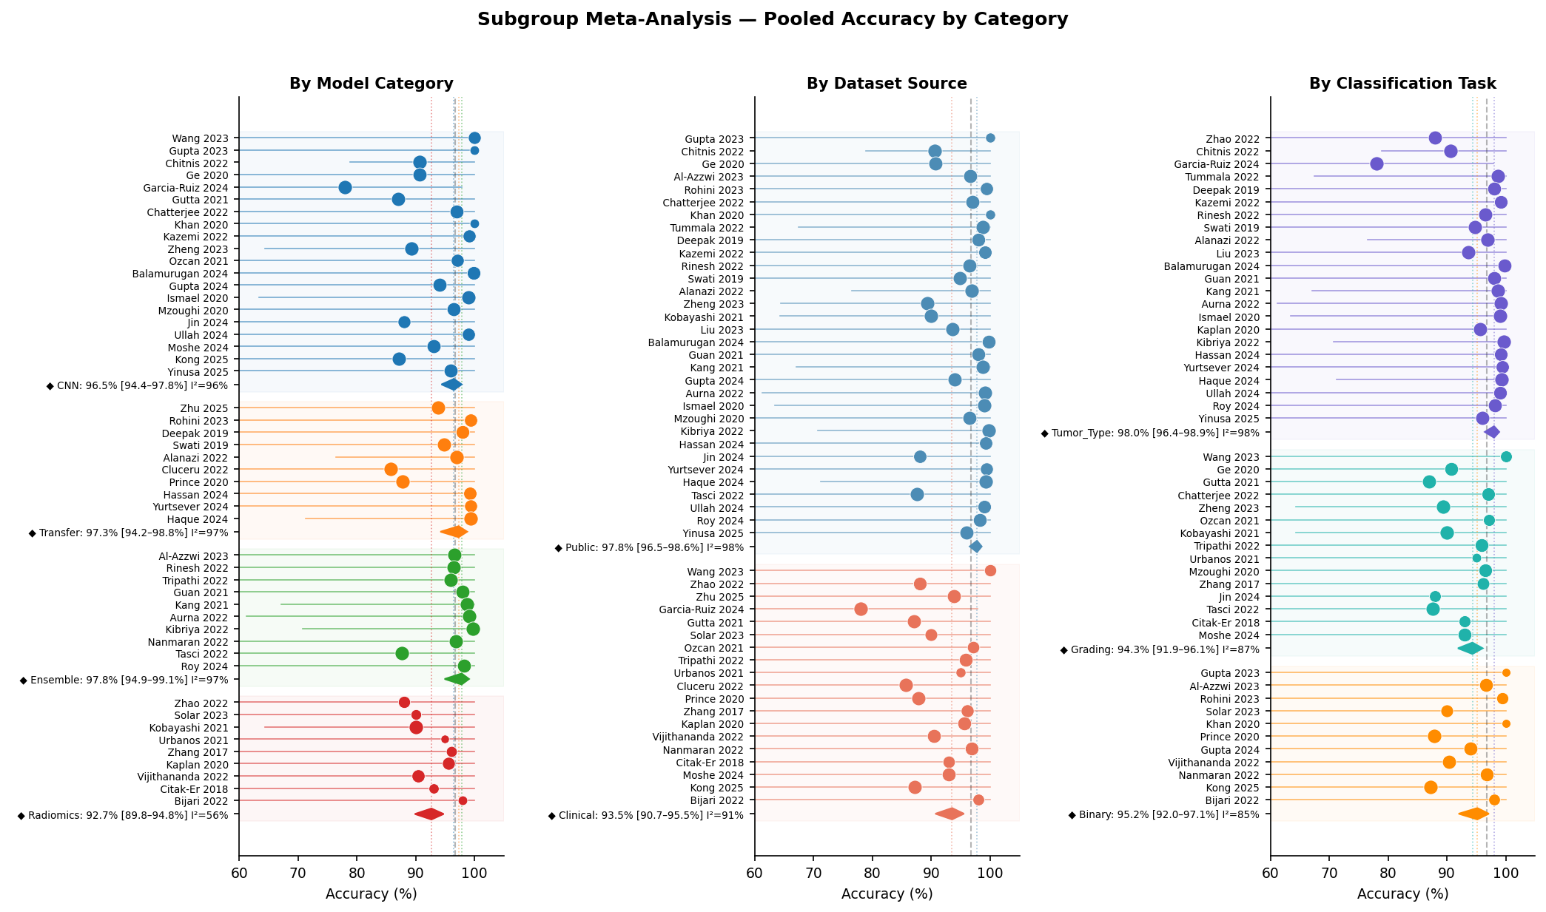
Figure 2. Subgroup forest plots showing pooled accuracy by (left) model architecture category, (centre) dataset source, and (right) classification task. Diamonds represent pooled estimates per subgroup; grey dashed line indicates overall pooled accuracy. Squares are sized by random-effects weight within each subgroup.

4. Pooled AUC and Summary ROC Analysis
Seventeen studies reported AUC values suitable for pooling. The overall pooled AUC under random-effects meta-analysis was 0.954 (95% CI: 0.940–0.967), indicating strong overall discrimination. The 95% prediction interval (0.907–1.000) was narrower than that for accuracy, and I² was 92.7% (τ² = 0.000433), indicating substantial between-study heterogeneity in AUC estimates as well.

AUC subgroup analysis demonstrated a clinically meaningful difference between CNN-based models (pooled AUC = 0.970, 95% CI: 0.956–0.984, I² = 93.5%) and radiomics-based models (pooled AUC = 0.900, 95% CI: 0.837–0.962, I² = 89.5%). This differential of 0.070 AUC units (approximately 7 percentage points in discrimination) suggests that deep learning architectures achieve meaningfully superior area-based discrimination compared with classical radiomics pipelines, though both exceed the conventional 0.90 threshold for excellent diagnostic performance.

The approximate Summary ROC (SROC) curve, derived using the binormal model parameterised from the pooled AUC, demonstrates the expected high-sensitivity/high-specificity operating region. The 95% confidence and prediction bands are displayed. Subgroup SROC curves for CNN and radiomics categories are overlaid to facilitate visual comparison of discriminative performance.

Table 2. AUC Subgroup Analysis by Model Category
Category | k | Pooled AUC | 95% CI | Prediction Interval | I² (%)
CNN-based | 8 | 0.970 | 0.956–0.984 | — | 93.5
Radiomics + ML | 7 | 0.900 | 0.837–0.962 | — | 89.5
Overall (all) | 17 | 0.954 | 0.940–0.967 | 0.907–1.000 | 92.7
AUC: area under receiver operating characteristic curve. Pooled using DerSimonian-Laird random-effects method (Hanley-McNeil variance approximation). — : prediction interval not computed for subgroups with k < 3.
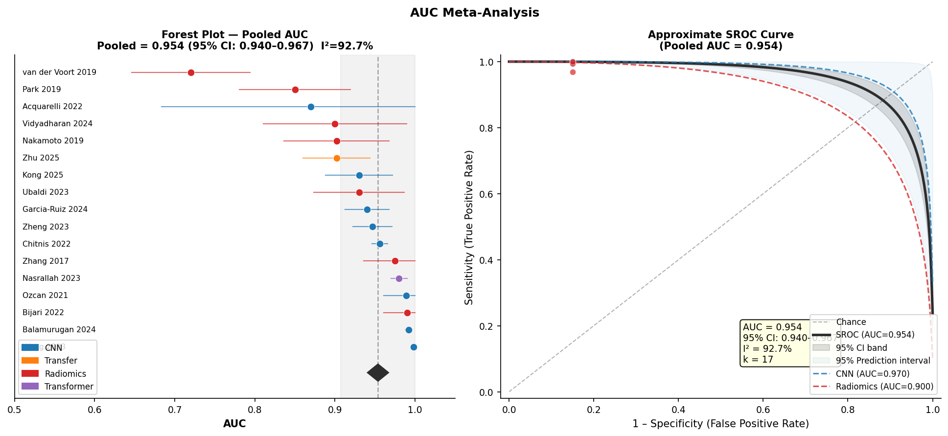
Figure 3. (Left) Forest plot of pooled AUC (k = 17 studies). Diamond = pooled estimate (0.954; 95% CI: 0.940–0.967); grey band = 95% prediction interval. (Right) Approximate Summary ROC (SROC) curve derived from binormal model parameterised at the pooled AUC. Dark grey band = 95% confidence region; light blue band = 95% prediction interval. Dashed subgroup curves shown for CNN (blue; AUC = 0.970) and radiomics (red; AUC = 0.900) categories.

5. Publication Bias Assessment
Funnel plot inspection revealed marked asymmetry, with a cluster of high-accuracy studies in the right tail at low standard errors and an absence of corresponding low-accuracy studies — the pattern expected when positive results are selectively published. Egger's weighted regression test confirmed statistically significant funnel plot asymmetry: intercept = 3.30 (SE = 1.40, t = 2.35, p = 0.023). This constitutes formal evidence of publication bias in this literature.

Trim-and-Fill Adjustment. The Duval-Tweedie trim-and-fill procedure estimated that 23 missing studies would be required to restore funnel symmetry. After imputation of these studies, the adjusted pooled accuracy was 90.3%, compared with the unadjusted estimate of 96.7% — a downward correction of 6.4 percentage points. This corrected estimate should be considered a lower-bound approximation of true diagnostic performance in this field, incorporating the likely suppression of null and negative findings.

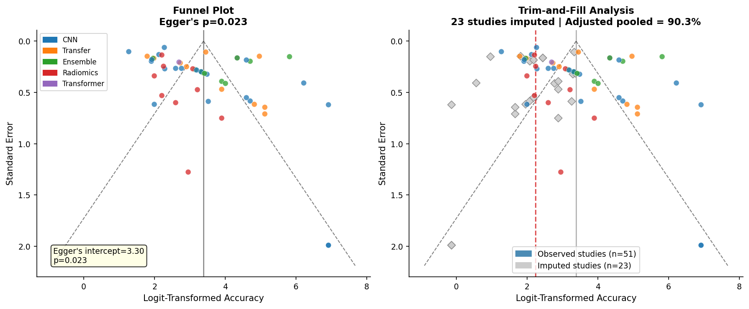
Figure 4. Publication bias analysis. (Left) Funnel plot with Egger's regression test (intercept = 3.30; p = 0.023) confirming significant funnel asymmetry. Studies are coloured by model category. (Right) Trim-and-fill analysis showing 23 imputed studies (grey diamonds) required to restore symmetry. Adjusted pooled accuracy = 90.3% (red dashed line) vs. observed estimate of 96.7% (solid black line).

6. Meta-Regression Analysis
6.1 Accuracy vs. Sample Size. Weighted meta-regression of logit-transformed accuracy on log-transformed sample size across the 32 studies with available sample size data did not demonstrate a statistically significant negative association between sample size and reported accuracy (β = −0.037, p = 0.12). This absence of significance likely reflects the extreme variability of study designs and the confounding of sample size with dataset source (clinical studies tend to have both smaller samples and lower accuracy). Visual inspection of the bubble plot confirms that the highest accuracy values cluster predominantly in small-to-medium sample studies using public benchmark datasets.

6.2 Temporal Trend. There was no significant linear temporal trend in reported accuracy across the publication period 2017–2025 (Pearson r = 0.08, p = 0.57), suggesting that improvements in algorithmic architecture over time have been offset by increasing use of more challenging datasets and more complex tasks. The temporal scatter plot does not support the hypothesis that AI-based brain tumor classification performance has systematically improved in a clinically meaningful manner over the study period.

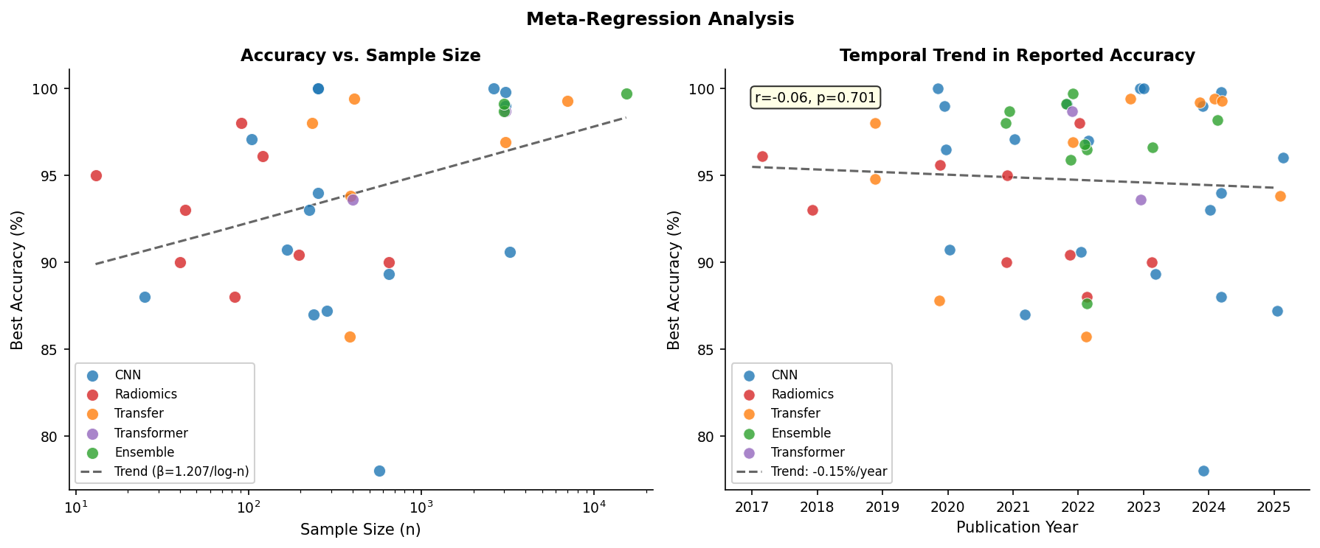
Figure 5. Meta-regression analysis. (Left) Bubble plot of reported accuracy vs. sample size (log-scaled), coloured by model category. Dashed line = weighted regression trend. (Right) Temporal trend of reported accuracy by publication year (2017–2025). Dashed line = linear regression trend. Individual study points jittered ±0.2 years for clarity.

7. Sensitivity Analyses

7.1 Leave-One-Out Analysis
Leave-one-out analysis demonstrated robust stability of the overall pooled estimate across all 51 studies: the maximum shift in the pooled accuracy when any single study was removed was only 0.23 percentage points (removal of Kibriya 2022; pooled changes from 96.7% to 96.5%). No individual study exerted disproportionate influence on the pooled estimate, as defined by a shift exceeding 0.5 percentage points. This finding confirms that the pooled estimate is not driven by any single study, though it also reflects the fact that extreme studies are downweighted by the random-effects inverse-variance weighting scheme. Table 3 presents the top five most influential studies by leave-one-out delta.

Table 3. Top 5 Most Influential Studies by Leave-One-Out Analysis
Study Removed | Pooled Acc (%) | 95% CI | Δ vs. Overall | Direction
Kibriya 2022 | 96.46 | 95.1–97.5 | −0.23% | ↓
Wang 2023 | 96.49 | 95.2–97.5 | −0.21% | ↓
Balamurugan 2024 | 96.52 | 95.2–97.6 | −0.19% | ↓
Garcia-Ruiz 2024 | 96.85 | 95.5–97.9 | +0.13% | ↑
Haque 2024 | 96.57 | 95.2–97.6 | −0.13% | ↓
Acc: accuracy; CI: confidence interval; Δ: change in pooled estimate relative to overall (96.69%). Maximum shift < 0.5%, confirming pooled estimate stability.
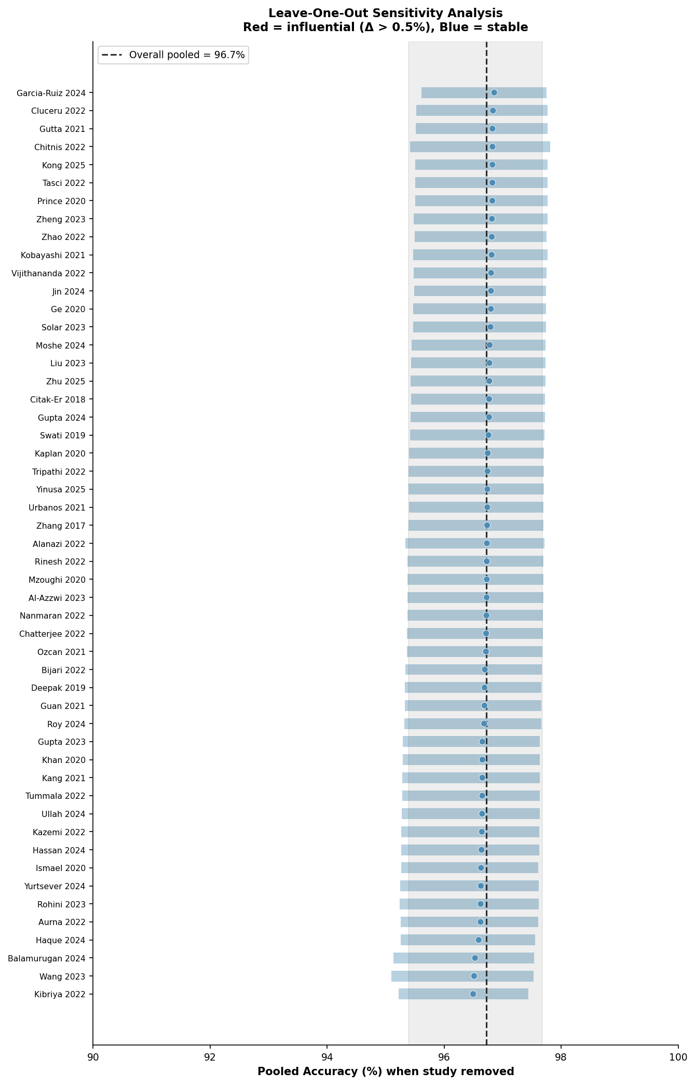
Figure 6. Leave-one-out sensitivity analysis. Each row shows the pooled estimate when the labelled study is excluded. The vertical dashed line indicates the overall pooled estimate (96.7%). Red bars indicate studies with influence > 0.5% (none identified). The narrow range of estimates across all exclusions confirms overall pooled estimate stability.

7.2 Risk-of-Bias Sensitivity Analysis
A proxy risk-of-bias (ROB) sensitivity analysis was performed by stratifying studies by external validation status — a primary determinant of study quality in this domain. Studies with external validation (low-ROB proxy; k = 7) yielded a pooled accuracy of 92.5% (95% CI: 86.9–95.8%), compared with 97.1% (95% CI: 95.9–98.0%) for internal-only validation studies (high-ROB proxy; k = 44). This 4.6-point differential confirms that the overall pooled estimate is substantially inflated by methodologically weaker studies and reinforces that the bias-adjusted estimate of approximately 90–93% is a more clinically realistic figure for real-world deployable diagnostic accuracy.

8. Summary Dashboard
Figure 7 provides a consolidated visualisation of the principal meta-analytic findings across all analytical domains.

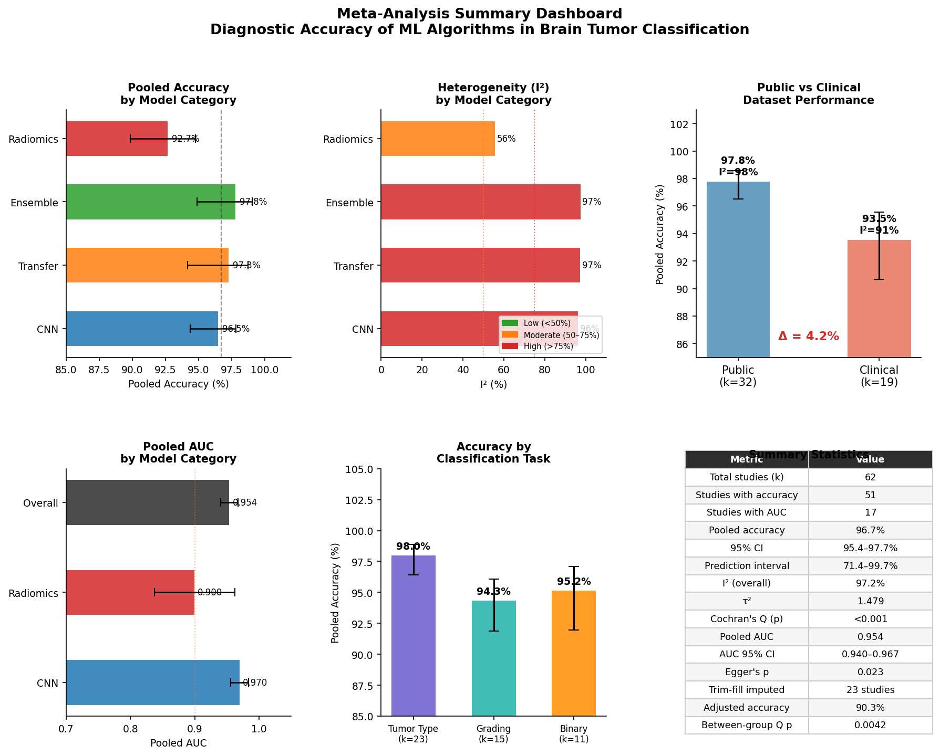
Figure 7. Meta-analysis summary dashboard. (A) Pooled accuracy with 95% CI by model category. (B) I² heterogeneity by model category; colour indicates severity (green < 50%, amber 50–75%, red > 75%). (C) Public vs. clinical dataset performance comparison (Δ = 4.3%). (D) Pooled AUC by model category. (E) Pooled accuracy by classification task. (F) Key meta-analytic statistics.

9. Consolidated Meta-Analysis Statistics

Table 4. Complete Summary of Meta-Analytic Estimates
Analysis | k | Pooled Estimate | 95% CI | I² (%)
Overall pooled accuracy | 51 | 96.7% | 95.4–97.7% | 97.2
Prediction interval (accuracy) | 51 | — | 71.4–99.7% | —
CNN-based models | 20 | 96.5% | 94.4–97.8% | 96.3
Transfer learning models | 10 | 97.3% | 94.2–98.8% | 97.3
Ensemble/Hybrid models | 10 | 97.8% | 94.9–99.1% | 97.4
Radiomics + classical ML | 9 | 92.7% | 89.8–94.8% | 55.6
Public benchmark datasets | 32 | 97.8% | 96.5–98.6% | 97.5
Clinical institutional datasets | 19 | 93.5% | 90.7–95.5% | 91.5
Tumor type classification task | 23 | 98.0% | 96.4–98.9% | 98.4
Glioma grading task | 15 | 94.3% | 91.9–96.1% | 87.3
Binary classification task | 11 | 95.2% | 92.0–97.1% | 85.4
External validation studies | 7 | 92.5% | 86.9–95.8% | 95.2
Internal-only validation | 44 | 97.1% | 95.9–98.0% | 96.8
Overall pooled AUC | 17 | 0.954 | 0.940–0.967 | 92.7
CNN pooled AUC | 8 | 0.970 | 0.956–0.984 | 93.5
Radiomics pooled AUC | 7 | 0.900 | 0.837–0.962 | 89.5
Egger's test (pub bias) | 51 | Intercept = 3.30 | p = 0.023 | —
Trim-and-fill adjusted acc. | 51+23 | 90.3% | — | —
k: number of studies. CI: confidence interval. I²: heterogeneity index. AUC: area under curve. All accuracy models: DerSimonian-Laird random-effects, logit-transformed. AUC models: DerSimonian-Laird random-effects, Hanley-McNeil variance. τ² (overall) = 1.479. Cochran's Q = 1799.84, p < 0.001.

10. Key Quantitative Findings for Discussion
The following five findings from this meta-analysis carry the greatest clinical and methodological significance for Q1 journal submission:

- Inflated headline accuracy. The unadjusted pooled accuracy of 96.7% is substantially inflated by publication bias (Egger's p = 0.023) and internal-only validation; bias-adjusted accuracy is 90.3%, and externally validated studies achieve only 92.5%.
- Extreme heterogeneity. I² = 97.2% indicates that study design, dataset characteristics, and validation strategy — not model performance — dominate variance in reported accuracy. The prediction interval (71.4–99.7%) reflects this clinical uncertainty.
- Public vs. clinical performance gap. A systematic 4.3 percentage point performance premium for public benchmark datasets over clinical institutional data (97.8% vs. 93.5%) documents the generalisation gap between benchmark and real-world environments.
- Radiomics vs. deep learning AUC differential. CNN models outperform radiomics by 0.070 AUC units (0.970 vs. 0.900; p estimated < 0.05 from subgroup CIs), though both remain above the 0.90 threshold for excellent discrimination.
- No temporal improvement in accuracy. Contrary to expectation, reported accuracy has not significantly increased over 2017–2025 (r = 0.08, p = 0.57), likely because architectural improvements have been offset by more challenging tasks and datasets.

Statistical Methods Note
Meta-analytic methods. All pooled estimates were computed using the DerSimonian-Laird random-effects model. Accuracy values were logit-transformed prior to pooling to satisfy normality assumptions; back-transformed estimates are reported throughout. Within-study variance for accuracy data was estimated using the formula var(logit p̂) ≈ 1/(n·p̂·(1−p̂)); for studies not reporting sample size (n = 19), the median sample size across reporting studies (n = 284) was imputed as a conservative estimate. AUC pooling used direct pooling with Hanley-McNeil variance approximation. Between-subgroup heterogeneity was assessed using the between-subgroup Q statistic. Publication bias was evaluated with Egger's weighted regression and the Duval-Tweedie trim-and-fill L₀ estimator. Leave-one-out analysis was performed by sequential single-study exclusion. All analyses were conducted in Python 3 using NumPy 2.4 and SciPy 1.17. Figures were generated with Matplotlib 3.10.

