Jumpbox Scripted Install Status
System Build Guide Steps | Pre-Configured? | System Build Guide Extra Hardening Steps | Pre-Configured?
OS installed | Yes | SSL wrapper between Guacd & Guacamole Client | No, optional. See Pax8 coaching guides.
Time zone set | No. Commands provided below | Nginx DDOS hardened configuration | No, optional. See Pax8 coaching guides.
Time sync set | Yes (syncs with Google or Microsoft.) | Dynamic IP blacklisting | No, optional. See Pax8 coaching guides.
Hostname set | Yes. Prompted by installer script. | Password auth for SSH Disabled | Run included automated script.
SSH keys set | Highly Recommended. Run included script. | Linux OS two factor authentication | No, optional. See Pax8 coaching guides.
Guacamole installed | Yes | Firewall configured | Yes – Allow all out Allow tcp 80,443,22 in
Reverse proxy installed | Yes (Port 80 only, No SSL as yet.) | Automatic updates & automatic reboot | Yes
SSL certificates  (Public IP Lets Encrypt)  or  SSL certificates  (Private IP self-signed) | Highly Recommended.  Choose from included scripts. | CIS Level 2 Compliance Benchmarks | No, optional. See Pax8 coaching guides.
Mandatory Nginx tweaks for Guacamole | Yes | System Build Guide Miscellaneous Steps | Pre-Configured?
Login Screen Branding | Activated & ready for customisation. | VMware Log Flood bugfix | No. Platform specific.
Two Factor Auth (TOTP)  or  Two Factor Auth (DUO) | Option at installation (or choose from included scripts if adding later.) | Ubuntu Noisy Syslog bugfix | No. Platform specific.
Two Factor Auth (TOTP)  or  Two Factor Auth (DUO) |  | USB boot storage fix (Raspberry Pi only) | No, hardware specific. Instructions included below.
Active Directory integration | Optional. Run included script.

Guacamole & Linux configuration tasks:

- Set Hostname
Hostname is set by the installer script. To change the name manually if desired:
- Create new sudo user

- Setup SSH keys for your sudo user
Copy the keys as the script directs. Test connect over SSH with the new keys before proceeding

- Disable Pax8 default user and root logins (Pax8 Raspberry Pi base images only)
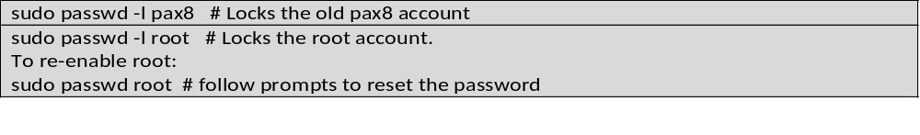

- Disable SSH password authentication

- Create a new guacadmin equivalent user, disable original guacadmin account

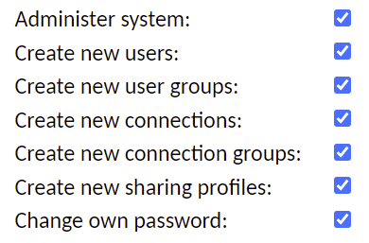
Create a new Guacamole user with full admin rights

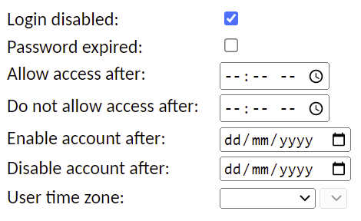
Next, disable the default guacadmin account.

- Configure Nginx front end HTTPS options:

Run your appropriate SSL installer script of choice:
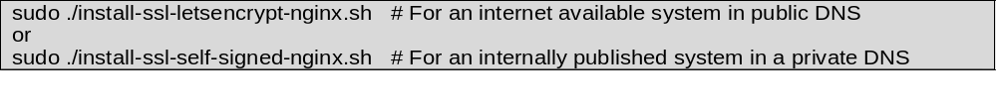Hardening steps in the above table should be considered for public Jumpboxes. See Pax8’s coaching literature for these extra secure steps.

- Add or remove MFA after install.
The installer prompts for either Duo or TOTP methods of MFA auth. If you did not choose this option at install, you can manually add MFA later as follows. (Active Directory auth is not supported by the install script, but can be added in the same way.)
Important: You can only apply ONE MFA authentication extension! (Active Directory extension is ok to mix with MFA)
Copy the appropriate extension file with the provided scripts.
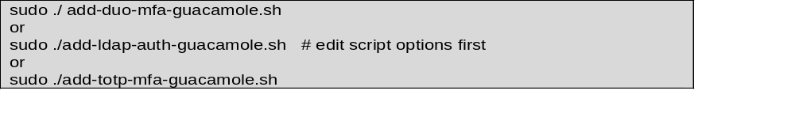
TOTP is very straightforward , just run the script.
DUO requires some additional config – see script output for further instructions.
Active Directory instructions are below…

To remove one of the above authentication extensions, simply delete or rename the relevant .jar file from /etc/guacamole/extensions

Integrating Guacamole with Active Directory (optional)
Edit the provided add-ldap-auth-guacamole.sh script to reflect your specific Active Directory environment. Change the values below in RED to suit. Be careful not to introduce new lines or carriage returns as these will cause the extension to fail. You have been warned!
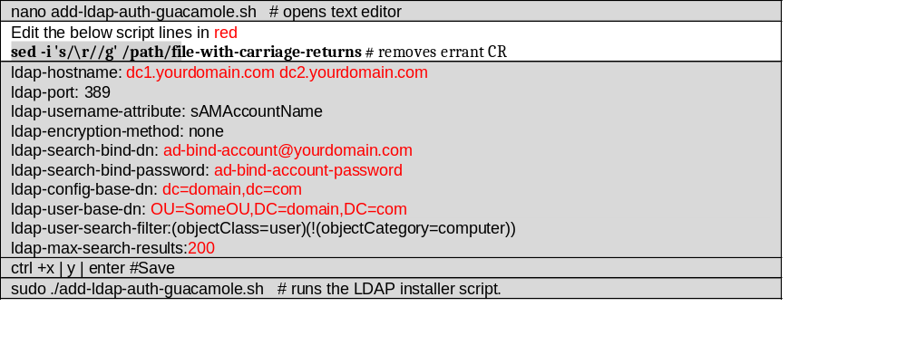
A “Domain Users” level of privilege is sufficient for Guacamole to bind with Active Directory.
Create a new local Guacamole administrator account, (or use the new Guacamole admin account created above in section 6 ) and then create a new domain account of EXACTLY THE SAME NAME in Active Directory. Now assign a DIFERENT PASSWORD IN ACTIVE DIRECTORY for the identically named Guacamole domain account.
For Active Directory binding, there must be two accounts of the same name, but each version must have different passwords. Entering a different password is how to control whether logging on to Active Directory, or whether logging on to manage the local system.
When logging in with the new LDAP account credentials named in the ldap-search-bind-dn line of the config file above, that user will be able to browse all the available users based on the OU settings provided in the script. When configured correctly, you will see a list of Active Directory users under Settings | Users of the Guacamole gui.
If you want to apply Guacamole’s MFA to a domain account, a local Guacamole account is always required that matches the same account name in Active Directory. Simply create local Guacamole accounts that mirror AD account names you wish to provice MFA. Important: When creating matching Guacamole local accounts to match account names in Active Directory, you must also create these Guacamole local accounts without passwords to allow MFA to trigger prior to an Active Directory auth challenge.
Users without a local account in the Guacamole database, will never be challenged for MFA – instead they will rely on whatever Active Directory authentication scheme is in place.
Important notes on /etc/guacamole/guacamole.properties settings:
You must carefully adjust the settings shown in red above within the add-ldap-auth-guacamole.sh script to suit your own environment. Specific LDAP authentication settings required are pictured above.

Two noteworthy settings within the guacamole.properties file are:
ldap-user-base-dn: All Guacamole users must be descendants of this distinguished name. User objects this point in your tree will not be visible.
mysql-auto-create-accounts: true (not included in the script) is an optional line that ensures that all LDAP user accounts will have a local Guacamole account created without a password (at first logon.) This may be a time saver if larger numbers of domain accounts must use Guacamole’s MFA.

LDAP auth firewall requirements:
If your Jump Server is operating in a separate network to that of your Active Directory Servers (highly recommended), the Jump Server will require TCP 389 available to all Active Directory Domain Controllers nominated in the ldap-hostname directive above.
RDP Single Sign On with Active Directory
If the Jump Server and remote RDP client connections will share a common AD domain:

- Create a Global Security domain group (e.g. Guac_Users) and populate it accordingly. Now add this new security group to the built-in “Remote Desktop Users” domain group.

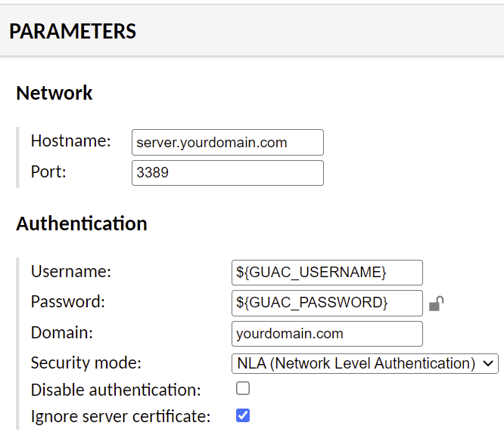
- For SSO, connection profiles do not need to be configured with specific usernames and passwords. For seamless RDP connections, remote connection profiles should be configured with ${GUAC_USERNAME} & ${GUAC_PASSWORD} parameter tokens as shown.

For testing and troubleshooting LDAP authentication, observe logs with these commands:
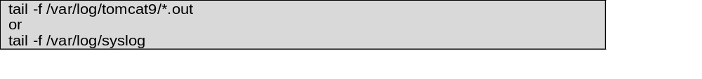

- Change the MYSQL root password (Pax8 Raspberry Pi base images only)
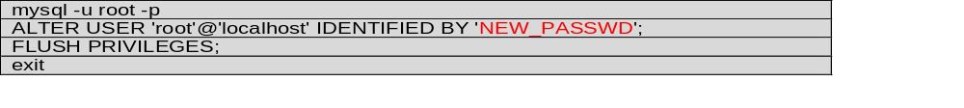

- Change the pre-set guacamole_user MYSQL password (Pax8 Raspberry Pi base images only)
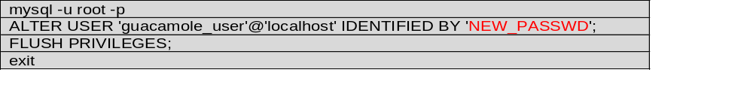
And adjust the /etc/guacamole.properties file to use the new password: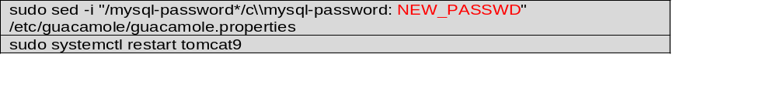
- Change the time zone
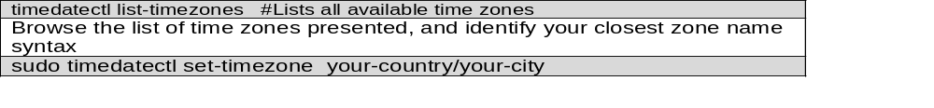

- Branding the Guacamole logon screen
The provided branding.jar file is basically a container file like a .zip archive. You should be able to use archive manager programs like 7-zip to open the .jar file and view/edit the files contained within it.
The internal file structure of branding.jar is:
- css (folder) -> .css (file)
- images (folder) -> location of a logo .png file
- translations (folder) -> en.json (file) and other language files as needed
- guac-manifest.json (file) ties all the parts together so Guacamole knows what to use.
- The background colours, logo image used and other cosmetic changes to the page are implemented by changing the stylesheets in the .css file.

The images folder must only contain a .png logo file of appropriate pixels to suit the logon dialogue box. 500x 500px is a good starting point.
The .json file(s) in the translations folder dictate what text is displayed for the title (and what language).
Lastly the guac-manifest.json basically ties all these parts together so Guacamole can customize the login screen to the desired specifications.

To add branding to Guacamole:
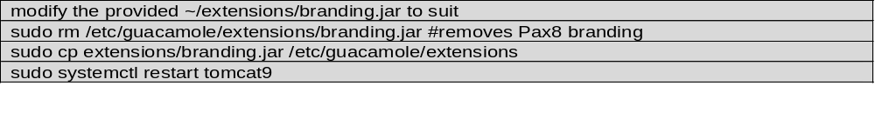

- If using Pax8 Raspberry Pi Image:

Default passwords
Root account is enabled, type su – to gain root. Root password = pax8
Default Ubuntu username = pax8 , password = pax8
Root MYSQL password = pax8
guacamole_user MYSQL password = pax8

- If using a Pax8 Raspberry Pi and USB3.0 boot performance is flaky.

To work around this issue:
- Insert the USB boot device into a Raspberry Pi USB2.0 port and power up. If the device boots properly on USB2.0, the solution below should address your USB3.0 boot issue.

- Run lsusb and check the output, search for the specific ID of the USB boot device.
Example lsusb output: (Note the specific ID numbers in XXXX:XXXX the output syntax.)
Bus 002 Device 002: ID 152d:0578 JMicron Technology Corp. / USA Tech Corp. JMS578 SATA 6Gb/s
(the /boot/cmdline.text file can be edited from a PC as the /boot partition is Fat32.)
Add the following line at the start of the cmdline.txt file (adjusting the XXXX:XXXX to your own lsusb ID output) 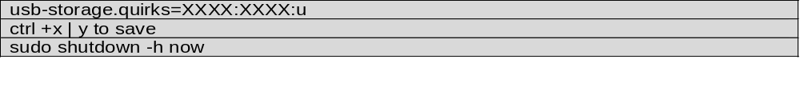
- Plug the USB SSD adapter into a Raspberry Pi USB3.0 port.

- Power up again, the device should boot faster and with more reliability on USB3.0

