# MAC Address Spoofing with Kali Linux

Time required: 30 minutes

# Lab Description

MAC address spoofing is a technique for temporarily changing your Media Access Control (MAC) address on your network connection. A MAC Address is a unique and hardcoded address programmed into network devices which cannot be changed permanently. The MAC address is in the 2nd OSI layer and should be the physical address of your interface.

**Macchanger** is a tool that is included with any version of Kali Linux and can change the MAC address to any desired address until the next reboot. In this tutorial we will be spoofing the MAC address of our network adapter with a random MAC address generated by Macchanger on Kali Linux.

1. Start both your Kali Linux and Windows 10 virtual machines.
2. Check in Settings to be sure they are both on the NAT network.
3. On Kali: Open a **Terminal** session.
4. Run the **ip a** command to determine the name of the network adapter connected to the network. It should be eth0.
5. **Insert a screenshot of the results:**

Click or tap here to enter text.

1. Use the following command to change your ethernet MAC address to a new random MAC Address:  
   **sudo macchanger -r eth0**
2. **Replace the following screenshot with yours:**

[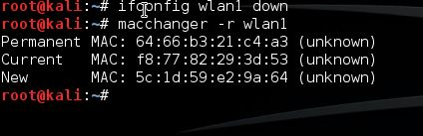](http://www.hackingtutorials.org/wp-content/uploads/2015/06/MAC-Address-spoofing-with-macchanger.jpg)

As shown on the screenshot, **macchanger** will show you the permanent, current, and changed MAC address. The permanent MAC Address will be restored to your network adapter after a reboot or you can reset your network adapters MAC address manually.

1. Use the following command to restore the permanent MAC address to your network adapter manually:  
   **sudo macchanger --permanent eth0**
2. **Insert a screenshot:**

Click or tap here to enter text.

## Assignment Submission

Attach this completed document to the assignment in Blackboard.