# MAC Address Spoofing with Windows

Time required: 30 minutes

## Lab Description

Watch: [MAC Address Explained](https://www.youtube.com/watch?v=TIiQiw7fpsU&t=284s)

MAC address spoofing is a technique for temporarily changing your Media Access Control (MAC) address on a network device. A MAC Address is a unique and hardcoded address programmed into network devices which cannot be changed permanently. The MAC address is in the 2nd OSI layer and should be the physical address of your interface. Changing your MAC address could allow a threat actor to redirect or capture traffic.

For example, if you spoofed the MAC address of the default gateway/router, you could intercept or disrupt network traffic.

This lab can be done on a physical or virtual machine.

## Use Device Manager

1. Use **ipconfig /all** to determine your current MAC address of the NIC connected to your network.
2. **Insert a screenshot of your MAC address:**

Click or tap here to enter text.

1. Go to Network and Sharing Center. Go to Change Adapter Settings.
2. Determine which network adapter is the one connected to the internet.
3. Right Click Start, Device Manager.
4. Go to Network Adapters, Right Click on the Network Adapter identified earlier and choose Properties.
5. Go to the Advanced tab. Click **Locally Administered Address**, click Value. Type in a fictitious MAC Address such as:  
   **24DBACED792C**
6. Click OK. **NOTE:** This may disrupt your network connection.
7. **Insert a screenshot of just the MAC address:**

Click or tap here to enter text.

1. Notice that it is the new MAC address.
2. Go back to the Device Manager and set the Network Adapter Network Address to Not Present.
3. **Insert a screenshot of just the MAC address:**

Click or tap here to enter text.

1. Your MAC address should be back to the original.

# Use a Program to Spoof Your MAC Address

1. Go to <https://technitium.com/tmac>, download and install Technitium MAC Address Changer.

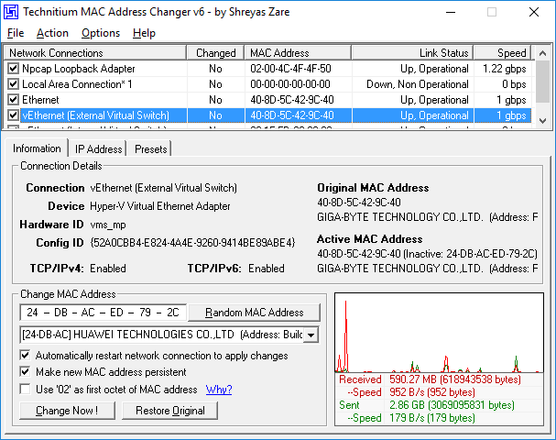

1. Choose the NIC attached to your network. You should see network activity.
2. Click Random MAC Address. Click Change Now.
3. **Insert a screenshot of the program showing your new MAC address:**

Click or tap here to enter text.

1. Click **Restore Original**.
2. **Insert a screenshot of the result**.

Click or tap here to enter text.

## Assignment Submission

Attach this completed document to the assignment in Blackboard.