# Netdiscover

Time required: 30 minutes

# Network Scanning

Please use a bridged adapter for this assignment. We want to scan your local network. Only scan a network you own or have permission to scan.

# What is Netdiscover?

Netdiscover is a simple ARP scanner which can be used to scan live hosts in a network. It can scan for multiple subnets also. It simply produces the output in a live display(ncurse). This can be used in the first phases of a pentest where you have access to a network. Netdiscover is a simple and initial-recon tool which can be very handy.

# Netdiscover Tutorial

1. Start Kali Linux 🡪 open a terminal session.
2. Make sure the Kali Linux VM is connected to the **Bridged Network**.
3. Type **ip a**
4. You should get a response like this. Notice **eth0: inet** is 192.168.9.0/24 That is the network range you will scan. Yes, your network range will be different.

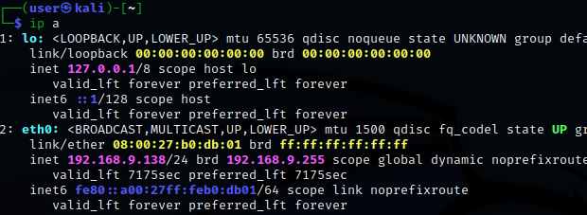

1. **Insert a screenshot:**

Click or tap here to enter text.

1. Type **sudo netdiscover -help**
2. The resulting help screen shows the arguments that can be used

This example is how to scan a network range. In a few moments, you should see your network devices.

|  |
| --- |
| # sudo netdiscover -r <range>  sudo netdiscover -r 192.168.9.0/24 |

1. **Insert a screenshot:**

Click or tap here to enter text.

1. Type **CTRL-C** to exit netdiscover.
2. Parse the output to a file as shown. Use your network settings.

|  |
| --- |
| sudo netdiscover -r 192.168.9.0/24 -P > network.txt |

1. You won’t see anything as the stdout was piped to a file.
2. Type **ls** to list the directory.
3. Type **nano network.txt**
4. You should see the devices on your network in the text file.

## Assignment Submission

Attach this completed document and network.txt to the assignment in Blackboard.