# IT Technical Support Final Project

Time required: 1 hour

# Create an Installation USB Drive with Rufus

1. Download the evaluation copy of **Windows 11 Enterprise**. (Skip the next 2 steps if you already have an ISO.)  
   <https://www.microsoft.com/en-us/evalcenter/evaluate-windows-11-enterprise>
   1. **Sign in** and choose the **ISO** option. You will need to **register**.
   2. Download the **ISO** option to a folder on your hard drive where you can find it.
2. Download the portable version of Rufus from <https://rufus.akeo.ie>   
   This utility can be used to take almost any ISO and create a bootable USB drive.
3. Double click the file your downloaded to launch **Rufus**. Choose the USB device you wish to use.
4. Go to **ISO Image** 🡪 click the CD drive icon 🡪 choose the Windows 11 Evaluation image you downloaded earlier.
5. Click **Start**. Click **OK**, you want to wipe out the USB drive. This may take some time.
6. Insert a screenshot of Rufus showing the progress of the boot USB creation. You do not have to complete the process.
7. Click or tap here to enter text.

# Scan Your Local Network

Advanced Port Scanner is a legitimate program used to scan your network.

You can scan any network you have permission to scan such as your home network or D1.

1. Go to <https://www.advanced-port-scanner.com/>
2. Download and install **Advanced Port Scanner**.
3. 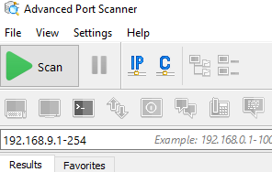Start Advanced Port Scanner. After Advanced Port Scanner loads, it will load all the IP addresses on your computer.
4. Go to the command prompt. Type **ipconfig /all**.
5. **Insert a screenshot.**

Click or tap here to enter text.

1. Remove all networks except your local network. See the example above.
2. Click the **Scan** button to scan your network. As the scanning progresses, the lower pane shows network devices and machines that the utility discovers.
3. Insert a screenshot showing the completed scan of your network.

Click or tap here to enter text.

1. Click the Expand All button.
2. Insert a screenshot showing the open ports and shares on your devices. Replace the example with your network scan.

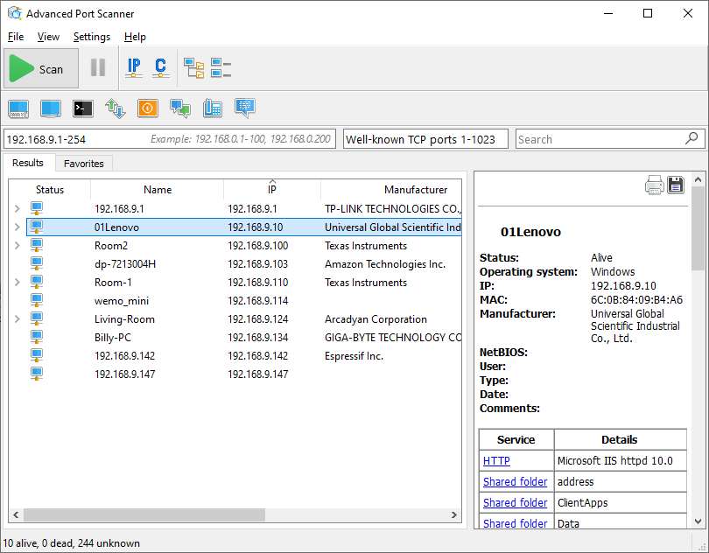

Click or tap here to enter text.

# Document Your Home Network in Packet Tracer

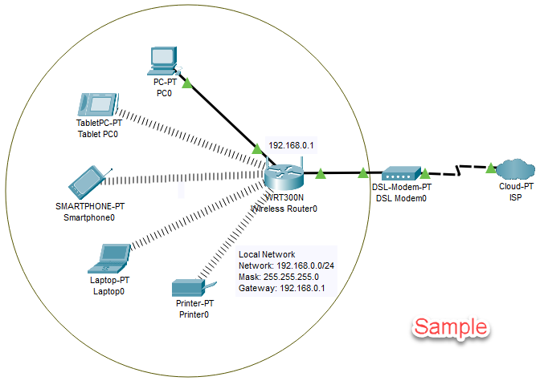

Document your home network with Packet Tracer.

Use your IP addressing scheme of your home network or D1.

Go to **Options**, **Preferences**, **Turn off Device Model Labels**. This allows modification of the names of the devices.

Include the following items:

* Wireless router
  + Make up a WPA2 key
  + Use your home SSID
* Type of Modem and ISP
* Computer and/or laptops
* Any other devices connected to your network
* Include a minimum of 5 end point devices
* Comment as shown in the example
* Insert a screenshot of your network in Packet Tracer

## Review Questions

1. What is the purpose of a subnet mask?

Click or tap here to enter text.

1. What is the purpose of a default gateway? How does a host use a default gateway?

Click or tap here to enter text.

1. What is the purpose of DNS?

Click or tap here to enter text.

1. What is the purpose of DHCP?

Click or tap here to enter text.

1. What is the network address of your network?

Click or tap here to enter text.

1. What layer is the MAC address on?

Click or tap here to enter text.

1. What is the purpose of the MAC address? How is it used?

Click or tap here to enter text.

1. What is a broadcast address used for?

Click or tap here to enter text.

## Assignment Submission

Attach this completed document and the Packet Tracer file to the assignment in BlackBoard.