# Backup and Restore (Windows 7)

Time required: 60 minutes

**How to Create Screenshots:** Please use the Windows Snip and Sketch Tool or the Snipping Tool. Paste a screenshot of just the program you are working on. If you are snipping a virtual machine, make sure your focus is outside the virtual machine before you snip.

1. Press and hold down the **Windows key** & **Shift**, then type **S.** This brings up the on-screen snipping tool.
2. Click and Drag your mouse around whatever you want to snip.
3. Release the mouse button. This places the snip into the Windows Clipboard.
4. Go into Word or wherever you want to paste the snip. Hold down **CTRL**, then type **V** to paste the snip.

# Lab Description

Windows includes the Windows 7 Backup and Restore program. It is now called Backup and Restore (Windows 7). Using Windows 7 [Backup and Restore](javascript://), you can create a backup schedule that can include any folder on the hard drive and a system image.

The [system image](javascript://) is a backup of the entire volume where Windows is installed. The folders and volume are first backed up entirely (called a full backup). On the schedule you set, any file or folder is backed up that has changed or been created since the last backup (called an incremental backup). Occasionally, Windows does another full backup.

# Add an Extra Hard Drive to a Virtual Machine in VirtualBox

Unless you have an external USB hard drive, do this lab on a virtual machine. It is easy to add an extra hard drive to a virtual machine.

**NOTE:** Your virtual machine must be powered off.

1. In VirtualBox, Right Click your virtual machine, and choose **Settings**.
2. Click Storage. Click the **Adds hard disk** button as shown below.

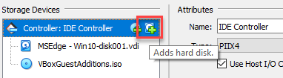

1. Click **Create**. Keep all default settings.
2. After your hard disk is created, Click it and Click **Choose**.
3. Click **OK**.

# Disk Management

1. Start your Windows virtual machine. Right Click the Start button. Choose **Disk Management**.
2. The new disk will be recognized 🡪 Click OK to Initialize Disk 1.
3. Right Click on Disk 1 where it says Unallocated 🡪 Click **New Simple Volume**.
4. Click Next 🡪 Specify the Volume Size 🡪 Click Next 🡪 Assign the following drive letter: E 🡪 Click Next 🡪 Volume label: Backup 🡪 Click Next.
5. Format the disk.

# Setup a Backup

Follow these steps to learn how to set up a backup schedule using Backup and Restore (Windows 7):

1. Click Start 🡪 type **Control Panel 🡪** Click **Control Panel**.
2. Click or search for **Backup and Restore (Windows 7)**. If no backup has ever been scheduled on the system, the window will look like the one shown below.

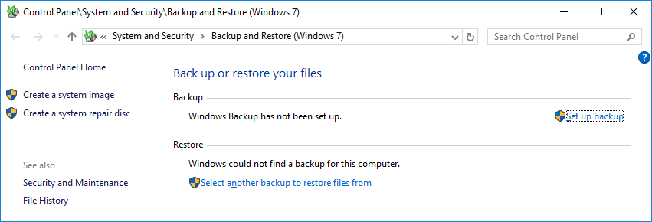

Sample

1. Click **Set up backup**.
2. **Insert a screenshot:**

Click or tap here to enter text.

1. In the next dialog box, select the media to hold the backup. In the figure below, choices are volume E: (a second internal hard drive).

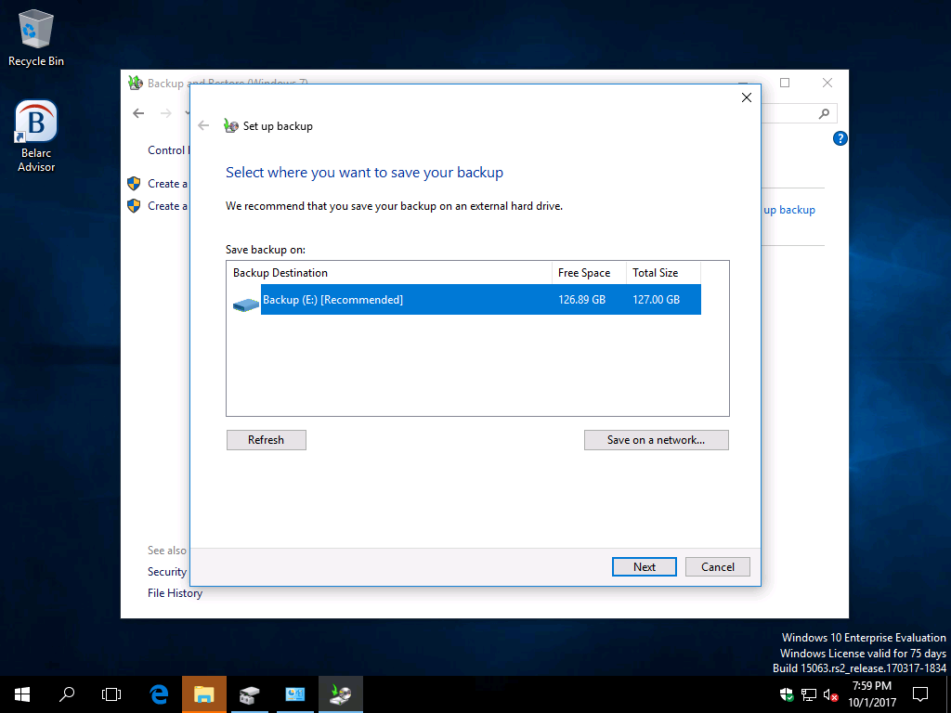

1. Make your selection and click **Next**.
2. **Insert a screenshot:**

Click or tap here to enter text.

1. In the next box, you can allow Windows to decide what to back up or decide to choose for yourself. Select **Let me choose** so that you can select the folders to back up. Click **Next**.
2. In the next box, select the libraries and folders you want to back up. Click the white triangle beside Local Disk (C:) to drill down to any folder on the hard drive for backup. Check folders or libraries to back up. If the backup media can hold the system image, the option to include the image is selected by default. If you don’t want to include the image, uncheck it.
3. Click **Next** to continue. Here is the folder that might contain important user data:   
   **C:\Users\username** (Where username is the user you logged in as.)
4. You may want to select the entire user profile folder, or just the important folders, like Documents, Music, Videos, Desktop, etc.
5. **Insert a screenshot of your selections:**

Click or tap here to enter text.

1. In the next box, verify the correct folders and libraries are selected. To change the default schedule, click **Change schedule**. In the next box, you can choose to run the backup daily, weekly, or monthly and select the time of day. Make your selections and click **OK**.
2. Review your backup settings and click **Save settings and run backup**. The backup proceeds. A [shadow copy](javascript://) is made of any open files so that files that are currently open are included in the backup.

Later, you can return to the Backup and Restore window to change the backup settings or to turn off the backup.

**Note:** One limitation of Windows Backup and Restore is that you can have only one scheduled backup routine.

**Manage space:** After Windows does a full backup, it only backs up files that have changed since the last full backup. Occasionally, it does another full backup. Each full backup is called a backup period. It keeps as many backup periods as it has space on the backup media. As the media fills, it deletes the oldest backup periods. To see how space is used on your backup media, click **Manage space** in the Backup and Restore window. In the Manage Windows Backup disk space, you can click **View backups** to delete a backup period. However, be sure to keep the most recent backup periods.

# Recover Backed-Up Items

1. To recover backed-up items, open the Windows 7 Backup and Restore window and scroll down to the bottom of the window and click **Restore my files**. Note that if the Restore my files button is missing from the Backup and Restore window, your backup media might not be available to Windows. You might need to plug in the media and then use Windows Explorer to verify you can access the backup folder on the media.
2. Use one of the three buttons on the window to locate the file or folder. Search allows you to search for a file or folder when you only know part of the file name or folder name. Browse for files allows you to drill down to the file to restore. Browse for folders allows you to search for the folder to restore. You can locate and select multiple files or folders to restore. Then follow the directions on screen to restore all the selected items.
3. Select one file from your backup to restore.
4. Restore it to your desktop.
5. **Insert a screenshot of the restored file:**

Click or tap here to enter text.

## Create a System Image

**NOTE:** This is not part of the assignment, just information if you want to create a system image of your computer.

A backup of an entire volume is called a system image. This is a recommended practice on a regular basis. If something goes wrong with your PC, you can go back to your last system image, which restores your computer to the exact state it was in when you made the system image.

1. To create a system image, click **Create a system image** in the Backup and Restore windows and follow the directions on the screen.

## Assignment Submission

Attach this completed document to the assignment in Blackboard.