# Create Synchronicity

Time required: 30 minutes

**How to Create Screenshots:** Please use the Windows Snip and Sketch Tool or the Snipping Tool. Paste a screenshot of just the program you are working on. If you are snipping a virtual machine, make sure your focus is outside the virtual machine before you snip.

1. Press and hold down the **Windows key** & **Shift**, then type **S.** This brings up the on-screen snipping tool.
2. Click and Drag your mouse around whatever you want to snip.
3. Release the mouse button. This places the snip into the Windows Clipboard.
4. Go into Word or wherever you want to paste the snip. Hold down **CTRL**, then type **V** to paste the snip.

## Lab Description

Using a backup program to back up your files is good practice. Sometimes you just want to synchronize folders of data. Create Synchronicity is a free open-source backup and synchronization program. This program is perfect for synchronizing the contents of your flash drive with your desktop computer and vice versa. It only copies the changed files, so it works very quickly. You can create different profiles for different synchronization folders.

1. Download Create Synchronicity from <http://synchronicity.sourceforge.net> Choose either the standalone or installer version.
2. Install or unzip Create Synchronicity.
3. Run Create Synchronicity.
4. You may be asked to **Download and Install .NET 3.5**. Agree, download and install. This may take a few minutes.
5. You don’t need to Agree to check for updates on startup.

Decide what to synchronize. A suggestion is to synchronize your school USB drive with a folder on your computer. This is a quick way to backup/synchronize your USB drive each day.

1. Click **New profile**. Name it **USB Drive to My Documents**. (Or the other way around if your documents are on your computer. Press **Enter**.
2. Click the box with the three dots to the right of **From:** and choose the source folder. Choose your documents folder, or a sub folder under documents.
3. Click the box with the three dots to the right of **To:** and choose the destination folder. Create a folder on the USB drive for the backup.

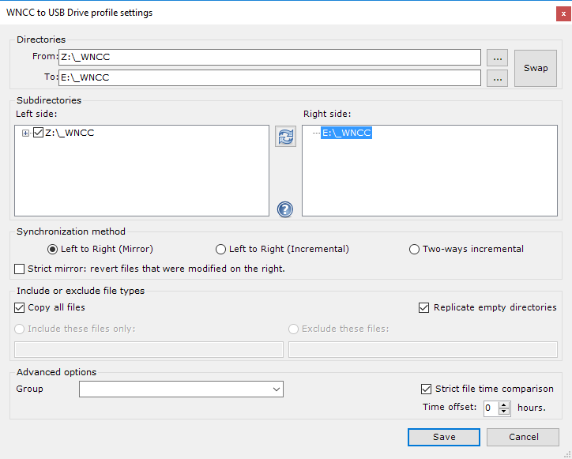

1. Click **Load folder tree**. Your setup should be like the example image.
2. **Insert a screenshot of your setup:**

Click or tap here to enter text.

1. Click **Save**.
2. To run your Synchronization, **Right Click** the profile you created, and choose **Synchronize**. You can choose Preview first, to test it out.
3. **Replace the example with a screenshot of your running process.**

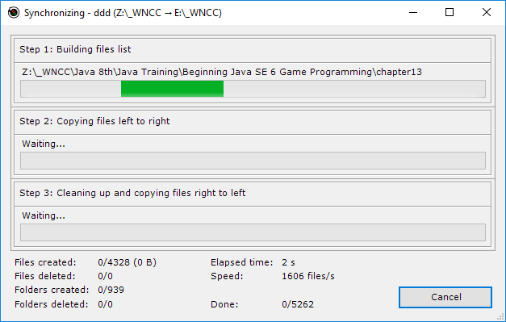

1. **What do you think? Is this something you might use or show someone else how to use?**

Click or tap here to enter text.

## Assignment Submission

Attach this completed document to the assignment in Blackboard.