# Folder Options and Power Management

Time required: 30 minutes

**How to Create Screenshots:** Please use the Windows Snip and Sketch Tool or the Snipping Tool. Paste a screenshot of just the program you are working on. If you are snipping a virtual machine, make sure your focus is outside the virtual machine before you snip.

1. Press and hold down the **Windows key** & **Shift**, then type **S.** This brings up the on-screen snipping tool.
2. Click and Drag your mouse around whatever you want to snip.
3. Release the mouse button. This places the snip into the Windows Clipboard.
4. Go into Word or wherever you want to paste the snip. Hold down **CTRL**, then type **V** to paste the snip.

## Change Folder Options

A technician is responsible for solving problems with system files (files that belong to the Windows operating system) and file extensions. To fix problems with these files and extensions, you need to see them. To change folder options so you can view system files and file extensions in Windows, do the following:

1. Click **Start** 🡪 Type **File Explorer**.
2. Go to the **View** tab.

1. Use the buttons shown to experiment with File Explorer settings.
   1. Change the size of the icons.
2. **Options** button (far right) 🡪 **Change folder and search options**.

As a technician, you may have to look at hidden files and folders.

1. Click the View tab. Scroll down in the Advanced settings group and make these selections to show hidden information about files, folders, and drives:
   1. Select **Show hidden files, folders, and drives**.
   2. Uncheck **Hide extensions for known file types**.
   3. Uncheck **Hide protected operating system files (Recommended)** Respond to the Warning box.
   4. Click **Apply to Folders**.
2. **Insert a screenshot:**

Click or tap here to enter text.

1. You can restore your Folder Options to their previous state if you wish.
   1. Click **Restore Defaults**.
2. To save your changes and close the Folder Options box, click OK.

## Configure Windows Power-Management Settings

Follow these steps to configure power in Windows:

1. Click Start 🡪 type **Control Panel**. Search for **Power Options**. The Power Options window opens. The plans might be different for other computers.

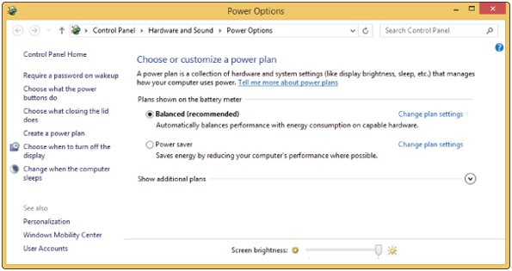

1. You can customize each plan. For example, under Balanced (recommended), click Change plan settings. The Edit Plan Settings window appears. Notice in the figure the various times of inactivity before the computer goes into sleep mode, which are called sleep timers.
2. To see other changes you can make, click Change advanced power settings. Using this Power Options box, you can do such things as control the minutes before the hard drive turns off; control what happens when you close the lid, press the sleep button, or press the power button; or set the brightness level of the LCD panel to conserve power. You can also use this box to set what happens when the battery gets low or critically low. Make your changes and click OK to close the box.

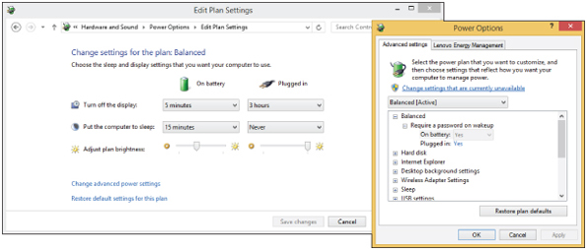

1. Experiment with Adjust plan brightness. If you have a laptop, this is where you can adjust the screen brightness when on power. You might turn it all the way to the right.
2. **Insert a screenshot of your power settings:**

Click or tap here to enter text.

1. If you made changes, click Save changes in the Edit Plan Settings window. Close the Power Options window.

## Assignment Submission

Attach this completed document to the assignment in Blackboard.