# Identify the Hardware on Your PC with Software

Time required: 30 minutes

**How to Create Screenshots:** Please use the Windows Snip and Sketch Tool or the Snipping Tool. Paste a screenshot of just the program you are working on. If you are snipping a virtual machine, make sure your focus is outside the virtual machine before you snip.

1. Press and hold down the **Windows key** & **Shift**, then type **S.** This brings up the on-screen snipping tool.
2. Click and Drag your mouse around whatever you want to snip.
3. Release the mouse button. This places the snip into the Windows Clipboard.
4. Go into Word or wherever you want to paste the snip. Hold down **CTRL**, then type **V** to paste the snip.

**NOTE:** This lab must be done on a physical machine. In class students can use the computer on the table in the back of the room.

# CPU-Z

Paste the screenshots and answer the following questions.

1. Go to [www.cpuid.com](http://www.cpuid.com)  
   **WARNING:** Be careful of ads and other downloads. Download **Cpu-z** and install it on your system. (There is a portable zip file which contains a standalone version that you can carry on a usb drive.)
2. Run the program. Paste a screenshot to replace the example below. Look at the other tabs.

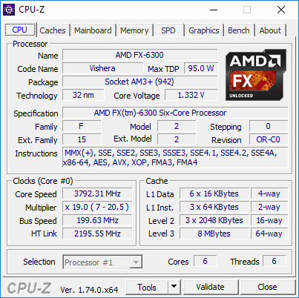

1. Go to the Mainboard tab and paste a screenshot to replace the example below.

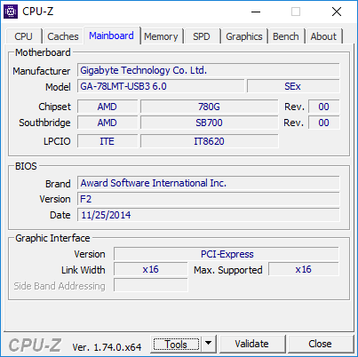

1. **Go to the Memory tab. Paste a screenshot. How much memory does your computer have? What is the type? Is it dual channeled?**

Click or tap here to enter text.

1. **What type of slot does your video card have (Graphic Interface, Version)?**

Click or tap here to enter text.

1. **What is the name of your video card? Paste a screenshot:**

Click or tap here to enter text.

1. **How much and what type of memory is in your video card?**

Click or tap here to enter text.

1. **What is the most interesting piece of information you discovered about your computer?**

Click or tap here to enter text.

# HWiNFO

1. Go to [www.hwinfo.com](http://www.hwinfo.com)   
   **WARNING:** Be careful of ads and other downloads. Download **HWiFO64** and install it on your system. (There is a portable zip file which contains a standalone version that you can carry on a usb drive.)
2. Run the program. Replace the sample screenshot with a screenshot on your system.

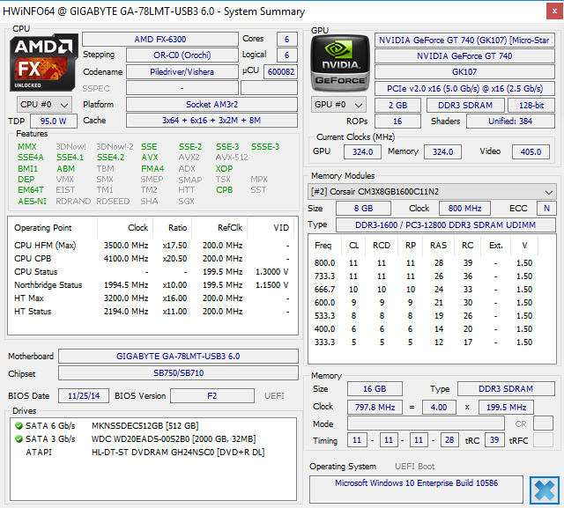

1. **Does this program give information that Cpu-z doesn’t? Give some examples.**

Click or tap here to enter text.

# Speccy

1. Go to <https://www.ccleaner.com/speccy>, download and install the free version of Speccy.
2. **Insert a screenshot of the Summary screen:**

Click or tap here to enter text.

# Assignment Submission

Attach this completed document to the assignment in Blackboard.