# Windows Full Shutdown

Time required: 15 minutes

**How to Create Screenshots:** Please use the Windows Snip and Sketch Tool or the Snipping Tool. Paste a screenshot of just the program you are working on. If you are snipping a virtual machine, make sure your focus is outside the virtual machine before you snip.

1. Press and hold down the **Windows key** & **Shift**, then type **S.** This brings up the on-screen snipping tool.
2. Click and Drag your mouse around whatever you want to snip.
3. Release the mouse button. This places the snip into the Windows Clipboard.
4. Go into Word or wherever you want to paste the snip. Hold down **CTRL**, then type **V** to paste the snip.

## Quick Shutdown

If you don't plan to use your PC for a while, then you could shut down your PC by pressing the **Win+X** keys, press **U**, and press **U** again. A shutdown will close all apps, sign out all users, and turn off the PC. Windows uses a feature called a hybrid shutdown (fast startup). This is a form of hibernation, it does not shut down the operating system, just saves it for the next startup. **Fast startup** is a setting that helps your PC start up faster after shutdown, even faster than hibernate.



**Hibernate** is a power-saving state designed primarily for laptops or tablets. If you use hibernation, when you start up the PC again, you’re back to where you left off.

**A full shutdown** will close all apps, sign out all users, completely shut down the operating system and completely turn off the PC. When the computer is started, the operating system does a complete startup.

# Option 1: Perform a full shutdown using Shift key

1. Open Start menu, select **Power** button.
2. Press and hold the **Shift** key on keyboard, while clicking on **Shut down**, and then release the **Shift** key to perform a full shutdown.

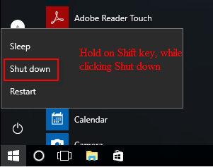

# Option 2: Perform a full Shutdown using Command Prompt

1. Click **Start**, type **command prompt**, Right Click the command prompt and choose **Run as Administrator**.  
   **Tip:** Instantly open the **Command Prompt(Admin)** by using [Windows key X keyboard shortcuts](https://www.isumsoft.com/windows-10/keyboard-shortcuts-for-winx-quick-link-menu.html): press **Win+X**, then **A**.
2. Execute the following command, and press Enter key.  
   **NOTE:** /s is shut down, /f is full shut down, /t 0 is shut down without delay.  
   **shutdown /s /f /t 0**

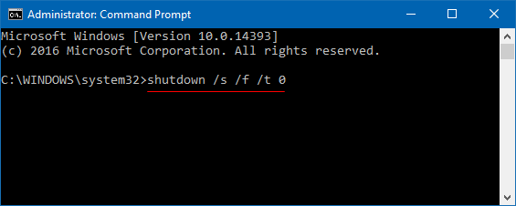

1. Insert a screenshot of your command prompt.

Click or tap here to enter text.

1. If you want to perform a system restart after fully shutting down Windows 10, run the following command:

**shutdown /r /f /t 0**

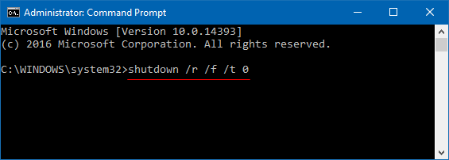

# Full Shutdown Shortcut

You can create a full shutdown shortcut on your desktop to make it easy to do a full shutdown on your computer.

1. Right Click your Desktop 🡪 **New** 🡪 **Shortcut**.
2. Type the location of the item: **shutdown.exe /s /f /t 0**
3. Insert a screenshot.

Click or tap here to enter text.

1. Click **Next.** Type a name for this shortcut: **Shutdown**
2. Insert a screenshot.

Click or tap here to enter text.

1. Click **Finish** to create the shortcut.
2. To add a nice icon to your shortcut, Right Click **Shutdown** and Click **Properties**.
3. Click **Change** Icon. Scroll around until you find the icon you like. Click **OK**, Click **OK**.
4. Close all programs. Double Click your shortcut to make sure it works.
5. **Insert a screenshot of your new shortcut on your desktop**.

Click or tap here to enter text.

## Assignment Submission

Attach this completed document to the assignment in Blackboard.