# Advanced Port Scanner

## Objectives

The goal of this lab is to set up and use Advanced Port Scanner to scan your network for host devices and open ports. This is a good way to take a quick look at what is on a network.

## Activity Background

Time required: 45 minutes

This lab may be done on a physical or virtual machine.

# Activity

1. Go to <https://www.advanced-port-scanner.com>.
2. Download and install **Advanced Port Scanner**. Accept all default installation choices.
3. Start **Advanced Port Scanner**. After **Advanced Port Scanner** loads, it will load all the IP addresses on your computer.
4. Go to the command prompt. Type **ipconfig /all**.
5. Insert a screenshot showing your local network settings.

Click or tap here to enter text.

1. 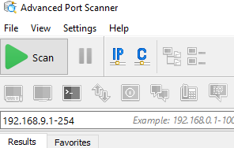In **Advanced Port Scanner**, remove all networks except your local network.
2. Click the **Scan** button to scan your network. As the scanning progresses, the lower pane shows network devices and machines that the utility discovers.
3. Insert a screenshot showing the completed scan of your network.

Click or tap here to enter text.

1. Click the **Expand All** button.
2. Insert a screenshot showing the open ports and shares on your devices.

Click or tap here to enter text.

1. Go to **File**, **Print**. **Choose the Microsoft Print to PDF** printer. Click **Print**. Save the pdf somewhere you can locate it again.

## Review Questions

1. What network layers does the Advanced Port Scanner give you information on?

Click or tap here to enter text.

1. What information does Advanced Port Scanner provide about your network?

Click or tap here to enter text.

1. As a Network technician in the field, how might you use this utility?

Click or tap here to enter text.

1. You used the Advanced Port Scanner print function earlier. How can this be useful?

Click or tap here to enter text.

## Assignment Submission

1. Attach this completed document.
2. Attach your pdf report.
3. Submit in Blackboard.