# Wi-Fi Analyzer

Time required: 15 minutes

## Lab Description

Wi-Fi Analyzer is a free application that can be downloaded and installed on a Windows device. The application can be used to detect and analyze the different available Wi-Fi access points. The application can be downloaded through the Microsoft Store.

In this task, the use of a Wi-Fi Analyzer application will be demonstrated.

1. Open the Windows Store 🡪 search for and install **Wi-Fi Analyzer**.
2. You should see something like the example screenshot.
3. **Insert a screenshot:**

Click or tap here to enter text.

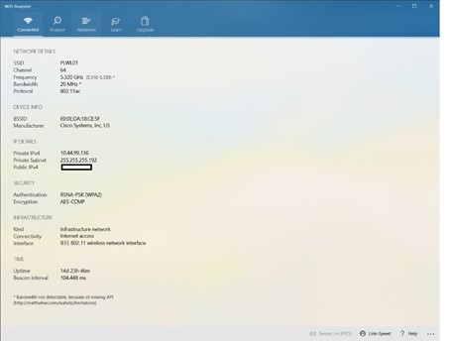

**Note:** Using the Wi-Fi Analyzer application, specific information can be gathered about the connected Wi-Fi network. A Network Administrator can use this information to troubleshoot connectivity-related issues on the network.

1. In the **Networks** tab of the **Wi-Fi Analyzer**, the different available Wi-Fi Networks that are available are displayed. A Network Administrator can use this information to determine how further Wi-Fi Access Points can be setup if needed and the range of the available Access Points.
2. **Insert a screenshot:**

Click or tap here to enter text.

1. Click the **Analyze** menu of the Wi-Fi Analyzer. More information on the Wi-Fi connection can be gathered. This information includes which frequency and channel the device is connected to on the Wi-Fi Access Point.
2. **Insert a screenshot:**

Click or tap here to enter text.

1. Close the **Wi-Fi Analyzer** application.

## Assignment Submission

1. Attach this completed document to the assignment in Blackboard.