# Wireless Network Scanning

Time required: 60 minutes

Contents

Wireless Network Scanning 1

Lab Description 1

Simple Wireless Analyzer 2

View Wireless Keys 3

Wireless Network Watcher 4

NetSurveyor Wireless Analyzer 4

Wireless Analyzer on Your Android Smartphone or Tablet 6

iPhone or IPad 7

Speedtest.net 7

Speedtest on Your Smartphone 8

Wigle.net 8

Assignment Reflection 9

# Lab Description

**NOTE:** This lab must be done on a physical machine with a wireless network card.

**MAC NOTE:** If you do not have a Windows machine, research how to use the built in Wi-fi Scanner tool for Mac for OS X.

**NOTE:** Some anti-virus/malware programs may not like the programs we will use in this lab. They are legitimate programs; but may be considered hacking tools by an anti-virus/malware program. If you have trouble, disable your anti-virus/malware while working with the Nirsoft programs.

You can download all the utilities in one Launcher package from <https://launcher.nirsoft.net/downloads/index.html>

# Simple Wireless Analyzer

Wireless network monitoring software can be used to examine your own wireless network and look for other nearby networks that may cause interference. This kind of software can usually capture details about networks, such as their network name or SSID, whether they use encryption, and their broadcasting frequency. Some programs will also capture and analyze packets transmitted on the WLAN. In this lab, you will use a common wireless network detector from Nirsoft called WirelessNetView.

1. Download and install **WirelessNetView** from [www.nirsoft.net](http://www.nirsoft.net) under the Network Monitoring Tools section. The zip file download link is at the bottom of the WirelessNetView page.  
   **NOTE:** Google Chrome blocks this file from being downloaded. Use Edge or Firefox.
2. Unzip and run **WirelessNetView**.

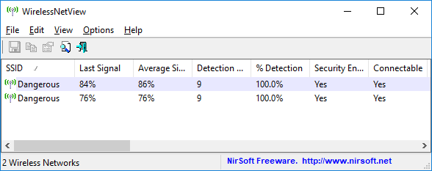

1. Click File, and then Clear Networks list.
2. After a few minutes, the **WirelessNetView** window should fill with all the available networks, as shown above.
3. **Insert a screenshot:**

Click or tap here to enter text.

1. Use WirelessNetView to determine if your wireless network is set up as you expected.
2. Double-click on your own network and record your network’s SSID, authentication type, channel number, and maximum speed.
3. **Insert a screenshot of your wireless network properties:**

Click or tap here to enter text.

1. If other networks are also visible, answer the following questions:
2. **Are any unsecured networks visible?**

Click or tap here to enter text.

1. **Do any other networks use the same channel number as your network?**

Click or tap here to enter text.

1. If possible, walk with your laptop while monitoring the signal strength. **How far from the wireless router could you get before the signal strength dropped by 10 percent?**

Click or tap here to enter text.

1. When you’re finished, exit WirelessNetView.

# View Wireless Keys

**NOTE:** Some anti-virus/malware programs may not like the programs we will use in this lab. They are legitimate programs; but may be considered hacking tools by an anti-virus/malware program. IF you have trouble, disable your anti-virus/malware while working with the Nirsoft programs.

WirelessKeyView recovers all wireless network security keys/passwords (WEP/WPA/WPA2) stored in your computer by the 'Wireless Zero Configuration' service of Windows XP or by the 'WLAN AutoConfig' service of Windows Vista, Windows 7, Windows 8, Windows 10, and Windows Server 2008. It allows you to easily save all keys to text/html/xml file, or copy a single key to the clipboard. You can also export your wireless keys into a file and import these keys into another computer.

**NOTE:** Disable your anti virus.

1. Go to <http://www.nirsoft.net/utils/wireless_key.html> and download the 64-bit version of **WirelessKeyView**. The download link is on the bottom of the page.
2. Extract the files from the downloaded file. Double Click the **WirelessKeyView.exe** file to run the program.
3. You will see the keys to all the wireless networks stored on your computer.
4. **Resize the program window or use the Word drawing tools to blank out they keys so that you can insert a screenshot of the program results without showing the keys:**

Click or tap here to enter text.

1. **Did you see the keys?**

Click or tap here to enter text.

1. **Do you think this presents a security risk? If so, why?**

Click or tap here to enter text.

# Wireless Network Watcher

Wireless Network Watcher is a small utility that scans your wireless network and displays the list of all computers and devices that are currently connected to your network.

For every computer or device that is connected to your network, the following information is displayed: IP address, MAC address, the company that manufactured the network card, and optionally the computer name.

You can also export the connected devices list into html/xml/csv/text file, or copy the list to the clipboard and then paste into Excel or other spreadsheet application.

1. Go to <http://www.nirsoft.net/utils/wireless_network_watcher.html> and download **Wireless Network Watcher**. The download file is toward the bottom of the page.
2. Extract the files from the downloaded file. Double Click **WNetWatcher.exe** to run the program.
3. It may take a moment, but all the devices on your network should show up.
4. **Insert a screenshot showing the devices on your network:**

Click or tap here to enter text.

## NetSurveyor Wireless Analyzer

You can analyze wifi networks with a free Windows program, NetSurveyor.

<http://nutsaboutnets.com/archives/netsurveyor-wifi-scanner>

Alternative site, as the one above is temporarily having trouble.

1. <https://www.techspot.com/downloads/6904-netsurveyor.html>
2. Use Direct Download
3. Download and install **NetSurveyor** on a computer that has a wireless network card.
4. Insert a screenshot below with one of your wireless networks.

Click or tap here to enter text.

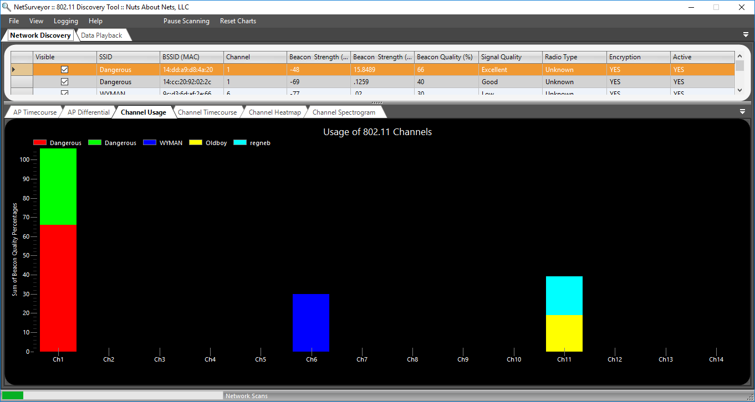

1. What channel is your wireless network set to?

Click or tap here to enter text.

1. Are there other networks on this channel? If so, what are they?

Click or tap here to enter text.

1. Notice the column Signal Quality.
2. The purpose of a Site Survey is to determine where wireless access points should be placed in a building for the best coverage. How could Signal Quality be used for a site survey?

Click or tap here to enter text.

1. Click the Channel Spectrogram tab.
2. **Insert a screenshot:**

Click or tap here to enter text.

1. Carry your laptop away or move your wireless router. Note the changes in signal strength.
2. How much did the signal degrade with distance?

Click or tap here to enter text.

1. Is there anything you can do to improve your WiFi?

Click or tap here to enter text.

1. Go to the File menu, then click Create Report. Give the report a useful name. Attach it to this assignment.

## Wireless Analyzer on Your Android Smartphone or Tablet

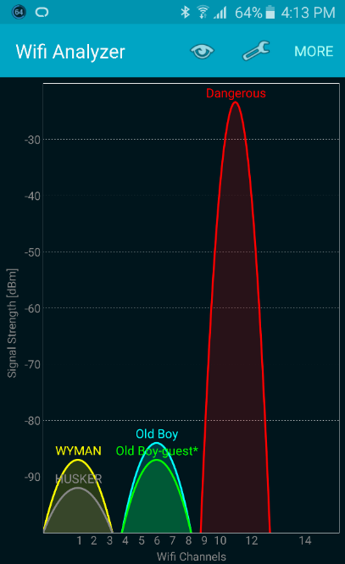You can turn your Android device into a portable Wi-Fi analyzer by installing a free or inexpensive app through Google Play for your Android device, or Amazon Apps for your Kindle. Please install this or a similar app and answer the questions below. The screenshots are for an Android phone.

If you don’t have an Android phone or tablet, or a Kindle Fire, borrow one from a friend.

1. Go to **Google Play** and search for **Ubiquiti WiFiman** or **Wifi Analyzer by farproc**
2. Install the app and open it.
3. The app will automatically start scanning for Wi-fi signals. The screenshot below gives an example of what you should see.
4. Explore the features of the app.
5. Research how to take a screenshot on your smartphone or tablet. Replace the screenshots in this document with a screenshot of channel graph and the AP list.
6. Insert a screenshot of the networks in your area using the settings of the sample screenshots.

Click or tap here to enter text.

1. What channel is your network programmed to?

Click or tap here to enter text.

1. 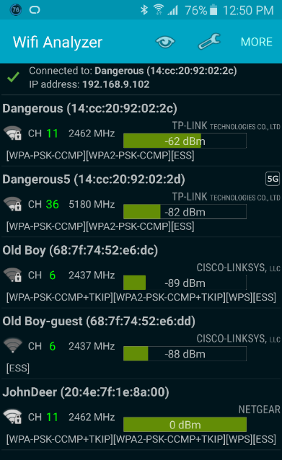What security is your network programmed to?

Click or tap here to enter text.

1. What is the signal strength of your network?

Click or tap here to enter text.

1. If your network is on the same channel as other networks, find a channel 1, 6, or 11 that isn’t as crowded. Change your Wi-fi channel on your wireless router if possible.
2. Please describe what you found on this step?

Click or tap here to enter text.

## iPhone or IPad

If you only have access to an Apple device, you can use the Airport Utility to scan for networks.

1. Go to the **App Store** 🡪 search for **AirPort** 🡪 Install **Airport**.
2. Go to the **Settings App** 🡪 **AirPort Utility**.
3. Turn on the Wi-Fi Scanner option.
4. Tap on the AirPort Utility App.
5. Tap on the "Wi-Fi Scan" option in the upper right-hand corner of the app.
6. For "Scan duration," select the option of choice or leave it set to "Continuous."
7. Tap on "Scan."
8. Insert a screenshot.

Click or tap here to enter text.

1. When done scanning, tap on "Stop." Then tap on "Done."
2. Since scanning uses the battery, disable this feature from the same location you enabled it before.

## Speedtest.net

1. Connect your computer by a network cable to your Wireless Router.
2. Go to [www.speedtest.net](http://www.speedtest.net) on your computer. Run the test.
3. Insert a screenshot.

Click or tap here to enter text.

1. Connect your computer to your wireless router by wireless. If your computer doesn’t have wireless, you can use your phone by downloading the speedtest app.
2. Run speedtest.net again.
3. Insert a screenshot.

Click or tap here to enter text.

1. Move as far away from your wireless router as you can and still maintain a connection. Run speedtest.net again.
2. Insert a screenshot and the distance you are from your wireless router? Notice the difference in speed.

Click or tap here to enter text.

1. Was the network cable speed the same or faster than your wireless speed? What did you find with this section of tests?

Click or tap here to enter text.

# Speedtest on Your Smartphone

1. 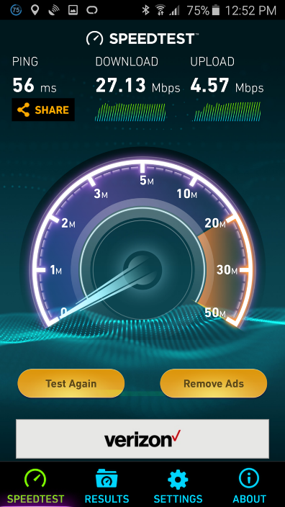Go to Google Play, Amazon Apps, or iTunes. Search for Speedtest.net by Ookla and install it on your smartphone.
2. Test your internet bandwidth (This is a safe app, but be careful not to tap on the ads).
3. What was your ping (latency), download and upload speeds?

Click or tap here to enter text.

1. Insert a screenshot of your results.

Click or tap here to enter text.

# Wigle.net

1. Go to [www.wigle.net](http://www.wigle.net) and see if you can find wireless access points in your area.
2. Is yours on the map?

Click or tap here to enter text.

1. Paste a screenshot of your neighborhood.

Click or tap here to enter text.

# Assignment Reflection

1. Please reflect on what you learned going through these exercises. Please be specific.

Click or tap here to enter text.

1. What did you learn that might improve your wireless network? For example, would it benefit you to change channels?

Click or tap here to enter text.

Attach this completed document and the NetSurveyor pdf report to the assignment in Blackboard.