# Packet Tracer SOHO Network

Contents

Packet Tracer SOHO Network 1

Objectives 1

Materials Required 1

Activity Background 1

Part 1: Download And Install Packet Tracer 2

Part 2: Build a SOHO Network in Packet Tracer 2

Test Connectivity 7

Review Questions 8

Assignment Submission 8

### Objectives

The goal of this lab is to implement a wired and wireless network with a SOHO (Small Office Home Office) router in Packet Tracer. After completing this lab, you will be able to:

* Set up a SOHO network in Cisco Packet Tracer

### Materials Required

This lab requires the following:

* Computer with Windows
* Internet access

### Activity Background

Cisco Packet Tracer simulates many functions of a network and can be useful to help you learn and practice networking skills. In this lab, you install Packet Tracer and use it to build and configure a small wired and wireless network that uses a SOHO router and cable modem for Internet connectivity.

**NOTES:** When loading a Packet Tracer file, it may take a minute for everything to connect. Sometimes a device may not get a DHCP address. Switch the IP Configuration from DHCP to Static then back to DHCP.

Time Required: 60 Minutes

# Part 1: Download And Install Packet Tracer

To get the Packet Tracer download, you must first sign up for the free Introduction to Packet Tracer online course on the Cisco Networking Academy website. Complete the following steps to create your account, download, and install Packet Tracer:

1. In your browser, navigate to [www.netacad.com/courses/packet-tracer](http://www.netacad.com/courses/packet-tracer). Enroll in the course.
2. Open the confirmation email and confirm your email address. Configure your account and save this information in a safe place. You will need this information again.
3. Click **Courses** and select the **Getting Started with Packet Tracer** course.
4. Inside the course 🡪 **Module 1: Download and Use Packet Tracer** 🡪 **Download Cisco Packet Tracer.** Download the latest version for your computer OS.
5. Install Packet Tracer.
6. When the installation is complete, run Cisco Packet Tracer.
7. When Packet Tracer opens, sign in with your Networking Academy account that you created earlier. If you see a Windows Security Alert, allow access through your firewall. Cisco Packet Tracer opens.

Take a few moments to explore the Packet Tracer menus and features.

**Note:** The web is an excellent source of information about Packet Tracer. For example, you can search [youtube.com](http://youtube.com) on “how to use packet tracer” for a quick tutorial.

# Part 2: Build a SOHO Network in Packet Tracer

Follow these steps to build a network in Packet Tracer:

To add a device to your network, select a category of devices in the bottom-left portion of the window, and then press and drag a device to the workspace. Follow these steps to add devices to your network, arranging the devices as shown in Figure 7-14. Do not worry about configuring any of the devices yet.

1. Select **End Devices.**
   1. Press and drag a **PC** to the workspace.
   2. Press and drag a **Laptop** to the workspace.
   3. Press and drag a **Printer** to the workspace.
   4. Press and drag a **Smartphone** to the workspace.
   5. Press and drag a **Tablet** to the workspace.
2. Select **Network Devices 🡪** select **Wireless Device.**
   1. Press and drag the **WRT300N** wireless router to the workspace.
   2. Select **WAN Emulation**, then press and drag **PT-Cloud** to the workspace.
      1. Click **Cloud-PT**. Click **Config**, set the **Display Name** as **ISP**.
   3. Select **WAN Emulation**, and then press and drag a **Cable-Modem-PT** to the workspace.

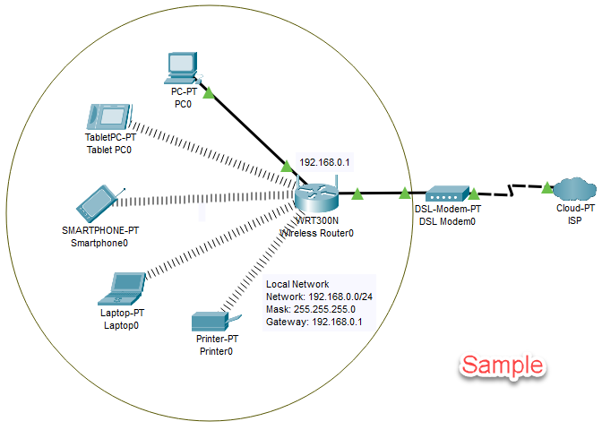

**Figure 7-14** Arrangement of devices in Packet Tracer

**NOTE:** To delete a device from the workspace, select the **Delete** icon in the menu bar. Your pointer changes to an **×**. Then click the device you want to delete. To return to the Select function, click the **Select** icon in the menu bar.

You’re now ready to use Ethernet cable to connect devices in your network.

1. To connect a cable, you first select the type of cable you want. Then click the first device in the connection and select its port.
2. Click the second device and select its port. The cable connects the two devices. If both devices are turned on, they will attempt to automatically establish connectivity.
3. In the categories of devices in the bottom-left portion of the window, select **Connections** (the lightning bolt icon). In the list of cable types, press and drag a **Copper Straight-Through cable** (a black solid line) to the **Wireless Router**. Select the first port on the **Wireless Router,** then click the **PC** and select the **FastEthernet port**. The Ethernet cable connects the **Wireless Router** and **PC**.
4. Connect the **Internet** port on the wireless router to **Port1** on the **Cable-Modem-PT**.
5. Use a **Coaxial** cable to connect **Port0** on the **Cable-Modem** to **Coaxial7** on the **Cloud-PT**.
6. To configure the **Wireless Router**, Click to open its configuration window.
   1. Click **GUI** to see the web-based utility on the **WRT300N** wireless router.
   2. Select the **GUI Setup** tab, and notice that the local IP address of the router is **192.168.0.1**. Also notice that DHCP is enabled, so devices on your network can be assigned dynamic IP addresses.
   3. Insert a screenshot.

Click or tap here to enter text.

* 1. What is the range of IP addresses to be assigned?

Click or tap here to enter text.

1. To secure the wireless network, select the GUI **Wireless** tab, select **Wireless Security**, and set the **Security Mode** to **WPA2 Personal**.
2. Set a Passphrase.
3. Save your settings.
4. Insert a screenshot.

Click or tap here to enter text.

* 1. Click **Basic Wireless Settings**. Change the **SSID** to something of your choosing.
  2. Insert a screenshot.

Click or tap here to enter text.

* 1. Save your settings.
  2. To secure the router, select the GUI **Administration** tab. Change the **Router Password**. Change the Password to **Password01**.
  3. Insert a screenshot.

Click or tap here to enter text.

* 1. Save your settings.

By default, end devices are set for static IP addresses and have not yet been assigned IP addresses. To change the setting to DHCP, follow these steps:

1. **TabletPC**
   1. Click the **TabletPC** to open the configuration window.
   2. Set to **DHCP**.
   3. Click **Wireless0**.
   4. Set the **SSID** to your SSID.
   5. Set the **WPA-PSK Pass Phrase** to the passphrase you created earlier.
   6. Insert a screenshot.

Click or tap here to enter text.

* 1. Close the configuration window.

1. **Smartphone**
   1. Click the **Smartphone** to open the configuration window.
   2. Set to **DHCP**.
   3. Click **Wireless0**.
   4. Set the **SSID** to your SSID.
   5. Set the **WPA-PSK Pass Phrase** to your passphrase.
   6. Insert a screenshot.

Click or tap here to enter text.

* 1. Close the configuration window.

1. **Laptop**

The Laptop has to be configured to use a wireless card.

* 1. Scroll down in **the Physical Device View**.
  2. Click the **Power Button** to turn off the laptop.
  3. Drag the ethernet module from the laptop to the module column.
  4. Drag the **WPC300N** module to the bottom right of the screen. Drop it right below **Customize Icon in Logical View**.

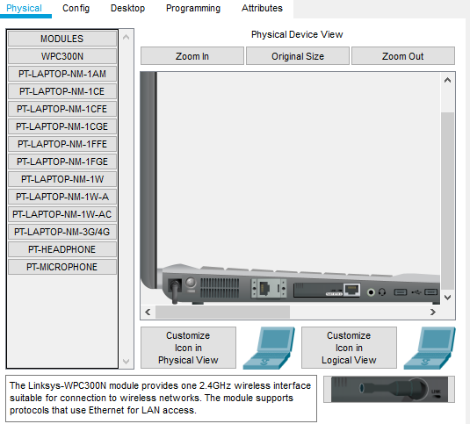

* 1. Click the **Power Button** to turn on the laptop.
  2. Click the **Config** tab. Set to **DHCP**.
  3. Click **Wireless0**.
  4. Set the **SSID** to the SSID you created earlier.
  5. Set the **WPA2-PSK Pass Phrase** to the passphrase you created earlier.
  6. Insert a screenshot.

Click or tap here to enter text.

* 1. Close the configuration window.

1. **Printer**

The Printer has to be configured to use a wireless card. It is the same process as the laptop.

* 1. Scroll down in **the Physical Device View**.
  2. Click the **Power Button** to turn off the printer.
  3. Drag the ethernet module from the printer to the module column.
  4. Replace it with the **WPC300N** module.
  5. Click the **Power Button** to turn on the printer.
  6. Click the **Config** tab. Set to **DHCP**.
  7. Click **Wireless0**.
  8. Set the **SSID** to the SSID you created earlier.
  9. Set the **WPA2-PSK Pass Phrase** to the passphrase you created earlier.
  10. Insert a screenshot.

Click or tap here to enter text.

* 1. Close the configuration window.

1. **PC**
   1. Click the PC 🡪 Desktop tab 🡪 IP Configuration.
   2. Choose DHCP.

### Test Connectivity

1. To test connectivity from the PC to your router, open the PC’s configuration window, Click **Desktop**, and then click **Command Prompt**.
   1. Determine the **IP address** of the **PC** using a command line utility.
   2. Insert a screenshot.

Click or tap here to enter text.

* 1. Test connectivity to the router using a command line utility.
  2. Insert a screenshot.

Click or tap here to enter text.

1. Click the Laptop.
   1. Determine the **IP address** of the Laptop using a command line utility.
   2. Insert a screenshot.

Click or tap here to enter text.

* 1. Test connectivity to the **PC** using a command line utility.
  2. Insert a screenshot.
  3. Click or tap here to enter text.

1. Insert a screenshot of your completed network.

Click or tap here to enter text.

1. Click File, click Save as, and save the Packet Tracer file in a safe place.

# Review Questions

1. What layer does a switch operate at?

Click or tap here to enter text.

1. Does an end device require an IP address in order to establish network connectivity with a switch? Please explain why.

Click or tap here to enter text.

1. What layer does Wireless Router operate at?

Click or tap here to enter text.

1. What is the exact TCP/IP command is used to test for connectivity between a device with an IP address of 192.168.1.101 and another device that has an IP address of 192.168.1.102?

Click or tap here to enter text.

## Assignment Submission

Attach this completed document and your Packet Tracer file and submit the assignment in BlackBoard.