# Packet Tracer Routing Between Two Networks

Contents

Packet Tracer Routing Between Two Networks 1

Objectives 1

Activity Background 1

Part 1: Download And Install Packet Tracer 1

Part 2: Setup the Network 2

Part 3: Configure the Router 3

Part 4: Configure the PC’s 5

Review Questions 8

Assignment Submission 8

Time Required: 60 Minutes

### Objectives

The goal of this lab is to implement a wired and wireless network with a SOHO router in Packet Tracer. After completing this lab, you will be able to:

* Set up a small routed network in Cisco Packet Tracer

### Activity Background

Cisco Packet Tracer simulates many functions of a network and can be useful to help you learn and practice networking skills. In this lab, you install Packet Tracer and use it to build and configure a small wired routed network.

# Part 1: Download And Install Packet Tracer

**NOTE:** If you already have Packet Tracer installed, go to the next step.

Follow these steps to download and install Packet Tracer:

To get the Packet Tracer download, you must first sign up for the free Introduction to Packet Tracer online course on the Cisco Networking Academy website. Complete the following steps to create your account, download, and install Packet Tracer:

1. In your browser, navigate to [www.netacad.com/courses/packet-tracer](http://www.netacad.com/courses/packet-tracer). Enroll in the course.
2. Open the confirmation email and confirm your email address. Configure your account and save this information in a safe place. You will need this information again.
3. Click **Courses** and select the **Getting Started with Packet Tracer** course.
4. Inside the course 🡪 **Module 1: Download and Use Packet Tracer** 🡪 **Download Cisco Packet Tracer.** Download the latest version for your computer OS.
5. Install Packet Tracer.
6. When the installation is complete, run Cisco Packet Tracer.
7. When Packet Tracer opens, sign in with your Networking Academy account that you created earlier. If you see a Windows Security Alert, allow access through your firewall. Cisco Packet Tracer opens.

# Part 2: Setup the Network

1. In Packet Tracer, place a router, two switches, and two PC’s.

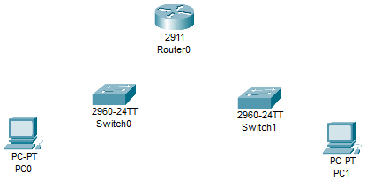

1. Connect the devices as shown below using copper straight cable.
2. Connect to the ports shown on the router.
3. The 2 switches and pc’s can be connected to any ethernet port.
4. Your network will not show green arrows until we configure the devices.
5. Please document the ip address as shown.

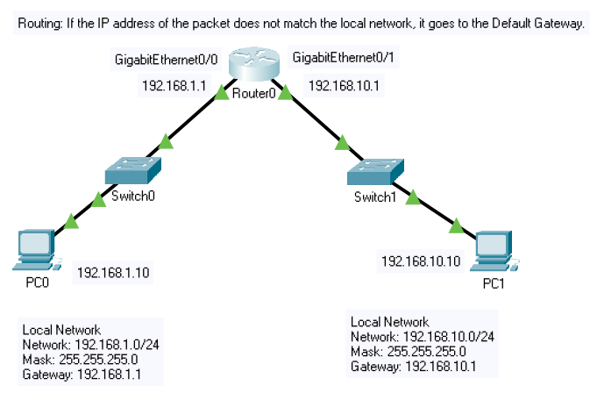

# Part 3: Configure the Router

1. Click **Router0**. That will bring up the settings where we will configure the IP addresses of the router interfaces.
2. Click the **Config** tab. Click **GigabitEthernet0/0**.
3. Click the **On** box to enable the port.
4. We will enter a standard private Class C network with 254 hosts.
5. IPv4 Address: **192.168.1.1** Subnet mask: **255.255.255.0**

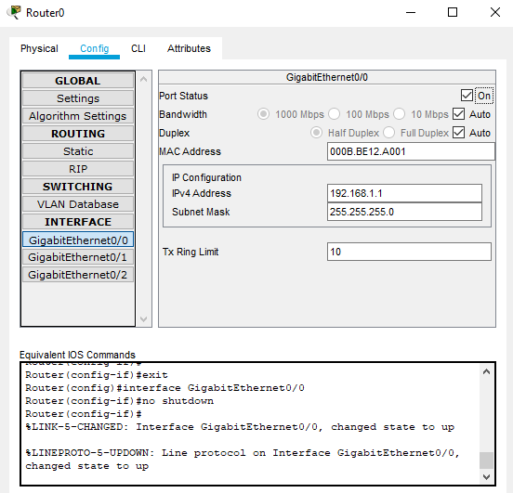

1. Click **GigabitEthernet0/1**.
2. Click the **On** box to enable the port.
3. We will enter another standard private Class C network with 254 hosts.
4. IPv4 Address: **192.168.10.1** Subnet mask: **255.255.255.0**
5. Close the Router0 window.

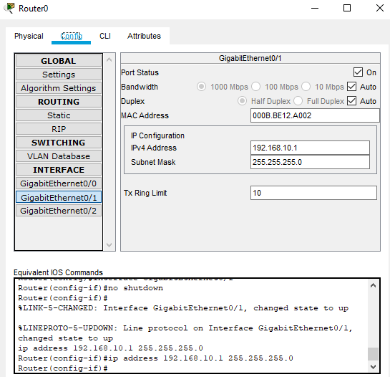

# Part 4: Configure the PC’s

We have enabled and configured the two interfaces of the router. The switches are layer 2 devices, and need no configuring. The PC’s will not have communication because they do not have IP addresses.

1. Click **PC0**. Click the **Desktop** tab 🡪 **IP Configuration**.
2. Click **Static**. Enter the following IP addressing information. Note that the Default Gateway address matches the IP address of the router interface we are connected to.
   1. IPv4 Address: **192.168.1.10**
   2. Subnet Mask: **255.255.255.0**
   3. Default Gateway: **192.168.1.1**

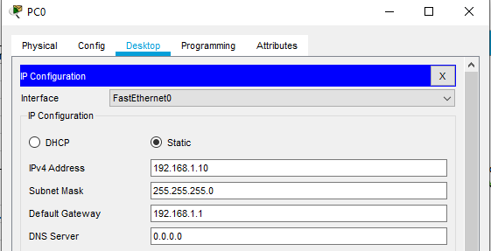

1. Close the Window.
2. Click **PC1**. Click the **Desktop** tab.
3. Click **Static**. Enter the following IP addressing information. Note that the Default Gateway address matches the IP address of the router interface we are connected to.
   1. IPv4 Address: **192.168.10.10**
   2. Subnet Mask: **255.255.255.0**
   3. Default Gateway: **192.168.10.1**

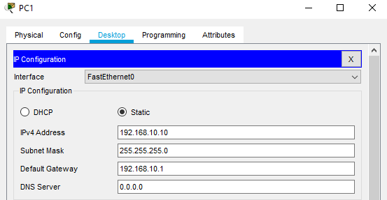

1. Click the X to the right of IP Configuration to go back to the Desktop.
2. Click the **Command Prompt**.
3. Type **ping 192.168.10.1**. You should see 4 successful replies from the router interface.
4. Insert a screenshot.

Click or tap here to enter text.

1. Type **ping 192.168.1.1**. You should see 4 successful replies from the other router interface.
2. Type **ping 192.168.1.10**. You should see 4 successful replies from PC0. Be patient, it may take a ping or two to get the ping crossing the router.
3. Close the Window.
4. Click **PC0**. Go to the **Desktop** tab 🡪 **Command line**.
5. Type **ping 192.168.10.10**. You should see 4 successful replies from **PC1**.
6. Insert a screenshot.

Click or tap here to enter text.

1. Drag the **PC0** windows to the left of the Packet Tracer Program. Click **Simulation**. Click the **Play** button.
2. At the PC0 command prompt, type **ping 192.168.10.10**.
3. You should see a simulation of the packets going back and forth.
4. Delete the Sample screenshot below. Insert a screenshot from your PacketTracer.

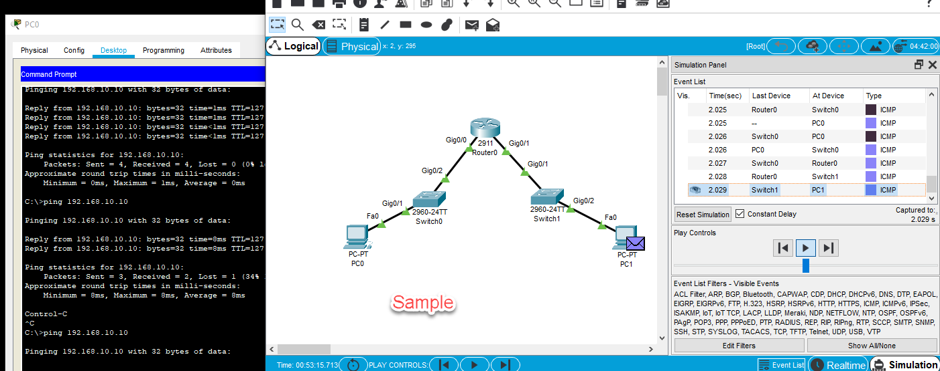

### Review Questions

1. What layer does a router operate at?

Click or tap here to enter text.

1. Explain the purpose of the default gateway in a network.

Click or tap here to enter text.

1. Which device moves the packet from one network to the other network?

Click or tap here to enter text.

1. Describe how an operating system determines from the IP address and subnet mask where to send a packet.

Click or tap here to enter text.

## Assignment Submission

Attach this completed document and the Packet Tracer file in BlackBoard and submit.