# 8-2 Create VLANs using IPv4 in Packet Tracer

Contents

8-2 Create VLANs using IPv4 in Packet Tracer 1

Lab Description 1

Part 1 - Build the Network in Packet Tracer 1

Part 2 - Setup the VLAN’s on the Router 3

Part 3 - Setup the VLAN’s on the LibrarySwitch 5

Step 4 – Setup Devices on the VLAN’s 5

Table 1 IP addresses and subnet masks for three VLANs 8

Table 2 DHCP, subnet masks, and default gateways for three VLANs 8

Table 3 TCP/IP settings for router and two printers 9

Step 5 - Configure VLAN 9

Assignment Submission 15

Time required: 180 minutes

## Lab Description

A well-designed network should work transparently for the end user, allowing them to connect to various resources on the LAN (local area network). This lab will implement a small library network.

Three separate networks will be created using a Cisco 1841 router, Cisco Catalyst 2960 switch and generic 802.11AC wireless access point. The network needs to be segmented for a staff network, patron network, and public wireless network using a VLSM (variable length subnet mask). The router will be configured to serve DHCP (Dynamic Host Control Protocol) addresses to the three VLANs (virtual local area networks).

In this lab, we will use Cisco Packet Tracer (PT) to create the networks using VLSM, DHCP and VLANs.

# Part 1 - Build the Network in Packet Tracer

Follow these steps to build the network in Packet Tracer:

1. Add the following devices. Arrange the devices as shown in Figure 1. Change the names of the devices, but do not worry about configuring any of the devices yet.
   1. Cisco 1841 Router
   2. Cisco 2960 Switch
   3. AA-PT-A (AccessPoint-PT-AC )
   4. Four PC’s (PC-PT)
   5. Two Printer’s (Printer-PT)
   6. Smart Phone (SMARTPHONE-PT)
   7. Tablet (TabletPC-PT)

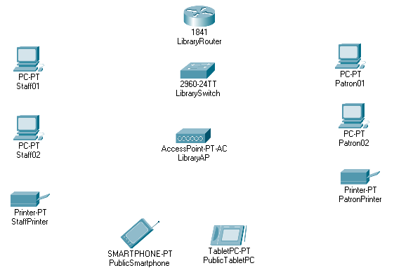

Figure 1: Arrangement of devices in Packet Tracer

1. Use Copper Straight-Through cables to connect the devices (except the two wireless devices) to ports on the switch, as listed in Table 4. Be sure each device is connected to the correct switch port.

Table 4 Device ports, interfaces, and names

|  |  |  |  |
| --- | --- | --- | --- |
| **Packet Tracer Device Type** | **Device Port** | **Switch Port** | **Device Name** |
| 1841 | FastEthernet0/0 | FastEthernet0/24 | LibraryRouter |
| 2960-24TT | n/a | n/a | LibrarySwitch |
| AccessPoint-PT-AC | Port 0 | GigabitEthernet 0/1 | LibraryAP |
| PC-PT | FastEthernet0 | FastEthernet0/1 | Staff01 |
| PC-PT | FastEthernet0 | FastEthernet0/2 | Staff02 |
| Printer-PT | FastEthernet0 | FastEthernet0/22 | StaffPrinter |
| PC-PT | FastEthernet0 | FastEthernet0/11 | Patron01 |
| PC-PT | FastEthernet0 | FastEthernet0/12 | Patron02 |
| Printer-PT | FastEthernet0 | FastEthernet0/23 | PatronPrinter |
| SMARTPHONE-PT | Wireless | n/a | PublicSmartphone |
| TabletPC-PT | Wireless | n/a | PublicTabletPC |

1. Change each device name as shown in the Device Name column in Table 4.
2. Set and confirm all other devices are using DHCP.
3. Insert a screenshot of your connected network.

Click or tap here to enter text.

# Part 2 - Setup the VLAN’s on the Router

You’re now ready to set up the VLAN Database on the router.

1. Click on the **LibraryRouter** (1841 Router)
2. Click the **Config** tab.
3. In the left pane 🡪 Click **FastEthernet0/0** 🡪 Click the **Port Status** to **On**.
4. In the left pane, click **VLAN Database.**
5. Create three VLANs, one for Staff, one for Patron and one for PublicWireless:
   1. Enter the following information for the first new VLAN, and then click **Add**:
      1. VLAN Number: 100
      2. VLAN Name: Staff
   2. Enter the following information for the second new VLAN, and then click **Add**:
      1. VLAN Number: 110
      2. VLAN Name: Patron
   3. Enter the following information for the third new VLAN, and then click **Add**:
      1. VLAN Number: 120
      2. VLAN Name: PublicWireless
6. Confirm that the three new VLANs appear in the middle pane as shown in Figure 2.

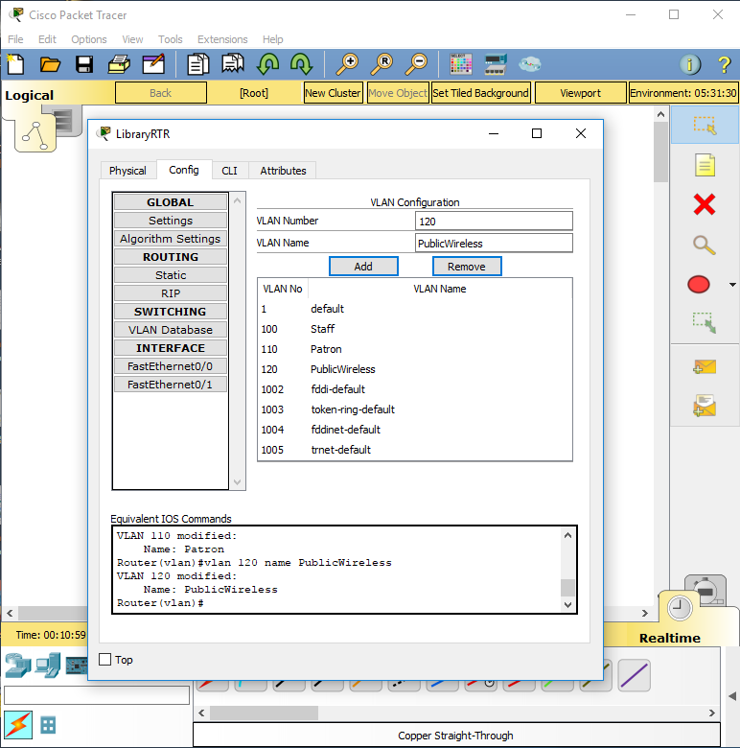

Figure 2: LibraryRouter VLAN configuration in Packet Tracer

# Part 3 - Setup the VLAN’s on the LibrarySwitch

1. Click the **LibrarySwitch** (2960-24TT switch).
2. Click the **Config** tab.
3. In the left pane, click **VLAN Database.**
4. Create three VLANs, one for Staff, one for Patron and one for PublicWireless:
   1. Enter the following information for the first new VLAN, and then click **Add**:
      1. VLAN Number: 100
      2. VLAN Name: Staff
   2. Enter the following information for the second new VLAN, and then click **Add**:
      1. VLAN Number: 110
      2. VLAN Name: Patron
   3. Enter the following information for the third new VLAN, and then click **Add**:
      1. VLAN Number: 120
      2. VLAN Name: PublicWireless

# Step 4 - Setup Devices on the VLAN’s

You are now ready to assign each interface on the switch to a VLAN. Let’s start with the Staff01 (PC-PT) workstation.

1. On the **LibrarySwitch** Config tab, click the **Interface FastEthernet 0/1** to select it. In the dropdown menu, select **Access** mode. In the VLAN dropdown menu, select **100:Staff** (see Figure 3).

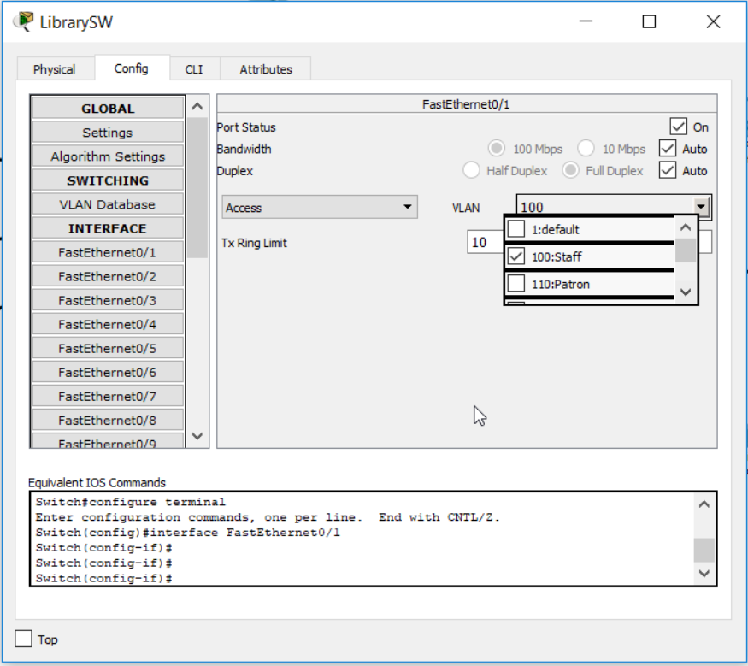

Figure 3: LibrarySwitch FastEthernet0/1 VLAN Interface configuration in Packet Tracer

1. Configure the remaining 7 wired devices, as shown in Table 5.

Table 5 VLAN assignments for each interface

|  |  |  |  |
| --- | --- | --- | --- |
| **Device** | **Interface** | **Mode** | **VLAN** |
| Staff01 | FastEthernet0/1 | Access | 100 |
| Staff02 | FastEthernet0/2 | Access | 100 |
| StaffPrinter | FastEthernet0/22 | Access | 100 |
| Patron01 | FastEthernet0/11 | Access | 110 |
| Patron02 | FastEthernet0/12 | Access | 110 |
| PatronPrinter | FastEthernet0/23 | Access | 110 |
| LibraryRouter | FastEthernet0/24 | Trunk |  |
| LibraryAP | GigabitEthernet0/1 | Access | 120 |

You’re now ready to configure the router to send traffic between VLANs. To do this, you have to configure a sub-interface on the router for each VLAN. Basically, this means you’re dividing the one physical interface into three logical interfaces.

1. Click **LibraryRouter**. Click the **CLI** tab.
2. Before you can configure the router interface, you must be in the correct command mode, which is indicated by the CLI prompt. Table 6 lists important prompts, modes, and commands to manage the interface. Read over the table so you are familiar with how to use the five commands, enable, exit, conf t, copy run start, and sh run that you might need to change modes or view/save the configuration settings. After you type a command, press Enter to execute it.

**Note:** When you first access the CLI on a Cisco device that has not yet been configured, answer *no* if you see a dialog box that says, “Would you like to enter the initial configuration dialog? [yes/no]:”. Then continue to configure the device manually.

Table 6 CLI prompts and the commands needed to change modes. This is for reference.

|  |  |
| --- | --- |
| **Prompts and Commands** | **Description** |
| Router> | The prompt indicates User EXEC mode, which has few privileges. |
| Router>**enable** Router# | Use the **enable** command to change from User EXEC mode to the more powerful Privileged EXEC mode. |
| Router# **conf t** Router(config)# | The prompt indicates the mode is Privileged EXEC mode. Use the **conf t** command to enter global configuration mode. |
| Router(config)# | The prompt indicates global configuration mode, used to configure the router. |
| Router(config-if)# | The prompt indicates interface mode, used to configure a router interface. |
| Router(vlan)# **exit** | The prompt indicates VLAN mode, used to configure a VLAN. Use the **exit** command at any time to return to Privileged EXEC mode. You might need to enter the command more than once. |
| Router# **copy run start** Destination filename [startup-config]? | The prompt indicates the mode is Privileged EXEC mode. The **copy run start** command saves the current settings so they will be reinstated after the next boot. By default, the settings are saved to the startup-config file. Press **Enter** to accept the default name. |
| Router# **sh run** | The prompt indicates the mode is Privileged EXEC mode. The sh run command displays the current configuration and is useful to verify your work and check for errors. Press **Enter** to advance one line at a time or **Space** to advance one page at a time through the command output. |

# Step 5 - Configure VLAN

Before you configure the router, save, close, and reopen the Packet Tracer file to reset the router.

Table 6

|  |  |  |
| --- | --- | --- |
| **Command** | | **Purpose** |
| enable  conf t | You are now read to configure the router. | |
| interface fastethernet0/0.100 | | Creates the sub-interface and enters interface configuration mode |
| encapsulation dot1Q 100 | | Sets encapsulation |
| ip address 192.168.100.193 255.255.255.192 | | Assigns network information to the sub-interface |
| exit | | Returns to global configuration mode |
| interface fastethernet0/0.110 | | Creates the sub-interface and enters interface configuration mode |
| encapsulation dot1Q 110 | | Sets encapsulation |
| ip address 192.168.100.129 255.255.255.192 | | Assigns network information to the sub-interface |
| exit | | Returns to global configuration mode |
| interface fastethernet0/0.120 | | Creates the sub-interface and enters interface configuration mode |
| encapsulation dot1Q 120 | | Sets encapsulation |
| ip address 192.168.100.1 255.255.255.128 | | Assigns network information to the sub-interface |
| Insert a screenshot of the commands you have run so far.  Click or tap here to enter text. | | |
| exit | | Returns to global configuration mode |
| interface fastethernet0/0 | | Enters the interface configuration mode |
| no shut | | Enables the interface |
| exit | | Returns to global configuration mode |
| exit | | Returns to privileged EXEC mode and Router# prompt appears |
| copy run start | | Saves the current settings. Accept the default name startup-config by pressing the **Enter** key. |
| sh run | | Shows the configuration currently running on the router. Use the **Enter** key to advance one line at a time or use the **Space** key to advance one page at a time. Verify your configuration using Figure 5. |

Enter the commands listed in Table 6 to configure a sub-interface for each VLAN, using three subnets of the original subnet for this network.

Figure 4 shows the first sub-interface for VLAN 100 configured. Remember to press **Enter** after each command and don’t be concerned if the prompt changes as you work through the list of commands.

### Table 1 IP addresses and subnet masks for three VLANs

|  |  |  |  |  |
| --- | --- | --- | --- | --- |
| **Network** | **VLAN** | **First Available Host** | **Last Available Host** | **Subnet Mask** |
| Staff | 100 | 192.168.100.193 | 192.168.100.254 | 255.255.255.192 |
| Patron | 110 | 192.168.100.129 | 192.168.100.190 | 255.255.255.192 |
| Public Wireless | 120 | 192.168.100.1 | 192.168.100.126 | 255.255.255.128 |

### Table 2 DHCP, subnet masks, and default gateways for three VLANs

|  |  |  |  |
| --- | --- | --- | --- |
| **Network** | **DHCP Range** | **Subnet Mask** | **Default Gateway** |
| Staff | 192.168.100.208 - 244 | 255.255.255.192 | 192.168.100.193 |
| Patron | 192.168.100.139 - 180 | 255.255.255.192 | 192.168.100.129 |
| Public Wireless | 192.168.100.6 - 121 | 255.255.255.128 | 192.168.100.1 |

### Table 3 TCP/IP settings for router and two printers

|  |  |  |  |  |
| --- | --- | --- | --- | --- |
| **Device** | **Interface** | **IP Address** | **Subnet Mask** | **Default Gateway** |
| Router | FastEthernet0/0.100 | 192.168.100.193 | 255.255.255.192 | n/a |
|  | FastEthernet0/0.110 | 192.168.100.129 | 255.255.255.192 | n/a |
|  | FastEthernet0/0.120 | 192.168.100.1 | 255.255.255.128 | n/a |
| Staff Printer | FastEthernet0 | 192.168.100.254 | 255.255.255.192 | 192.168.100.193 |
| Patron Printer | FastEthernet0 | 192.168.100.190 | 255.255.255.192 | 192.168.100.129 |

**NOTE:** You can use the up and down arrow/cursor keys to navigate through a command history. This will save a lot of typing.

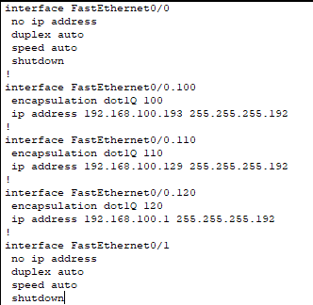

Figure 5: LibraryRouter **sh run** command verifying FastEthernet0/0 interface configuration

1. Return to global configuration mode by using commands in Table 6 as needed. You should have the prompt: Router(config)#
2. Configure DHCP on the router. Enter the global configuration mode commands listed in Table 8. When you’re finished, close the router’s window.

Table 8 DHCP configuration for each VLAN

|  |  |
| --- | --- |
| **Command** | **Purpose** |
| ip dhcp excluded-address 192.168.100.1 192.168.100.5 | Excludes the IP address from the DHCP pool |  |
| ip dhcp excluded-address 192.168.100.122 192.168.100.126 | Excludes the IP address from the DHCP pool |  |
| ip dhcp excluded-address 192.168.100.129 192.168.100.138 | Excludes the IP address from the DHCP pool |  |
| ip dhcp excluded-address 192.168.100.181 192.168.100.190 | Excludes the IP address from the DHCP pool |  |
| ip dhcp excluded-address 192.168.100.193 192.168.100.207 | Excludes the IP address from the DHCP pool |  |
| ip dhcp excluded-address 192.168.100.245 192.168.100.254 | Excludes the IP address from the DHCP pool |  |
| ip dhcp pool Staff | Creates the first DHCP pool and enters DHCP configuration mode |  |
| network 192.168.100.192 255.255.255.192 | Defines network information for the DHCP pool |  |
| default-router 192.168.100.193 | Defines the default router for the DHCP pool |  |
| exit | Returns to global configuration mode |  |
| ip dhcp pool Patron | Creates the second DHCP pool and enters DHCP configuration mode |  |
| network 192.168.100.128 255.255.255.192 | Defines network information for the DHCP pool |  |
| default-router 192.168.100.129 | Defines the default router for the DHCP pool |  |
| exit | Returns to global configuration mode |  |
| ip dhcp pool PublicWireless | Creates the third DHCP pool and enters DHCP configuration mode |  |
| network 192.168.100.0 255.255.255.128 | Defines network information for the DHCP pool |  |
| default-router 192.168.100.1 | Defines the default router for the DHCP pool |  |
| exit | Returns to global configuration mode |  |
| exit | Returns to privileged EXEC mode and Router# prompt appears |  |
| copy run start | Saves the current settings. Accept the default name by pressing the **Enter** key. |  |
| sh run | Shows the configuration currently running on the router. Use the **Enter** key to advance one line at a time or use the **Space** key to advance one page at a time. Verify configuration using Figure 8. |  |

Replace the screenshot with one of your CLI window.

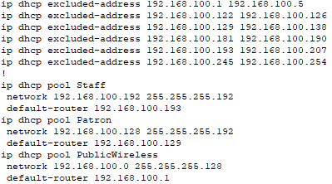

Figure 6: LibraryRouter sh run command verifying DHCP configuration

Let’s configure some devices on the network.

1. On the **StaffPrinter** 🡪 Click the **Config** tab 🡪 **Gateway**: 192.168.100.193
2. Click Interface **FastEthernet0** 🡪 IP Configuration: Static.
   1. IP v4 Address: 192.168.100.254
   2. Subnet Mask: 255.255.255.192
3. Insert a screenshot of your config tab.

Click or tap here to enter text.

1. On the **PatronPrinter** 🡪 Click the **Config** tab 🡪 **Gateway**: 192.168.100.193
2. Click Interface **FastEthernet0** 🡪 IP Configuration: Static.
   1. IP v4 Address: 192.168.100.190
   2. Subnet Mask: 255.255.255.192
3. Insert a screenshot of your config tab.

Click or tap here to enter text.

1. Test your DHCP configurations. Click on Staff01, Desktop, and IP Configuration. This PC is currently configured with a static IP address. Select DHCP and wait while the DHCP request is resolved.
2. Insert a screenshot of the IP Configuration Screen.

Click or tap here to enter text.

1. What IP address, subnet mask, and default gateway was assigned to Staff01? If Staff01 did not lease an IP address in the correct range of IP addresses, troubleshoot the problem.

Click or tap here to enter text.

**Notes:** To troubleshoot a DHCP problem, begin by rechecking your dhcp configuration on the router using the sh run command.

1. Repeat step 18 for each of the three other desktop PCs and two public wireless devices.

# Step 6 - Test the Network

What is the IP address and default gateway address on each of these devices?

1. Staff02:

Click or tap here to enter text.

1. Patron01:

Click or tap here to enter text.

1. Patron02:

Click or tap here to enter text.

1. PublicSmartphone:

Click or tap here to enter text.

1. PublicTabletPC:

Click or tap here to enter text.

1. On Patron01, select the **Desktop** tab, then **Command Prompt**. Ping the StaffPrinter’s IP address. Does it work? Why do you think this is?

Click or tap here to enter text.

1. Insert a screenshot of the results of your ping command.

Click or tap here to enter text.

1. On Patron01, select the **Desktop** tab, then **Command Prompt**. Ping the PatronPrinter’s IP address. Does it work? Why do you think this is?

Click or tap here to enter text.

1. Insert a screenshot of the results of your ping command.

Click or tap here to enter text.

1. On PublicSmartphone, select the **Desktop** tab, then **Command Prompt.** Ping the StaffPrinter’s IP address. Does it work? Why do you think this is?

Click or tap here to enter text.

1. Insert a screenshot of the results of your ping command.

Click or tap here to enter text.

## Assignment Submission

Attach this completed document and the Packet Tracer file to the assignment in Blackboard.