# Packet Tracer Smart Home IoT Network

Time required: 60 minutes

## Objectives

Your goal in this lab is to use Packet Tracer to explore the basics of setting up a smart home with IoT devices and controlling these devices with a smartphone. After completing this lab, you will be able to:

* Describe the components of a smart home network
* Use Packet Tracer to practice setting up a smart home with IoT devices

## Activity Background

As an IT support technician, you can expect that your career will lead you into learning many new technologies. The world of IoT and smart homes is one example of the changing landscape of knowledge and skills expected of a technician. In this lab, you get the chance to practice setting up a smart home without the investment of buying IoT devices. You use Packet Tracer to control a garage door and lamp from a smartphone.

**NOTE:** When loading a Packet Tracer file, it may take a minute for everything to connect.

## Download And Install Packet Tracer

To get the Packet Tracer download, you must first sign up for the free Introduction to Packet Tracer online course on the Cisco Networking Academy website. Complete the following steps to create your account, download, and install Packet Tracer:

1. In your browser, navigate to [www.netacad.com/courses/packet-tracer](http://www.netacad.com/courses/packet-tracer). Enroll in the course.
2. Open the confirmation email and confirm your email address. Configure your account and save this information in a safe place. You will need this information again.
3. Click **Courses** and select the **Getting Started with Packet Tracer** course.
4. Inside the course 🡪 **Module 1: Download and Use Packet Tracer** 🡪 **Download Cisco Packet Tracer.** Download the latest version for your computer OS.
5. Install Packet Tracer.
6. When the installation is complete, run Cisco Packet Tracer.
7. When Packet Tracer opens, sign in with your Networking Academy account that you created earlier. If you see a Windows Security Alert, allow access through your firewall. Cisco Packet Tracer opens.

Take a few moments to explore the Packet Tracer menus and features.

**Note:** The web is an excellent source of information about Packet Tracer. For example, you can search [youtube.com](http://youtube.com) on “how to use packet tracer” for a quick tutorial.

# Activity

1. Place devices on the Packet Tracer workspace.
2. A smart home needs a gateway device to connect all IoT devices. Select the **Network Devices** category, select the **Wireless Devices** subcategory, and press and drag a **Home Gateway** to your workspace.

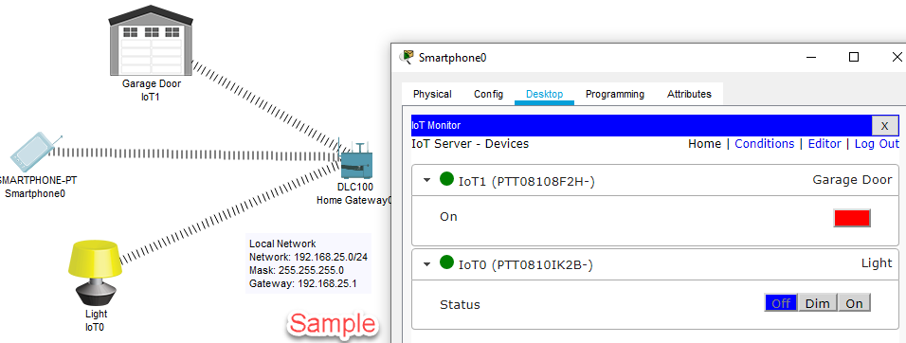

1. Select the **End Devices** category, select the **End Devices** subcategory, and press and drag a **Smart Phone** to the workspace. A Smartphone is added to the workspace.
2. In the **End Devices** category, select the **Home** subcategory, and press and drag a **Light** to the workspace.
3. Press and drag a **Garage Door** to the workspace.
4. Click the **Home Gateway** to open its configuration window. Select the **Config** tab. Click **LAN**.
5. What is the IP address of the home gateway?

Click or tap here to enter text.

1. Click **Wireless**. What is the SSID of the wireless network that the home gateway provides?

Click or tap here to enter text.

1. The IoT devices are connected to the gateway. Register them with the IoT server embedded in the gateway. Click the **Light** and click the **Config** tab.
2. Select **IoT Server** 🡪 **Home Gateway**. Close the configuration window. Do the same for the **Garage Door**.
3. Let’s connect the smartphone to the home gateway and configure an app on the phone to manage the devices connected to the home gateway. To connect to Wi-Fi, click the smartphone and click **Config**. Click **Wireless0**. Change the **SSID** to the SSID of the **HomeGateway**.
4. Insert a screenshot.

Click or tap here to enter text.

1. Close the configuration window and verify that the wireless connection is made.
2. To use the phone to manage the IoT devices, click the smartphone and click **Desktop**. Click **IoT Monitor**. Notice the IP address of the IoT server is correct. Click **Login** to sign in to the server. You should now be able to control the light and the garage door from the IoT Monitor app on the smartphone.
3. Insert a screenshot.

Click or tap here to enter text.

1. Insert a screenshot of your completed network.

Click or tap here to enter text.

## Review Questions

1. In this Packet Tracer lab, which component (hardware or software) is similar in concept to the Amazon Alexa app?

Click or tap here to enter text.

1. In this Packet Tracer lab, which component (hardware or software) is similar in concept to a Home or SOHO router?

Click or tap here to enter text.

1. Which Packet Tracer component (hardware or software) in this lab acted as your IoT gateway?

Click or tap here to enter text.

1. What is an IoT gateway or app?

Click or tap here to enter text.

1. When setting up the Amazon Echo, you communicate with it through your smartphone and configure the Echo to connect to the home Wi-Fi network. Then you must register IoT devices with the Echo by adding these devices to your Alexa account. In this Packet Tracer lab, which action is equivalent to registering IoT devices in your Alexa account?

Click or tap here to enter text.

Attach this completed document and the Packet Tracer file and submit in Blackboard.