# Week 13 Windows Server Activities - Odds and Ends

Activities

Week 13 Windows Server Activities - Odds and Ends 1

Activity 14-1: Enable the Active Directory Recycle Bin 1

Activity 14-2: Create a Shortcut on the All Users Desktop 3

Activity 14-3: Enable Remote Access Through the Administrator Remote Desktop 5

Activity 14-4: Installing and Using the Remote Server Administration Tools for Windows 6

Activity 14-5: Installing Software with Group Policy 6

Activity 14-6: Windows Security 8

Assignment Submission 9

**How to Create Screenshots:** Please use the Windows Snip and Sketch Tool or the Snipping Tool. Paste a screenshot of just the program you are working on. If you are snipping a virtual machine, make sure your focus is outside the virtual machine before you snip.

1. Press and hold down the **Windows key** & **Shift**, then type **S.** This brings up the on-screen snipping tool.
2. Click and Drag your mouse around whatever you want to snip.
3. Release the mouse button. This places the snip into the Windows Clipboard.
4. Go into Word or wherever you want to paste the snip. Hold down **CTRL**, then type **V** to paste the snip.

# Activity 14-1: Enable the Active Directory Recycle Bin

Time Required: 10 minutes

Objective: Enable the Active Directory Recycle Bin

Required Tools and Equipment: Server1

Description: Enable the Active Directory Recycle Bin. This allows easy recovery of deleted Active Directory Objects.

1. Logon to Server1 as your administrator account, and open **Server Manager**.
2. Go to **Tools**, **Active Directory Administrative Center**.
3. Click on the domain object **MyDomain (local)**. On the right side of the screen, Click **Enable Recycle Bin …**
4. Click **OK** to confirm that you want to enable the Recycle Bin. Close the window.
5. Open Active Directory Users and Computers. Create an **OU** called **TestOU**.
6. Create a user called **TestUser20** as the first name. Use **testuser20** as the user logon name.
7. Open an **Administrator PowerShell** prompt.
8. Type the following command, and press enter. This command should show the user and any deleted objects.  
   **get-adobject -filter {displayname -eq "testuser20"} -includedeletedobjects**
9. This should show the user.
10. Insert a screenshot of the result:

Click or tap here to enter text.

1. Delete that user.
2. Type the following command 🡪 press enter. This command should show the deleted user.

**get-adobject -filter {displayname -eq "testuser20"} -includedeletedobjects**

1. You should see the user listed showing **Deleted: Yes**.
2. Insert a screenshot of the result:

Click or tap here to enter text.

1. To restore the user, use the following command.

**(Get-ADObject -SearchBase (get-addomain).deletedobjectscontainer -IncludeDeletedObjects -filter "samaccountname -eq 'testuser20' ") | Restore-ADObject**

1. **Insert a screenshot of the restored user in Active Directory:**

Click or tap here to enter text.

# Activity 14-2: Create a Shortcut on the All Users Desktop

Time Required: 10 minutes

Objective: Create a Shortcut on the Public Desktop.

Required Tools and Equipment: Server1 and Win11

Description: Use Group Policy Preferences to deploy a shutdown and logoff shortcut to everyone’s desktop. Any shortcuts or files in the c:\public\desktop folder shows up on everyone’s desktop.

1. Logon to Server1 as your administrator account. Open Group Policy Management.
2. At the domain object level, create and link a GPO named **Desktop Shortcuts**.
3. Open **Computer Configuration** 🡪 **Preferences** 🡪, **Windows Settings** 🡪 **Shortcuts**.
4. Right Click **Shortcuts**, Click **New** 🡪 **Shortcut**.
5. Use the following settings on the General tab.
   1. Name: **Shutdown**
   2. Location: **All Users Desktop**
   3. Target: Type in **c:\windows\system32\shutdown.exe**
   4. Arguments: **-s** **-t** **0**   
      There is a space between -s -t and 0 (zero)
   5. Icon file path: On the right, Click the button with the 3 dots ...
6. Click the **Common** tab.
   1. Select **Remove this item when it is no longer applied.**
7. Click **OK.**

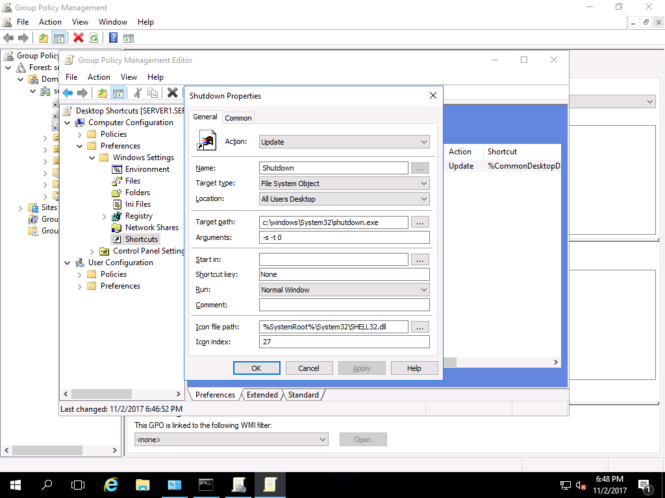

1. Insert a screenshot of the **General** tab of the **Shutdown** shortcut:
2. Click or tap here to enter text.
3. Create a **Sign Out** shortcut using the same process. Use **shutdown -l** (Lower case L) for the arguments. Use a different icon.
4. Insert a screenshot of the **General** tab of the **Sign Out** shortcut:
5. Click or tap here to enter text.
6. Close the Group Policy Editor.
7. Optimize the Group Policy by going to the Details tab, and choosing **GPO Status**, **User configuration settings** disabled.
8. **Insert a screenshot:**

Click or tap here to enter text.

1. Close the Group Policy Management console.
2. On Server1, use **gpupdate** to make sure both of your shortcuts show up. Test them both.
3. **Insert a screenshot of the server desktop showing both shortcuts:**

Click or tap here to enter text.

1. Logon to **Win11**. If the shortcuts don’t show up, use **gpupdate** to update group policy.
2. **Insert a screenshot showing both shortcuts on your Win11 desktop.**

Click or tap here to enter text.

# Activity 14-3: Enable Remote Access Through the Administrator Remote Desktop

Time Required: Approximately 10 minutes

Objective: Windows Server allows 2 simultaneous administrative connections through Remote Desktop. Enable access to Windows Server through Remote Desktop.

Description: In this activity, you configure Windows Server to be accessed from Windows workstations, such as Windows 10, through Administrator Remote Desktop using NLA.

1. Start **Server1**. Open Server Manager, if it is not open.
2. In the left pane, click **Local Server**.
3. In the right pane, click the setting for **Remote Desktop.** Click **Enabled**.
4. In the System Properties dialog box with the Remote tab displayed, ensure that Allow remote connections for this computer is selected as well as Allow connections only from computers running Remote Desktop with Network Level Authentication (recommended), if it is not already selected.
5. Click OK in the **Remote Desktop Users** dialog box.
6. Click OK in the **System Properties** dialog box.
7. Sign in to **Win11**.
8. Use your administrator credentials with the Remote Desktop Connection to connect to Server1.
9. **Insert a screenshot showing the Server1 desktop from Win11:**

Click or tap here to enter text.

# Activity 14-4: Installing and Using the Remote Server Administration Tools for Windows

Time Required: Approximately 15 minutes

Objective: Learn how to use the Remote Server Administration Tools capability for Windows

Description: Many of the MMC snap-ins can be implemented using the Remote Server Administration Tools capability. In this activity, you learn how to download and install the Remote Server Administration Tools for Windows. As an administrator, you will normally have two accounts, one for administration, and one for normal work that is at the user level.

1. Start **Server1** and **Win11**.
2. Login to Win11 as your domain administrator account.
3. Click **Start**, Click **Settings**. Type in **Optional Features**. Click **Add a feature**.
4. Type **RSAT**. Click **RSAT: Active Directory Domain Services and Lightweight Directory Services Tools.** Click **Install**.
5. Click **Start**, go to **Windows Administrative Tools**. Right Click **Active Directory Users and Computers**, Click **More**, Click **Run as Administrator**. Type in your domain administrator credentials.
6. **Insert a screenshot showing Active Directory Users and Computers connected to and showing your domain.**

Click or tap here to enter text.

# Activity 14-5: Installing Software with Group Policy

Time Required: Approximately 15 minutes

Objective: Learn where to set up software installation in a Group Policy.

Description: Simple software can be installed by GPO. For more advanced deployments, you would need something like Microsoft System Management Server or a third-party software. In this activity, you view where to configure software to be published or assigned. You will install 7-Zip to Win11.

1. On **Server1**, go to <http://www.7-zip.org/download.html> and download the .msi (alternative MSI installer) 7-Zip for 64-bit Windows x64 (Intel 64 or AMD64).
2. Create a folder under the C: called **ClientApps**.
3. Move the 7-zip installation file you downloaded earlier to the ClientApps folder.
4. Set the **Share** permission to **Everyone Full Control**.
5. Set the Security permission to System and Administrators **Full Control**, and Users **Read & execute** (This includes list folder contents and Read.)
6. In Active Directory Users and Computers, make sure you have a **Workstations** OU. Make sure Win11 is in it.
7. Open the Group Policy Management console. Create a GPO called **Install 7-Zip** in the **Workstations** OU.
8. Open **Active Directory Users and Computers** and confirm that **Win11** is in the Workstations OU.
9. Go back to Group Policy Management. Under **Computer Configuration** 🡪 **Policies** in the tree, click **Software Settings**.
10. In the right pane, right-click **Software installation**, and then click **Properties**.
11. Make sure that the General tab is displayed in the Software installation Properties dialog box. Notice that you can use the Default package location box to specify the location of the software that users will install, which can be on this server or on a different server in the network. Also, among the New packages parameters, there are options to Publish or Assign software.
12. Click each of the Advanced, File Extensions, and Categories tabs to view the properties that can be configured on these tabs. Click **Cancel**.
13. Right Click **Software Installation**, Click **New**, **Package**.
14. Browse to the Network **\\server1\ClientApps** and click the file you downloaded earlier.
15. **Insert a screenshot:**

Click or tap here to enter text.

1. Click **Open**.
2. Keep the default choice of **Assigned**. Click **OK**.
3. Right Click on the newly created software package and choose **Properties**.
4. Go to the **Deployment** tab. Select **Uninstall this application when . . .**
5. **Insert a screenshot:**

Click or tap here to enter text.

1. Click OK.
2. Close the Group Policy Editor.
3. Click the **Details** tab of the **Install 7-Zip** GPO and change the GPO status to **User configuration settings disabled**. You are installing to a computer, you do not need the User configuration policies.
4. **Insert a screenshot:**

Click or tap here to enter text.

1. Click the **Settings** tab. You should see the details of the Assigned Application.
2. **Insert a screenshot:**

Click or tap here to enter text.

1. Start **Win11**. Logon as any user. Use **gpupdate /force** to update group policies. Restart Win11.
2. If you go to File Explorer, and Right Click on any folder, you should see 7-Zip in the context menu. If not, you may need to restart Win11 again.
3. Insert a screenshot:

Click or tap here to enter text.

# Activity 14-6: Windows Security

Time Required: Approximately 5 minutes

Objective: Use the Windows Security GUI.

Description: In this activity, you learn how to use Windows Security.

1. Start Server1. Click **Start**, type in and click **Windows Security**.
2. Click **Virus & threat protection**.
3. Notice the Current threats. The last scan is listed.
4. Click **Scan options**: Quick, Full, and Custom. Go back to **Virus & threat protection**.
5. Scroll down to **Virus & threat protection settings**, Click **Manage settings**. Note the various settings in this window. Make sure that real-time protection is turned on.
6. Go back to Virus & threat protection. Scroll down to Virus & protection updates.
7. Click **Check for updates**. You can use the Update definitions button on this tab to get the latest updates for Windows Security, including new virus definitions.
8. **Insert a screenshot:**

Click or tap here to enter text.

1. Close Windows Security.

## Assignment Submission

Attach this completed file to the assignment in Blackboard.