# Week 1 Server Activities – Getting Started with Windows Server

Activities

Week 1 Server Activities – Getting Started with Windows Server 1

How to Create Screenshots 1

Snapshots are Important! 2

Download Windows Server 2025 Evaluation 2

VirtualBox 2

Install VirtualBox 2

Activity 1-1: Create a Windows Server Virtual Machine 3

Activity 1-2: Install Windows Server 6

Activity 1-3: Configuring Windows Server 7

Activity 1-4: Network Settings 8

Activity 1-5: Add Internet Access to your Internal Network 8

After the Evaluation Expires: How to Reset the Evaluation Period for Windows 10

**Video Walkthrough:** [Windows Server 2025 Installation](https://youtu.be/jcm0j-VxmNM)

**Watch:** [How to Take a Screenshot of a Virtual Machine﻿](https://wnccnet-my.sharepoint.com/:v:/g/personal/loringw_wncc_edu/EWBvJf9vFHRArpcGPAWnzXYBWAj49j9ox7-CiOoI9THuPg?e=eBQ44w)

## How to Create Screenshots

Please use the Windows Snip and Sketch Tool or the Snipping Tool. Paste a screenshot of just the program you are working on. If you are snipping a virtual machine, make sure your focus is outside the virtual machine before you snip.

1. Press and hold down the **Windows key** & **Shift**, then type **S.** This brings up the on-screen snipping tool.
2. Click and Drag your mouse around whatever you want to snip.
3. Release the mouse button. This places the snip into the Windows Clipboard.
4. Go into Word or wherever you want to paste the snip. Hold down **CTRL**, then type **V** to paste the snip.

## Snapshots are Important!

Create snapshots in VirtualBox whenever you make a major configuration change. If you have issues, you can revert to a previous working image. Keep an eye on your physical hard drive disk space, snapshots can use a lot of disk space.

# Download Windows Server 2025 Evaluation

**DANGER!! Will Robinson!!!!**

When downloading this ISO:

* **DO NOT OPEN IT.**
* **DO NOT TOUCH IT!**

You can wipe the hard drive of your computer if you don’t pay attention. It has happened before with other students.

1. Download the evaluation copy of **Windows Server 2025**.  
   <https://www.microsoft.com/en-us/evalcenter/evaluate-windows-server-2025>
2. **Sign in** and choose the **ISO** option. You will need to **register**.
3. Download the **ISO** option to a folder on your hard drive where you can find it.

# VirtualBox

VirtualBox is an open-source virtualization hypervisor that works on multiple operating systems.

You may have to enable virtualization technology (VT) on your computer’s processor by editing the BIOS settings at boot-up (many computer BIOS have VT disabled). You may have to research how to do this.

# Install VirtualBox

Even if you already have VirtualBox on your computer, download and install the latest version.

1. Download the latest version of VirtualBox from [www.virtualbox.org](http://www.virtualbox.org)
2. Double Click the file you downloaded to start the VirtualBox installation.
3. If you receive an error that says install Microsoft Visual C++ 2019 Redistributable Package, download and install the following.  
   <https://aka.ms/vs/17/release/vc_redist.x64.exe>
4. Accept the default choices on the installation screens and prompts.

# Activity 1-1: Create a Windows Server Virtual Machine

Time required: 30 minutes

1. Start VirtualBox.
2. Click **New.**

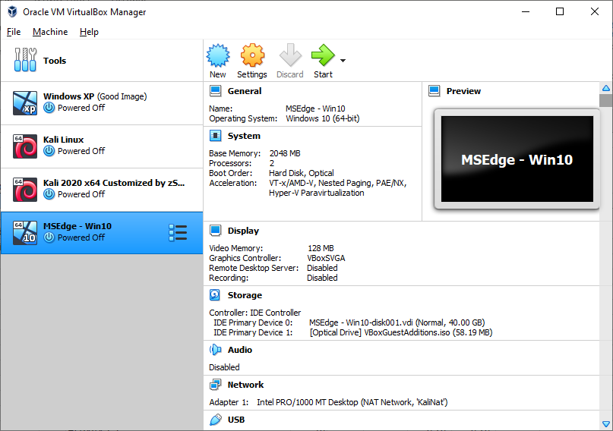

1. Name and operating system: Enter **Server1** for the Name.
2. Set the Version: **Windows 2025 (64-bit)**. Click **Next**.

# Activity 1-2: Install Windows Server

Time required: 30 minutes

1. In VirtualBox **🡪** Click **Server1** 🡪 click **Start**.
2. **Select a start-up disk:** Click the **browse button 🡪 Click Other.**

1. Go to your Downloads folder.
2. Choose the Windows Server Evaluation ISO. Click **Open**. Click **Mount and Retry Boot**.

1. With the Windows Server Evaluation ISO Selected, Click **Choose**.
2. The Windows Server installation screen should appear.
3. Click **Next**. Click **Install now**.
4. Click **Windows Server 2025 Standard Evaluation (Desktop Experience).** Click **Next.**
5. Accept the license terms, Click **Next**.
6. Click **Disk 0 Unallocated Space**, Click **Next**. (If there are any existing partitions, remove them.)
7. Windows Server will install. This may take some time.
8. After Server reboots 🡪 go to **Devices** 🡪 **Optical Drives** 🡪 **Remove disk from virtual drive**.
9. The installation will continue.

# Activity 1-3: Configuring Windows Server

Time required: 10 minutes

1. The first time you logon, you are required to change the Administrator password. Use **Password01** for your password.
2. In Server Manager 🡪 click **Local Server** 🡪click the current server name. This will bring up the **System Properties**. Click **Change**.
3. Change the computer name to **Server1**
4. Click OK twice 🡪 Restart the server.
5. Google how to set the time zone to Mountain Time.
6. In VirtualBox 🡪 Click **Devices** 🡪 **Insert Guest Additions CD**.
7. Install the Guest Additions.
8. Insert a screenshot of your VM running on your desktop.

Click or tap here to enter text.

# Activity 1-4: Network Settings

Time required: 10 minutes

Set the server to these static IP addresses.

1. Click Start 🡪 Type and choose **Control Panel** 🡪 choose **Network and Internet** 🡪 **Network and Sharing Center**.
2. Click **Ethernet 🡪** **Properties 🡪** **Internet Protocol Version 4** 🡪 **Properties.**
3. Server1: IP Address: 10.10.1.10  
   Subnet Mask: 255.255.255.0  
   Default Gateway: 10.10.1.1  
   DNS: 8.8.8.8

# Activity 1-5: Add Internet Access to your Internal Network

Time required: 10 minutes

In this activity we add internet access to our VirtualBox network.

1. **Oracle VM VirtualBox Manager 🡪 File 🡪 Tools 🡪 Network Manager**.

1. **Click Create. Add the settings shown below**

1. **Name**: Server
2. **Network CIDR: 10.10.1.0/24**
3. Un Check **Supports DHCP.** Click **OK.** Click **OK.**
4. **In Oracle VM VirtualBox Manager:** Right Click each Virtual Machine 🡪 **Settings**.
5. **Network 🡪** **Attached to**: **NatNetwork Name: Server**
6. Each VM should have internet access and activate.

## After the Evaluation Expires: How to Reset the Evaluation Period for Windows

Sometime before the end of the semester, your evaluation period may be up. When the initial evaluation period nears its end, you can run the Slmgr.vbs script to reset the evaluation period. To do this, follow these steps:

1. Right Click **Start**, and then click Administrator Command Prompt.
2. Type **slmgr.vbs -dli**, and then press **ENTER** to check the status of your evaluation period.
3. To reset the evaluation period, type **slmgr.vbs –rearm**, and then press **ENTER**.
4. Restart the computer.

This resets the evaluation period to 180 days.

Attach this completed document to the assignment in Blackboard.