Packet Tracer Install and Use
Time required: 30 minutes
How to Create Screenshots: Please use the Windows Snip and Sketch Tool or the Snipping Tool. Paste a screenshot of just the program you are working on. If you are snipping a virtual machine, make sure your focus is outside the virtual machine before you snip.
- Press and hold down the Windows key & Shift, then type S. This brings up the on-screen snipping tool.
- Click and Drag your mouse around whatever you want to snip.
- Release the mouse button. This places the snip into the Windows Clipboard.
- Go into Word or wherever you want to paste the snip. Hold down CTRL, then type V to paste the snip.

Lab Description
If you plan to pursue networking or security as your area of specialty in IT, you might consider earning a few Cisco networking certifications after you complete your CompTIA A+, Network+, and Security+ certifications.
The Cisco Networking Academy website provides many useful tools for advancing your networking education. One of those tools is a network simulator called Packet Tracer.
In this project, you download and install Packet Tracer, and create a very basic network using simulated devices in Packet Tracer. This version of Packet Tracer is free to the public, and your school does not have to be a member of Cisco’s Networking Academy for you to download and use it.
To get the Packet Tracer download, you must first sign up for the free Introduction to Packet Tracer online course on the Cisco Networking Academy website. Complete the following steps to create your account:
- In your browser, navigate to www.netacad.com/courses/packet-tracer. Enroll in the course.
- Open the confirmation email and confirm your email address. Configure your account and save this information in a safe place. You will need this information again.
- Click Courses and select the Introduction to Packet Tracer course.
- Inside the course, click Student Resources, and then click Download and install the latest version of Packet Tracer. Download the latest version for your computer. Decompress the zipped file and install Packet Tracer.
- When Packet Tracer opens, sign in with your Networking Academy account that you created earlier. If you see a Windows Security Alert, allow access through your firewall. Cisco Packet Tracer opens. The interface window is shown in Figure 7-66.
Explore the Packet Tracer window
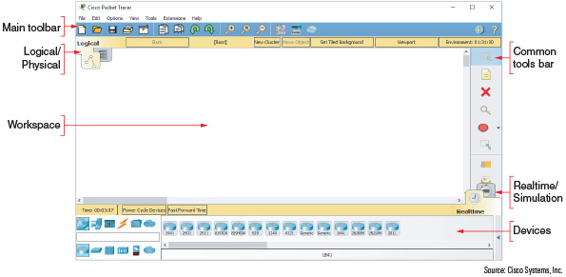
Source: Cisco Systems, Inc.
The Introduction to Packet Tracer course presents an excellent introduction to Packet Tracer and provides lab activities.
We will build a very simple network in Packet Tracer so you can begin to get familiar with the user interface.
- Save your Packet Tracer file as PacketTracer
- First you need a router. In Packet Tracer (and in most network diagrams), routers look like a hockey puck with four arrows on top. In the Devices pane, make sure the Network Devices group is selected and the Routers subgroup, is selected. Drag a 2901 router from the selection pane into the workspace.
- Add a switch. In network diagrams, switches look like rectangular boxes with four arrows on top. Click to select the Switches subgroup, then drag a 2960-24TT switch to the workspace.
- Add a couple of computers. Select the End Devices group. Drag a Generic PC and a Generic Laptop to the workspace. Arrange all the devices as shown in Figure 7-67.
Figure 7-67
Arrange the devices on your network diagram
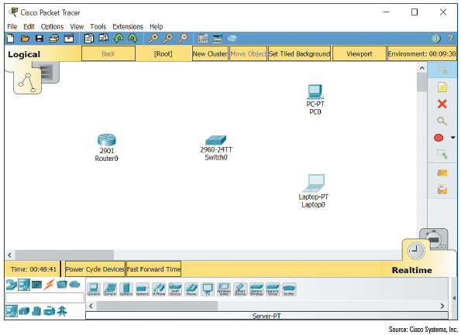
- You’re ready to connect the devices with Ethernet cables. Click the orange lightning icon to select the Connections group. Use the lightning icon from the selection pane to automatically select the correct connection type for each connection you make. After you click the Automatically Choose Connection Type lightning icon, click PC0 to start the connection, then click Switch0 to complete the connection. The link starts as orange, and as the connection is negotiated between the PC and the switch, the link turns to green on both ends.
- Create an automatic connection from Laptop0 to Switch0, and another automatic connection from Switch0 to Router0. The laptop-to-switch connection will come up automatically. The switch-to-router connection will remain red because it requires additional configuration before it will work.
- Click Router0 to see its configuration window. On the Physical tab, you can see a picture of the device itself, both front and back. Explore this window to see what information is available to you, but don’t change anything. When you’re ready, click the Config tab.
In Packet Tracer, you can perform all the configurations at the CLI (command line interface) or through a GUI (graphic user interface). In this project, you’ll use the GUI options, and watch the Equivalent IOS Commands pane at the bottom of the window to see what commands you’re executing.
- To activate the router’s interface, click the GigabitEthernet0/0 interface in the left pane. Position the configuration window off to the side of the workspace so you can see Router0 and monitor any changes to the connection. Change the Port Status to On.
- What happens to the connection in the workspace?
Click or tap here to enter text.
- Let’s add IP configuration information. Give the connection the IP Address of 192.168.43.1 and a Subnet Mask of 255.255.255.0. Close Router0’s configuration window.
- Add IP address configuration information to the endpoint devices. Click PC0 to open its configuration window. Here, you could use the Config tab or tools from the Desktop tab. Click Desktop, then click IP Configuration. You have two options: DHCP or Static. For now, you’ll have to use Static.
- Why?
Click or tap here to enter text.
- Make sure Static is selected, then give the PC the following IP configuration:
IP Address: 192.168.43.100
Subnet Mask: 255.255.255.0
Default Gateway: 192.168.43.1
- With this configuration, what device will the PC use as its default gateway?
Click or tap here to enter text.
- Close PC0’s configuration window, then use the same steps to give Laptop0 the following IP configuration:
IP Address: 192.168.43.200
Subnet Mask: 255.255.255.0
Default Gateway: 192.168.43.1
- On Laptop0, close the IP Configuration pane. On the Desktop tab, click Command Prompt. Ping PC0’s IP address from Laptop0.
- What command did you use? Did it work?
Click or tap here to enter text.
- You can use Simulation mode to watch the ping messages travel over the network. Close Laptop0’s configuration window, then click the Simulation mode tab in the bottom right of the Packet Tracer window (refer back to Figure 7-66). Open Laptop0’s Command Prompt window again, and position this window off to the side of the workspace so you can see the devices. Ping the router’s IP address.
- What command did you use? Did it work?
Click or tap here to enter text.
- Insert a screenshot of the ping results.
Click or tap here to enter text.
- This network is not connected to a simulated WAN connection, although it could be.
- Which device in this network would you connect to the modem for the ISP’s network?
Click or tap here to enter text.
- Insert a screenshot of your final work in Packet Tracer.
Click or tap here to enter text.
Assignment Submission: Attach this completed document and your Packet Tracer file to the assignment in BlackBoard.
Packet Tracer gives you a safe and fun environment to explore networking concepts. Take a few minutes to look around the Packet Tracer menus and options, and perhaps add more devices to your network. When you’re ready, close all open windows.

