Character-based Names Used on a Network
Contents
Character-based Names Used on a Network 1
Lab Description 1
Activity 2
DNS 3
DNS Cache 4
TCP/IP Protocol Layers 5
TCP/IP Protocols Used by Applications 6
TCP/IP Protocols Used by the OS 8
Port Addresses 9
Review Questions 10
Assignment Submission 11

Time required: 30 minutes
How to Create Screenshots: Please use the Windows Snip and Sketch Tool or the Snipping Tool. Paste a screenshot of just the program you are working on. If you are snipping a virtual machine, make sure your focus is outside the virtual machine before you snip.
- Press and hold down the Windows key & Shift, then type S. This brings up the on-screen snipping tool.
- Click and Drag your mouse around whatever you want to snip.
- Release the mouse button. This places the snip into the Windows Clipboard.
- Go into Word or wherever you want to paste the snip. Hold down CTRL, then type V to paste the snip.

Lab Description
In this lab, you learn about character-based named that can substitute for IP addresses when used to locate devices on a network and about the various protocols, or rules for communication, that networked devices use for communication. You also learn about port addresses used to find applications on a computer and how to find a computer’s current TCP/IP settings.

Activity
The numeric IP addresses used to identify devices on a network can be hard to remember. Therefore, character-based names are typically substituted instead. Here are the possibilities:
- A host name, also called a computer name, is the name of a computer and can be used in place of its IP address. The name can have up to 63 characters, including letters, numbers, and special characters. Examples of computer names are www, ftp, JeansComputer, TestBox3, and PinkLaptop.
- Recall that a workgroup is a group of computers on a peer-to-peer network that are sharing resources. The workgroup name assigned to this group is only recognized within the local network.
- A domain name identifies a network. Examples of domain names are the names that appear before the period in microsoft.com, cengage.com, and mycompany.com. The letters after the period are called the top-level domain and tell you something about the domain. Examples are .com (commercial), .org (nonprofit), .gov (government), and .info (general use).
- A fully qualified domain name (FQDN) identifies a computer and the network to which it belongs. An example of an FQDN is www.cengage.com. The host name is www (a web server), cengage is the domain name, and com is the top-level domain name of the Cengage network. Another FQDN is joesmith.mycompany.com.
- On the Internet, a fully qualified domain name must be associated with an IP address before this computer can be found. This process of associating a character-based name with an IP address is called name resolution. The DNS (Domain Name System or Domain Name Service) protocol is used by a DNS server to find an IP address for a computer when the fully qualified domain name is known. On home or small company networks, the ISP is responsible for providing access to one or more DNS servers as part of the service it provides for Internet access. Larger corporations have their own DNS servers to perform name resolution for the enterprise network. When an individual or organization, which has its own DNS servers, leases a public IP address and domain name and sets up a website, it is responsible for entering the name resolution information into its primary DNS server. This server can present the information to other DNS servers on the web and is called the authoritative name server for the website.
When you first install Windows, a computer name is automatically assigned. You can change the computer name at any time using the System window. Here’s how:
- Right Click the Start button.
- Choose System.
- What is your computer name?
Click or tap here to enter text.
- Click Rename this PC. Enter a new name for your computer and click OK. You will need to restart your computer for the change to take effect.
- After your computer has restarted, return and verify your computer name changed.
- Insert a screenshot showing the new name
Click or tap here to enter text.
- You can return the computer name to the original name if you wish

DNS
When you enter a fully qualified domain name such as www.cengage.com in a browser address bar, that name is translated into an IP address followed by a port number. Do the following to discover the IP address of the web server www.cengage.com:
- Type cmd in the search box and press Enter.
- In the command prompt window, type the following command to determine the IP address of the web server www.cengage.com:
nslookup www.cengage.com
- What is the IP address for www.cengage.com?
Click or tap here to enter text.
- Insert a screenshot.
Click or tap here to enter text.
- Open your web browser, type www.cengage.com in the address box and press Enter. The Cengage home page appears.
- What characters were added in the address box?
Click or tap here to enter text.
- Generally, a website is configured so that you are not allowed to use its IP address to access it. Try it for yourself. Enter the IP address of the www.cengage.com server in the address box of your browser and press Enter.
- What error message do you get?
Click or tap here to enter text.
- Insert a screenshot of the error message.
Click or tap here to enter text.

DNS Cache
When Windows is trying to resolve a computer name to an IP address, it first looks in the DNS cache it holds in memory. If the computer name is not found in the cache, Windows then turns to a DNS server if it has the IP address of the server. When Windows queries the DNS server for a name resolution, it is called the DNS client.
Do the following to explore the DNS cache on your computer:
- In the command prompt window, enter this command to view the DNS cache on your computer: ipconfig /displaydns
- What are some of the websites listed in your cache?
Click or tap here to enter text.
- Insert a screenshot showing part of your dns cache.
Click or tap here to enter text.
Sometimes a problem accessing a website can be resolved by emptying (flushing) the DNS cache, which may contain errors.
- Enter this command to clear the DNS cache: ipconfig /flushdns
- Enter the ipconfig /displaydns cache again. Is the cache empty?
Click or tap here to enter text.
- Insert a screenshot.
Click or tap here to enter text.

TCP/IP Protocol Layers
Recall that a protocol is an agreed-to set of rules for communication between two parties. Operating systems and client-server applications on the Internet all use protocols that are supported by TCP/IP. Take a look at the left side of Figure 3 to see the various protocols used in networking. In the figure, these protocols are organized in three groups: protocols used by applications, operating systems, and hardware. Within the operating system protocols on the left side of the figure, there are three groups or layers. For example, HTTP and HTTPS, used by web browsers, are at the top of the OS layers. TCP and UDP are in the middle layer, and IP is at the bottom of the three general layers used by the operating system. Actually, seven layers of network communication have been defined and are shown on the right side of Figure 3.
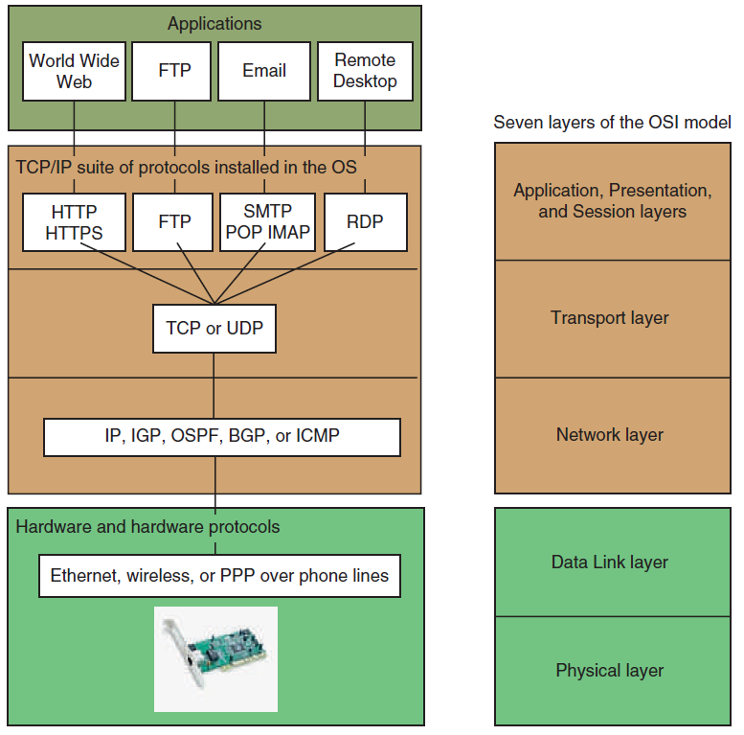
Figure 3: How software, protocols, and technology on a TCP/IP network relate to each other
The seven protocol layers are defined in the OSI (Open Systems Interconnection) model, which provides a framework or structure for all network communication. It sounds complicated to require seven layers for communication. But not so much when you consider the complexity required when a business send mail to its customers and uses the postal service, which uses the road system, to make the deliver – many layers are involved. Here’s a quick overview of the seven networking layers:
Five OSI layers are used primarily by the operating system:
- The Application, Presentation, and Session layers are generally used when the OS is communicating with an application or preparing data to be sent to or from an application on the network. (Think of businesses preparing letters to send to customers.)
- The Transport layer protocols deliver data over networks. TCP and UDP or the two most-used protocols at this layer. (Think of the entire US Postal Service, which delivers the mail.)
- The Network layer protocols route data over multiple networks. (Think of the US Postal Service trucking system.)
Two OSI layers are used primarily by hardware:
- The Data Link layer protocols are used by hardware to prepare data for transmission on the network. (Think of traffic laws and traffic cops.)
- The Physical layer protocols are used by hardware to transmit data wirelessly or on cabling. (Think of freeways and local streets.)
As you work through this lab, Figure 3 can serve as your road map to the different protocols. In the following sections, the more significant applications and operating system protocols are introduced. However, you should know that the TCP/IP protocol suite includes more protocols than just those mentioned in this lab; only some of them are shown in Figure 3.

TCP/IP Protocols Used by Applications
Some common applications that use the Internet are web browsers, email, FTP, Remote Desktop, and Remote Assistance. The protocols used by these applications work at the Application, Presentation, and Session layers of the OSI model. For now, it’s not important to distinguish between these three layers. Let’s just get a general idea of which protocols are used by these common applications:
- HTTP (Hypertext Transfer Protocol) is the protocol used for the World Wide Web. Web browsers and web servers use it to communicate. You can see when a browser is using this protocol by looking for http at the beginning of a URL in the address bar of a browser, such as http://www.microsoft.com.
- The “S” at the end of HTTPS (HTTP secure) tells you that the HTTP protocol is working with a security protocol to encrypt data before it is transmitted and then decrypting it before the data is processed. To verify that a secured protocol is being used, look for https in the URL, as in https://www.wellsfargo.com.
- SMTP (Simple Mail Transfer Protocol) is used to send an email message to its destination (see Figure 4). The email server that takes care of sending email messages (using the SMTP protocol) is often referred to as the SMTP server.
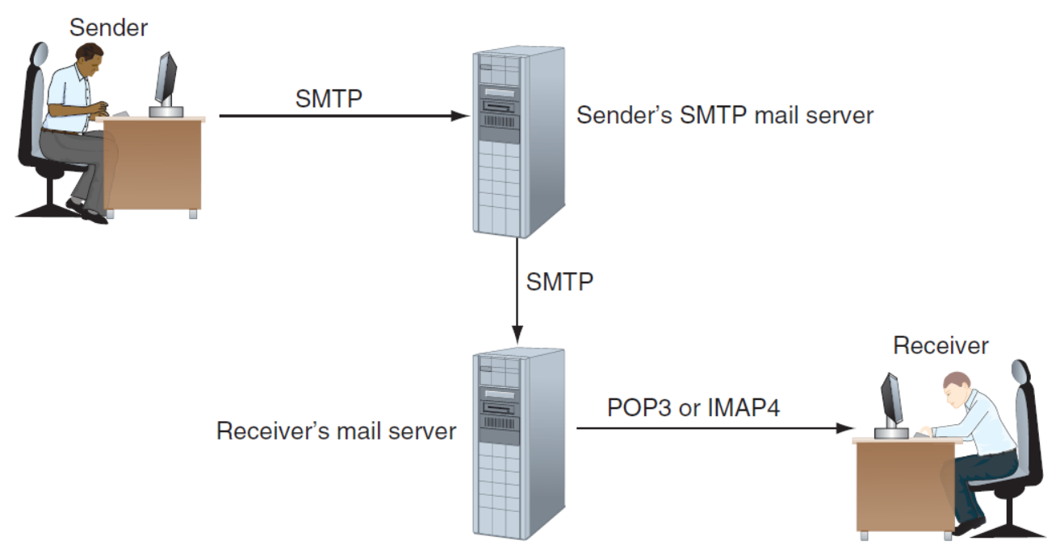
Figure 4: The SMTP protocol is used to send email to a recipient’s mail server, and the POP3 or IMAP4 protocol is used by the client to receive email
- POP3 (Post Office Protocol, version 3) or IMAP4 (Internet Message Access Protocol, version 4) is used to deliver an email messages to the recipient. After an email message arrives at the destination email server, it remains there until the recipient requests delivery. The recipient’s email server then uses either POP3 or IMAP4 to deliver the message. Using POP3, email is downloaded to the client computer and, unless the default setting is changed, the email is then deleted from the email server. Using IMAP, the client application manages the email stored on the server.
- FTP (File Transfer Protocol) is used to transfer files between two computers. Web browsers can use the protocol. Also, third-party FTP client software such as CuteFTP by GlobalSCAPE (www.cuteftp.com) and others, offers more features for file transfer than does a browser. By default, FTP transmissions are not secure. Secure FTP (SFTP) uses encryption.
- Remote Desktop Protocol (RDP) is used by the Windows Remote Desktop, Remote Assistance, and Windows 10 Quick Assist utilities to connect to and control a remote Windows computer.
In general, application protocols are responsible for formatting messages so they are suitable for network transmission. They depend on lower-level protocols to actually send the message.

TCP/IP Protocols Used by the OS
When application protocols, such as HTTP or FTP, need to send messages over a network, they turn to Transport layer protocols to do the job. The two main Transport layer protocols are TCP and UDP, which are generally responsible for the delivery of messages. TCP and UDP, in turn, depend on the Network layer protocols, which control communication on the network. Let’s see how TCP and UDP work.
TCP Guarantees Delivery: All communication on a network happens by way of messages delivered from one location on the network to another. In TCP/IP, the protocol that guarantees message delivery is TCP (Transmission Control Protocol). TCP makes a connection, checks whether the data has been received, and resends it if it has not. TCP is, therefore, called a connection-oriented protocol. TCP is used by applications such as web browsers and email. Guaranteed delivery takes longer and is used when it is important to know that the data reached its destination.
To guarantee delivery, TCP uses protocols at the Network layer, primarily the IP protocol, to establish a session between client and server to verify that communication has taken place. When a TCP message reaches its destination, an acknowledgment is sent back to the source (see Figure 5). If the source TCP does not receive the acknowledgment, it resends the data or passes an error message back to the higher-level application protocol.
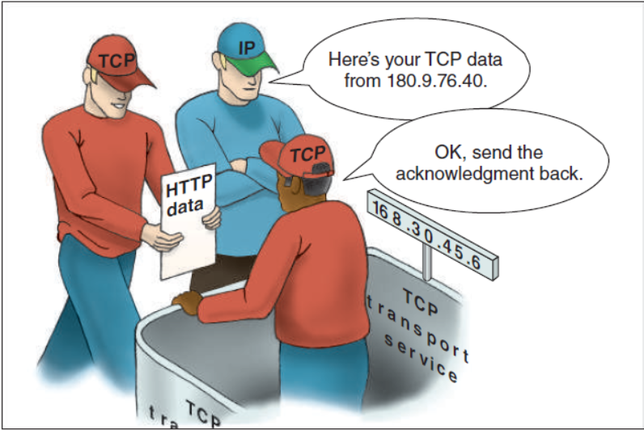
Figure 5: TCP guarantees delivery by requesting an acknowledgment
UDP Provides Fast Transmissions: On the other hand, UDP (User Datagram Protocol) does not guarantee delivery by first connecting and checking whether data is received; thus, UDP is called a connectionless protocol or best-effort protocol. UDP is used for broadcasting, such as streaming video or sound over the web, where guaranteed delivery is not as important as fast transmission. UDP is also used to monitor network traffic.

Port Addresses
Recall that client-server applications use ports to address each other. Table 1-1 lists the port assignments for common applications. A port is either open or closed; you can think of a port as a portal or door to your system. When a port is open, a remote application can use it to reach an application running on your system, which is listening at that port. When a port is closed, it cannot be used to gain access to your system. Generally, an application on your computer will open its port only when it is expecting an incoming message and then close the port for better security.
Table 1-1 Common TCP/IP port assignments for client-server applications
Port | Protocol and Application | Description
20 | FTP client | The FTP client receives data on port 20 from the FTP server.
21 | FTP server | The FTP server listens on port 21 for commands from an FTP client.
25 | SMTP email server | An email server listens at port 25 to receive email from a client computer. This is an unencrypted connection and rarely used.
80 | Web server using HTTP | A web server listens at port 80 when receiving HTTP requests.
110 | POP3 email client | An email client using POP3 receives email at port 110.
143 | IMAP email client | An email client using IMAP receives email at port 143.
443 | Web server using HTTPS | A web server listens at port 443 when receiving HTTPS transmissions.
465  587 | SMTP mail server | Encrypted SMTP, or SMTPS, is a way to secure email transmission using Transport Layer Security (TLS). Either port can be used.
3389 | RDP apps such as Remote Desktop | Remote Desktop and Remote Assistance listen at port 3389.

Review Questions
- At what port does an SMTP email server listen to receive email from a client computer?
Click or tap here to enter text.
- What type of server resolves fully qualified domain names to IP addresses?
Click or tap here to enter text.
- Which transport protocol is reliable and considered a connection-oriented protocol?
Click or tap here to enter text.
- Which transport protocol is typically used for streaming media?
Click or tap here to enter text.
- Before you can host a Remote Desktop connection on your computer, which port must be opened?
Click or tap here to enter text.
- What happens if TCP does not receive an acknowledgement packet?
Click or tap here to enter text.
- What does the s in https stand for?
Click or tap here to enter text.
- What is the purpose of a port in network communication?
Click or tap here to enter text.

Assignment Submission
Attach this completed document to the assignment in Blackboard and submit.

