Bettercap Web GUI
Contents
Bettercap Web GUI 1
Lab Requirements 1
Bettercap Web GUI 1
1. View Local IP Address Information 1
2. bettercap Web GUI 2
Assignment Submission 3

Time required: 30 minutes

Lab Requirements
This lab can disrupt network communications on a production network. We want to do this lab in a completely virtual environment.
- Kali Linux VM
- Windows VM with Google Chrome
- Both VM’s on same NAT network

Bettercap Web GUI
We know how to be the man in the middle and capture all the packets from a victim. We can do this from a GUI interface.
Connect both VM’s to the NAT network we created earlier.

1. View Local IP Address Information
On your Kali Linux: run the following command in the terminal to find out the name and IP address of the network interface that you’re using. It is commonly eth0.
ip a
Insert a screenshot:
Click or tap here to enter text.

2. bettercap Web GUI
Bettercap that comes installed with Kali Linux doesn’t work right. It does if we do a clean build direct from the bettercap github.
- Type the following commands separately at the terminal to do a clean install of bettercap.
sudo apt update
sudo apt install -y golang git libusb-1.0-0-dev libpcap-dev libnetfilter-queue-dev
git clone https://github.com/bettercap/bettercap.git
cd bettercap
go install
go build
sudo ./bettercap
caplets.update
ui.update
- Quit bettercap.
- Enter the following command to open the hstshijack.cap for editing.
sudo geany /usr/local/share/bettercap/caplets/hstshijack/hstshijack.cap
This is the contents of the alert.js file we created earlier
alert('You have been hacked!')
- Go to the set hstshijack.payloads line shown at the bottom, add the path to your alert.js file.
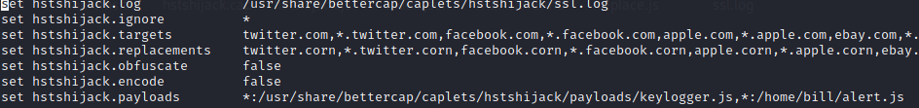
,*:/home/user/alert.js
- Run the following commands to start bettercap and the web ui.
cd ./bettercap
sudo ./bettercap -iface eth0
http-ui
- Insert a screenshot:
Click or tap here to enter text.
- In your web browser: go to localhost
- You should see the bettercap web ui.
- Username: user Password: pass
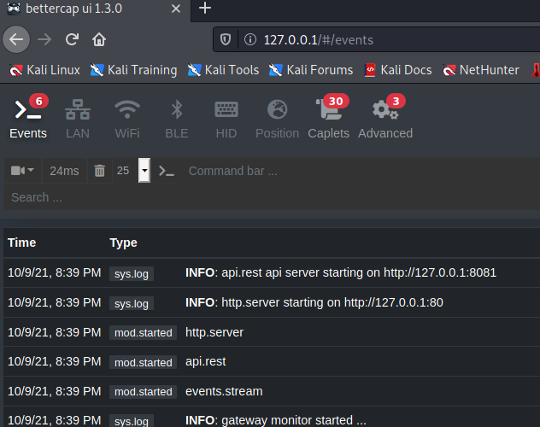
- Click the LAN tab. Click the play button for net.probe. This will automatically start net.recon. Those are the play buttons to the right of the trash can.
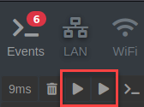
- You should see your gateway, your Kali machine, .3 is the VirtualBox DHCP server and the victim computer’s IP address.
- Click the downward pointing triangle next to the victim computer’s IP address Add to arp.spoof.targets.
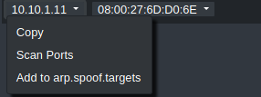
- Click full-duplex spoofing. Click Start arp.spoof.
- You will see a little red icon indicating that you are spoofing the target.
- Go to your Windows victim machine. At a command prompt: ping google.com
- Run arp -a You should see that the gateway MAC address is the same as the Kali machine.
- Insert a screenshot:
Click or tap here to enter text.
- On Kali: Click the Caplets tab. Click hstshijack
- Click the play button above the display of the hstshijack.cap file.
- Go to www.vulnweb.com Click one of the websites to see the javascript file showing an alert.
- Insert a screenshot:
Click or tap here to enter text.
- Close the web browser. Type quit to stop bettercap.

Assignment Submission
Attach this completed document to the assignment in Blackboard.

