IT Hardware Support Final Project
Contents
IT Hardware Support Final Project 1
Design a Network with Packet Tracer 1
Create a Network with Packet Tracer 3
Assignment Submission 3

Time required: 1 hour

Design a Network with Packet Tracer
This is the design phase of your Packet Tracer Network.
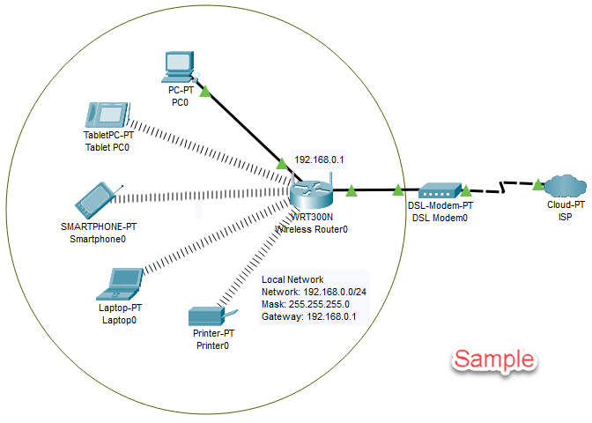
NOTE: Do not copy the example, create your own IP addressing scheme and devices.
Design a local area, privately addressed home network like the example shown.
These questions are part of the design which will be implemented in Packet Tracer toward the end of this project.
- What is a network address? What does it designate?
Click or tap here to enter text.
- What is the network address of your network?
Click or tap here to enter text.
- What is the broadcast address of your network?
Click or tap here to enter text.
- What is the purpose of a broadcast address?
Click or tap here to enter text.
- What is the purpose of a subnet mask?
Click or tap here to enter text.
- What is your subnet mask?
Click or tap here to enter text.
- What is the purpose of a Default Gateway?
Click or tap here to enter text.
- What is the gateway/router address of your network?
Click or tap here to enter text.
- What is the purpose of a DNS server?
Click or tap here to enter text.
- What DNS server addresses will you use and why? (Research public DNS servers)
Click or tap here to enter text.
- What is the DHCP range for your network?
Click or tap here to enter text.
- What is the purpose of an SSID?
Click or tap here to enter text.
- What is the SSID for your wireless network?
Click or tap here to enter text.
- What is the purpose of a WPA2 key?
Click or tap here to enter text.
- What is the WPA2 key for your network?
Click or tap here to enter text.

Create a Network with Packet Tracer
- Use and connect following devices:
  - Wired PC
  - Wireless laptop
  - SmartPhone
  - Wireless router
  - Cable modem
  - Cloud to designate ISP
- Comment the appropriate network settings.

Assignment Submission
Attach this completed document and the Packet Tracer file to the assignment in BlackBoard.

