Hping3 Spoof IP Address
Time required: 60 minutes

Lab Description
The hping3 command in Kali Linux is a network tool used for sending custom ICMP, UDP, and TCP packets. It's often employed for network testing and troubleshooting.
There are potential security risks associated with MAC address spoofing, such as bypassing MAC address filtering or impersonating other devices on the network.
It is important to obtain proper authorization before attempting any form of network manipulation or spoofing.
NOTE: Don’t do this lab on any network other than one that you own or have permission to use.

Update Kali
- Open Terminal. (Look in the topbar.) Run the following commands. These commands will update Kali.
- sudo apt update (This command gets the lists of updates and upgrades. If you receive an error on this step, restart Kali.)
- sudo apt upgrade (This command installs the updates and upgrades. There should be a bunch of different updates.)
- There may be some screens of information, press Enter until the upgrade process continues and completes. Restart Kali at the end of the update process. Kali may take longer than usual to start, be patient.

Getting Started
NOTE: Both VM’s should be on the bridged adapter.
- Start your Windows and Kali Linux virtual machines.
- Logon to the Windows virtual machine.
- Click Start, type in Windows Firewall Click Windows Firewall Click Turn Windows Firewall on or off. Turn the Windows Firewall off for both networks. Click OK.
- Right Click Start Click Terminal Type in ipconfig. Press the Enter key. Note the IP address.
- Insert a screenshot.
Click or tap here to enter text.

Normal IP Packets
Our first step is to send some normal IP packets to ensure we have connectivity between our virtual machines. We will capture these packets to see what normal IP packets look like. The source and destination IP addresses will have unique MAC addresses.
- Logon to Kali Linux
- At the Terminal prompt, type:
sudo hping3 –1 WindowsIPAddress
(Substitute the IP address you discovered earlier for WindowsIPAddress.)
Press the Enter key.
You should see successful replies from the other virtual machine. If not, check the Windows firewall and ip address to make sure they are set properly.
- Paste a screenshot of the Terminal window with successful pings.
Click or tap here to enter text.
- Type CTRL C to stop hping3.
- Go to the Kali menu in the upper left corner. Type Wireshark Click Wireshark to start the program.
- Click the Capture menu Click Options Click eth0 Click Start.
- Click the Terminal icon on the top bar. This will create a new terminal session.
- Type
sudo hping3 –1 WindowsIPAddress
(Substitute the IP address you discovered earlier for WindowsIPAddress.)
Press the Enter key.
- Click Wireshark. Click the Stop button.
Let’s setup a filter to see only the traffic between the two machines.
- In the filter bar: ip.addr==WindowsIPAddress
Example from my network. Notice the normal ping packets going back and aforth.
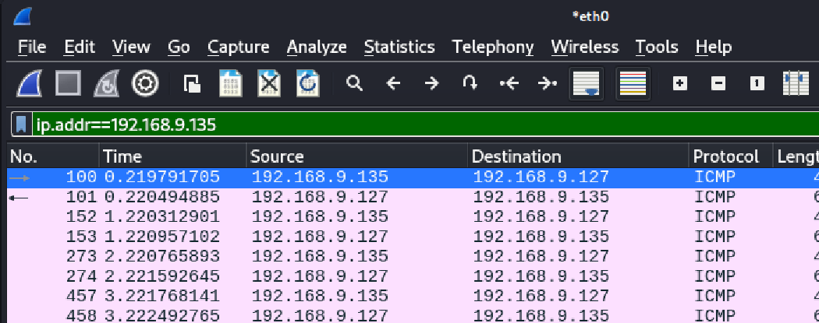
- Paste a screenshot of Wireshark.
Click or tap here to enter text.
- Click back to your Terminal session. Press CTRL C to break the hping3 command if it is still running.

Spoofed IP Packets
We will make the Windows computer think the packets we are sending are from itself. We will spoof our IP address.
- In Wireshark Click Start to start capturing packets.
- Type sudo hping3 -S WindowsIPAddress -a WindowsIPAddress
(Substitute the IP address you discovered earlier for WindowsIPAddress.)
  - -a spoof our Kali IP address using the target Windows MAC address
- Press the Enter key..
- Insert a screenshot.
Click or tap here to enter text.
- Hping3 will show the source and destination IP address are the same, but you won’t see packets being sent.
- Click Wireshark. Click the Stop button.
- Apply filter: ip.dst==WindowsIPAddress and ip.src==WindowsIPAddress
Example from my network. Notice that the source and destination are the same.
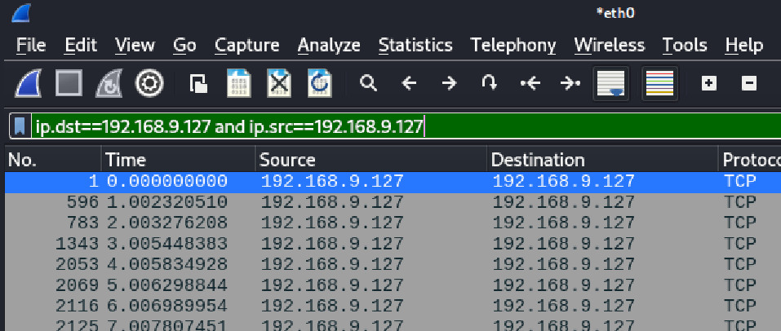
You should see a capture where the source and destination packets have the same IP address. Notice that the MAC addresses are still different. Remember, you could also spoof your MAC address to be exactly the same as the Windows computer.
You have successfully spoofed your IP address. The Windows computer has no way of knowing that the ping from the Kali Linux didn’t come from itself. The only way it would know is to look at the MAC addresses, which can also be spoofed. By looking at the traffic on the network, you have no way of knowing where the packet actually came from.
- Paste a screenshot of WireShark showing the identical IP addresses in the source and destination.
Click or tap here to enter text.

Assignment Submission
Attach this document to the assignment in Blackboard.

