Netdiscover
Time required: 30 minutes

Network Scanning
Please use a bridged adapter for this assignment. We want to scan your local network. Only scan a network you own or have permission to scan.

What is Netdiscover?
Netdiscover is a simple ARP scanner which can be used to scan live hosts in a network. It can scan for multiple subnets also. It simply produces the output in a live display(ncurse). This can be used in the first phases of a pentest where you have access to a network. Netdiscover is a simple and initial-recon tool which can be very handy.

Netdiscover Tutorial
- Start Kali Linux open a terminal session.
- Make sure the Kali Linux VM is connected to the Bridged Network.
- Type ip a
- You should get a response like this. Notice eth0: inet is 192.168.9.0/24 That is the network range you will scan. Yes, your network range will be different.
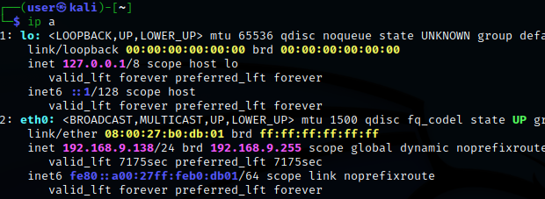
- Insert a screenshot:
Click or tap here to enter text.
- Type sudo netdiscover -help
- The resulting help screen shows the arguments that can be used
This example is how to scan a network range. In a few moments, you should see your network devices.
# sudo netdiscover -r <range>
sudo netdiscover -r 192.168.9.0/24
- Insert a screenshot:
Click or tap here to enter text.
- Type CTRL-C to exit netdiscover.
- Parse the output to a file as shown. Use your network settings.
sudo netdiscover -r 192.168.9.0/24 -P > network.txt
- You won’t see anything as the stdout was piped to a file.
- Type ls to list the directory.
- Type nano network.txt
- You should see the devices on your network in the text file.

Assignment Submission
Attach this completed document and network.txt to the assignment in Blackboard.

