Enumerate a Network with Kali and Zenmap
Contents
Enumerate a Network with Kali and Zenmap 1
Lab Description 1
Installing Zenmap in Kali Linux 1
Zenmap In Kali Linux 2
Windows Zenmap Install 4
Scan Localhost 4
Scan Local Network 4
scanme.nmap.org 5
Assignment Submission 6

Time required: 60 minutes

Lab Description
One of the first steps of penetration testing or doing a security audit is to find out what devices are on the network.
DANGER ZONE: Make sure that you own the devices you perform a scan on. If you are performing this scan on a device or network you do not own, make sure to get a written consent from the owner of the device to avoid legal issues.
You have permission to scan the network in D1.

Installing Zenmap in Kali Linux
Zenmap is a graphical user interface for the command line tool nmap.
- In a Kali Linux terminal session, update Kali.
# Update the packages list
sudo apt update

# Perform the update
sudo apt dist-upgrade -y
- Do an apt-search for ZenMap
apt search zenmap
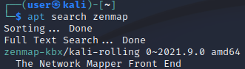
- Install zenmap-kbx
sudo apt install zenmap-kbx -y

Zenmap in Kali Linux
- In the Kali Linux VM Go to Machine menu Settings Network. Make sure you are attached to the Bridged Adapter.
- In a Kali Linux terminal session type ip a
Use this information to figure out your network Target. For example: If your IP address was 192.168.1.106, and your subnet mask is 255.255.255.0, then your network Target is 192.168.1.1-254 or 192.168.1.0/24
- Insert a screenshot showing your IP address.
Click or tap here to enter text.
- Go to the Kali start menu type zenmap
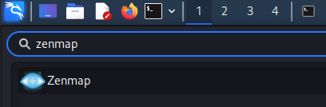
- Click Zenmap. You should see the following.
- Target: Put in your network information.
- By Profile: choose Quick scan.
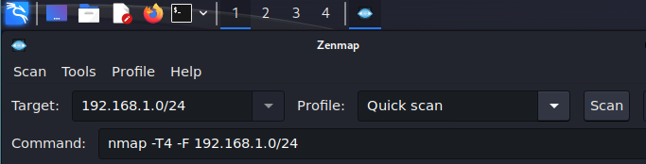
- Click Scan.
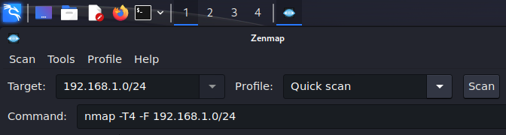
- Insert a screenshot of the results of your scan:
Click or tap here to enter text.
- How many IP addresses were scanned?
Click or tap here to enter text.
- How many hosts are up?
Click or tap here to enter text.
- Choose a host with open ports reported, use the Ports/Hosts tab to list the ports and services.
- What type of information is available?
Click or tap here to enter text.
- Choose the host details tab.
- What type of information is available?
Click or tap here to enter text.
- Can you figure out which machine is the one you are scanning from?
Click or tap here to enter text.
- What other information is provided?
Click or tap here to enter text.
- Insert a screenshot of the host details of one of your hosts.
Click or tap here to enter text.

Windows Zenmap Install
You can use your local Windows computer or a VM on a bridged adapter.
- Go to www.nmap.org.
- Go to Microsoft Windows binaries.
- Download and install Latest stable release self-installer.

Scan Localhost
Let’s start by scanning our local computer.
localhost refers to a network address that points to the current device or computer that you are working on. It is often represented as 127.0.0.1 in IPv4 or "::1" in IPv6. Localhost is used to establish a connection to the device itself, allowing applications and services to communicate with each other on the same machine without going through a network, which can enhance security by keeping certain processes isolated from external networks and potential threats.
- Run Zenmap.
  - Target: localhost
  - Profile: Quick scan plus
- Click Scan.
- Insert a screenshot:
Click or tap here to enter text.

Scan Local Network
- Run ipconfig.
- Use the ipconfig information to figure out your network Target.
For example: If your IP address was 192.168.1.106, and your subnet mask is 255.255.255.0, then your network Target is 192.168.1.1-254.
- Enter your network range in the Target field. Click Scan.
- Insert a screenshot:
Click or tap here to enter text.
- How many IP addresses were scanned?
Click or tap here to enter text.
- How many hosts are up?
Click or tap here to enter text.
- Choose a host with open ports reported, use the Ports/Hosts tab to list the ports and services.
- What type of information is available?
Click or tap here to enter text.
- Choose the host details tab.
- What type of information is available?
Click or tap here to enter text.
- Can you figure out which machine is the one you are scanning from?
Click or tap here to enter text.
- What other information is provided?
Click or tap here to enter text.
- Insert a screenshot of the host details of one of your hosts.
Click or tap here to enter text.

scanme.nmap.org
scanme.nmap.org or 45.33.32.156 is a public ip address provided by nmap for practicing scanning.
- Insert a screenshot of a regular scan of this host.
Click or tap here to enter text.

Assignment Submission
Attach this completed document to the assignment in Blackboard.

