Bettercap Web GUI
Contents
Bettercap Web GUI 1
Update Kali Linux 1
Install or Update Bettercap 1
Injecting JavaScript 2
1. Create a NAT Network 2
Lab Requirements 3
Bettercap Web GUI 3
1. View Local IP Address Information 4
2. bettercap Web GUI 4
Assignment Submission 6

Time required: 60 minutes

Update Kali Linux
This is a good idea to do before starting any lab with Kali Linux.
sudo apt update
sudo apt dist-upgrade -y

Install or Update Bettercap
Sniffing is the process of capturing and monitoring data packets that are passed through the network. It is used to capture the data of the victim. Bettercap is a powerful tool used to perform various MITM (man in the middle) attacks on a network. ARP Spoofing is a type of attack in which an attacker sends false ARP (Address Resolution Protocol) messages over a LAN (local area network).
To install Bettercap, let’s do a clean build direct from the bettercap github repository. To make it easy, we are going to create a shell script to do it automatically.
- In Linux create a file named install_bettercap.sh
- Copy and paste the following commands into the script file.
sudo apt update
sudo apt install -y golang git libusb-1.0-0-dev libpcap-dev libnetfilter-queue-dev
git clone https://github.com/bettercap/bettercap.git
cd bettercap
go install
go build
sudo ./bettercap
- Type: bash install_bettercap.sh to run the shell script. This may take some time.
- In bettercap type in the following command to update bettercap.
caplets.update
update.check on
- Type q to quit bettercap.

Injecting JavaScript
We know how to be the man in the middle and capture all the packets from a victim. We can insert JavaScript code into the html that is passing through our Kali Linux.
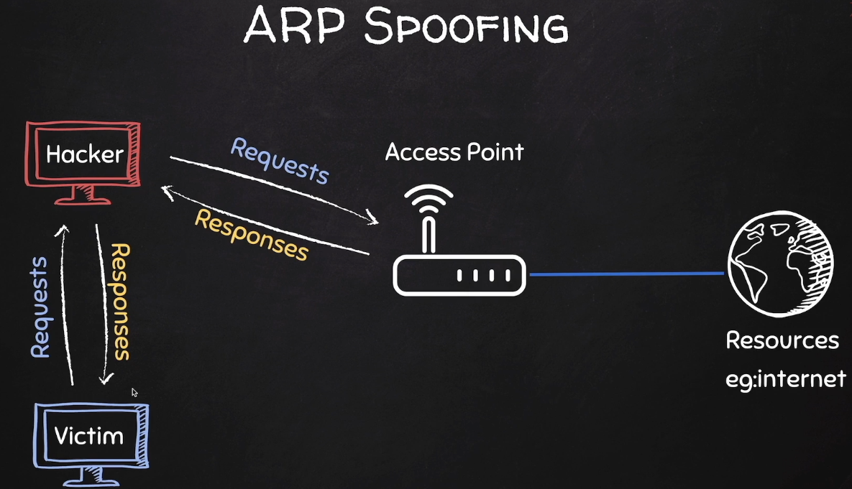

1. Create a NAT Network
If you already have an EthicalHacking VM as shown, you can skip this step.
- In VirtualBox Manager In VirtualBox Manager File Tools Network Manager
- Nat Networks tab Click Create.
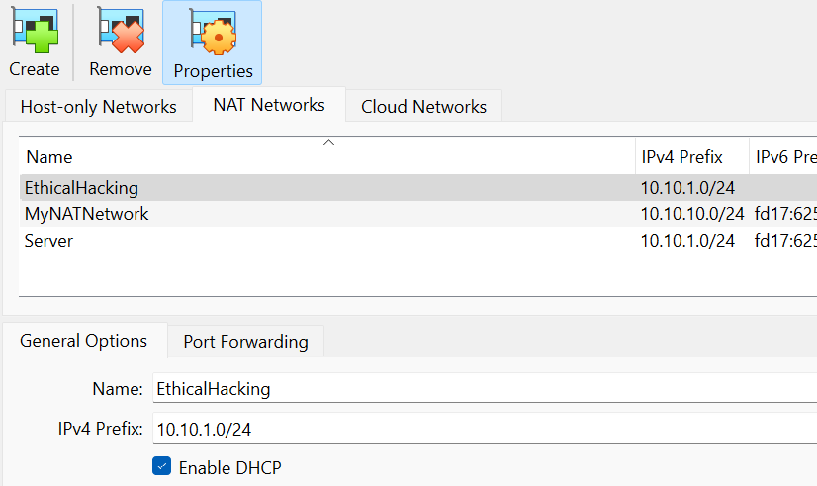
You should have internet access on both VM’s.
If not in the VirtualBox Manager go to Settings Network switch to Bridged Adapter Click OK go back and switch to NAT Network Click OK.

Lab Requirements
This lab can disrupt network communications on a production network. We want to do this lab in a completely virtual environment.
- Kali Linux VM
- Windows VM with Google Chrome
- Both VM’s on same user created NAT network with DHCP enabled

Bettercap Web GUI
We know how to be the man in the middle and capture all the packets from a victim. We can do this from a GUI interface.
Connect both VM’s to the NAT network we created earlier.

1. View Local IP Address Information
On your Kali Linux: run the following command in the terminal to find out the name and IP address of the network interface that you’re using. It is commonly eth0.
ip a
Insert a screenshot:
Click or tap here to enter text.

2. bettercap Web GUI
- In the user home folder Create the following file: alert.js
- Enter the following code.
alert('You have been hacked!')
- Enter the following command to open the hstshijack.cap for editing. We are going to use geany, a GUI editor for this task.
sudo geany /usr/local/share/bettercap/caplets/hstshijack/hstshijack.cap
- Put the path to your alert.js file at the end of the set hstshijack.payloads as shown below. The path will be longer than is shown.
# Add this to the end of the set hstshijack.payloads path
,*:/home/user/alert.js

# Comment out the following line, net recon has already started
# net.recon on

set http.proxy.script /usr/local/share/bettercap/caplets/hstshijack/hstshijack.js
http.proxy on

set dns.spoof.domains google.corn,*.google.corn,gstatic.corn,*.gstatic.corn
set dns.spoof.all true
dns.spoof on
- Run the following commands to start bettercap and the web ui.
cd ./bettercap
sudo ./bettercap -eval "ui on"
- Insert a screenshot:
Click or tap here to enter text.
- In your web browser: go to http://localhost:8080
- You should see the bettercap web ui.
- Username: user Password: pass
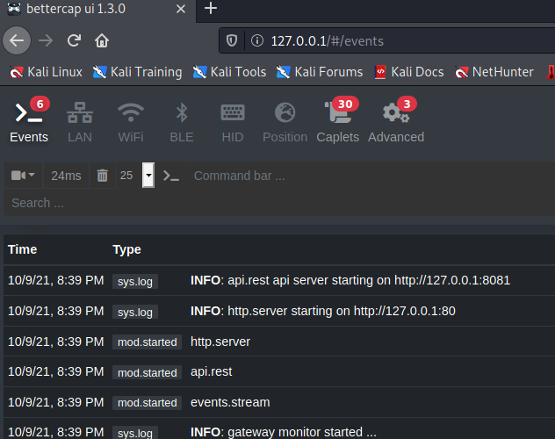
- Click the LAN tab. Click the play button for net.probe. This will automatically start net.recon. Those are the play buttons to the right of the trash can.
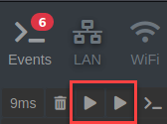
- You should see your gateway, Kali machine, and the victim computer’s IP address.
Gateway: .1
VirtualBox DHCP server: .3
eth0: Kali Linux
Victim computer IP address:
- Click the downward pointing triangle next to the victim computer’s IP address Add to arp.spoof.targets.
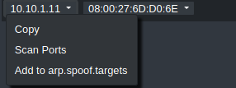
- Click full-duplex spoofing. Click Start arp.spoof.
- You will see a little red icon indicating that you are spoofing the target.
- Windows VM: At a command prompt: ping google.com
- Run arp -a You should see that the gateway MAC address is the same as the Kali machine.
- Insert a screenshot:
Click or tap here to enter text.
- Kali VM: Click the Caplets tab. Click hstshijack
- Click the play button above the display of the hstshijack.cap file.
- Windows VM: Go to http://www.vulnweb.com Make sure the address has http://www.vulnweb.com
- Go to a couple of the websites until one shows the javascript file showing an alert.
- Insert a screenshot:
Click or tap here to enter text.
- Close the web browser. Type quit to stop bettercap.

Assignment Submission
Attach this completed document to the assignment in Blackboard.

