Hack a Wireless Network with Wifite
Contents
Hack a Wireless Network with Wifite 1
Hacking Wireless Networks 1
Logon to Kali Linux 1
rockyou.txt 2
Wifite 2
Assignment Submission 4

Time required: 60 minutes

What I Want You to Do
This proof of concept lab is designed to give you hands-on experience with wireless network hacking and dictionary attacks.

Why I Want You to Do This
Understand how wireless encryption can be circumvented. Older wireless encryption protocols along with simple shared keys allow your network to be vulnerable. You can protect your network by using good password and shared key practices, as well as using the most up to date encryption protocols.

Hacking Wireless Networks
Hacking wireless networks requires a special wireless chipset.
We are using a ALFA AWUS036NHA wireless adapter.
This adapter supports promiscuous mode, which is for packet sniffing. It also supports monitor mode which allows packets to be captured without having to associate with an access point or ad hoc network first. Monitor mode only applies to wireless networks, while promiscuous mode can be used on both wired and wireless networks.

Logon to Kali Linux
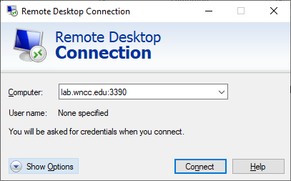
You will be logging into an older Dell laptop computer in D1 at the WNCC Scottsbluff campus. Please be patient!
You will use Remote Desktop Connection on your Windows computer (not the virtual machine) to connect to the remote Kali Linux laptop.
- Go to Start, type Remote Desktop Connection.
- Computer from outside D1: lab.wncc.edu:3390
In D1: 172.16.1.3:3390
- Username: user
- Password: ToweringFence2344

rockyou.txt
rockyou.txt is a dictionary attack file containing passwords from data breaches. It contains real passwords used by real users.
- Google rockyou.txt. You can download it on your Windows computer and look at it in Notepad. It will take a while for Notepad to load the file. Look at what is inside it.
- Describe what rockyou.txt is and what it contains.
Click or tap here to enter text.

Wifite
Wifite is a Python script that can capture an WPA2 authentication hash and decrypt it using a dictionary file. Deauthenticate a client to make it authenticate again, grab the hash of the shared key authentication password, and decrypt the hash.
- Open a Terminal session: sudo wifite --kill
- Enter the password: ToweringFence2344
- wifite will scan for wireless networks.
- Press CTRL+C when you see WildWest has some clients.
- Select the target number of WildWest.
- Wifite will attempt to find PMKID. Press CTRL+C.
- Type c to continue
- wifite will automatically deauthenticate and try to crack the password.
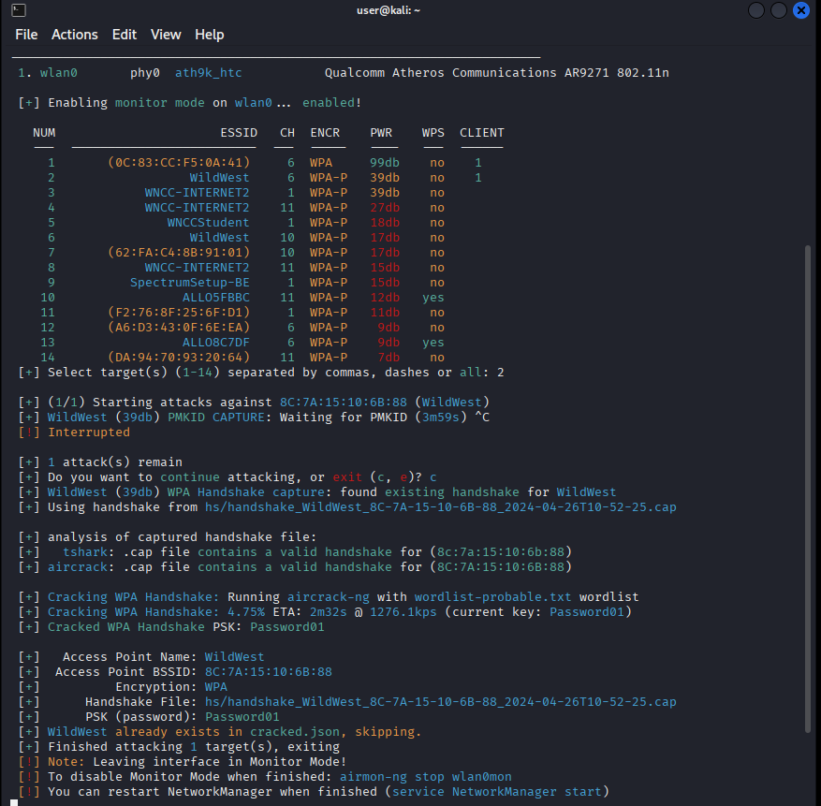
- Insert a screenshot of your successful attack.
Click or tap here to enter text.
- What was the key?
Click or tap here to enter text.
- Remove cracked.json This file stores the cracked password.
rm cracked.json

Assignment Submission
- Type sudo reboot to restart Kali.
- Write a 200 word reflection on what you learned in this assignment.
For instance, what could you have done to make this wireless network more secure?
Click or tap here to enter text.
- Attach this completed document to the assignment in BlackBoard.

