Identify the Hardware on Your PC with Software
Time required: 30 minutes
How to Create Screenshots: Please use the Windows Snip and Sketch Tool or the Snipping Tool. Paste a screenshot of just the program you are working on. If you are snipping a virtual machine, make sure your focus is outside the virtual machine before you snip.
- Press and hold down the Windows key & Shift, then type S. This brings up the on-screen snipping tool.
- Click and Drag your mouse around whatever you want to snip.
- Release the mouse button. This places the snip into the Windows Clipboard.
- Go into Word or wherever you want to paste the snip. Hold down CTRL, then type V to paste the snip.
NOTE: This lab must be done on a physical machine. In class students can use the computer on the table in the back of the room.

CPU-Z
Paste the screenshots and answer the following questions.
- Go to www.cpuid.com
WARNING: Be careful of ads and other downloads. Download Cpu-z and install it on your system. (There is a portable zip file which contains a standalone version that you can carry on a usb drive.)
- Run the program. Paste a screenshot to replace the example below. Look at the other tabs.
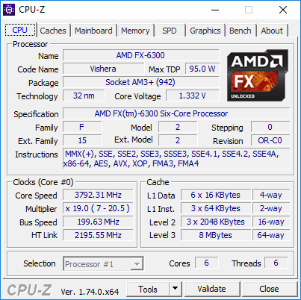
- Go to the Mainboard tab and paste a screenshot to replace the example below.
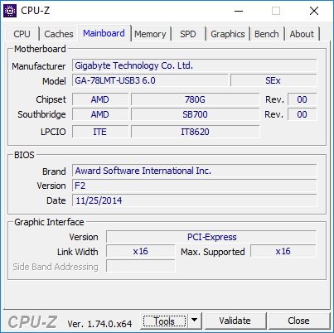
- Go to the Memory tab. Paste a screenshot. How much memory does your computer have? What is the type? Is it dual channeled?
Click or tap here to enter text.
- What type of slot does your video card have (Graphic Interface, Version)?
Click or tap here to enter text.
- What is the name of your video card? Paste a screenshot:
Click or tap here to enter text.
- How much and what type of memory is in your video card?
Click or tap here to enter text.
- What is the most interesting piece of information you discovered about your computer?
Click or tap here to enter text.

HWiNFO
- Go to www.hwinfo.com
WARNING: Be careful of ads and other downloads. Download HWiFO64 and install it on your system. (There is a portable zip file which contains a standalone version that you can carry on a usb drive.)
- Run the program. Replace the sample screenshot with a screenshot on your system.
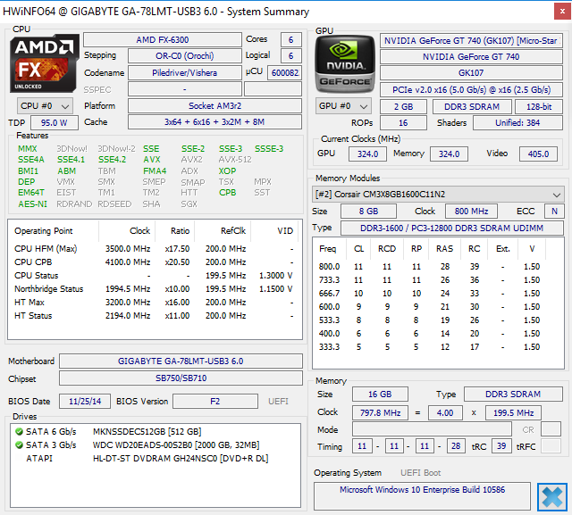
- Does this program give information that Cpu-z doesn’t? Give some examples.
Click or tap here to enter text.

Speccy
- Go to https://www.ccleaner.com/speccy, download and install the free version of Speccy.
- Insert a screenshot of the Summary screen:
Click or tap here to enter text.

Assignment Submission
Attach this completed document to the assignment in Blackboard.

