Network Two Computers
Time required: 60 minutes
Contents
Network Two Computers 1
Lab Description 1
Change Network Location to Private 1
Change wired connection 1
Change wireless connection 2
Workgroup Names 2
Workgroup Sharing 2
Map Network Drives 2
Net Use 3
Activate the Local Administrator Account 4

Time Required: 60 Minutes
How to Create Screenshots: Please use the Windows Snip and Sketch Tool or the Snipping Tool. Paste a screenshot of just the program you are working on. If you are snipping a virtual machine, make sure your focus is outside the virtual machine before you snip.
- Press and hold down the Windows key & Shift, then type S. This brings up the on-screen snipping tool.
- Click and Drag your mouse around whatever you want to snip.
- Release the mouse button. This places the snip into the Windows Clipboard.
- Go into Word or wherever you want to paste the snip. Hold down CTRL, then type V to paste the snip.

Lab Description
This lab can be done with physical computers and a wireless router. It can also be done with a virtual machine and a physical machine, or with 2 virtual machines. This lab is designed for Windows 10 or 11.

Virtual Machine Network
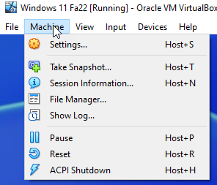
In your Windows Virtual Machine at the top in the
- Machine Settings Network Attached To: Bridged Adapter.
- The adapter showing in Name: should be the adapter that connects your computer to your network.
- Click OK to save the changes.

Change Network Location to Private
Do this lab between your Virtual Machine and your local machine.
Start with your Windows Virtual Machine.
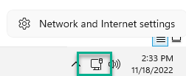
- Right Click the Network Icon in the system tray Click Network and Internet settings.
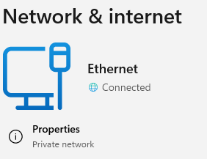
- Click Properties. (Yours will likely say Public network.)

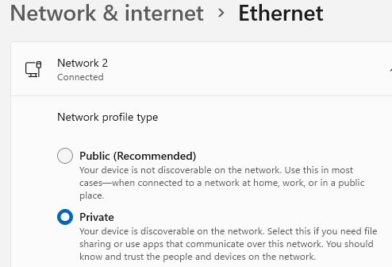
- Scroll to the top Click Private. There isn’t an OK button to click, the setting is changed.

Workgroup Sharing
Workgroup sharing allow sharing of any resource in a small network.
- On the Windows Virtual Machine open File Explorer
- Go to Network Click on the Network icon. You should receive a prompt asking you to enable file sharing. Do so.
- Create a folder c:\data
- Right Click c:\data Show More Options Give access to Specific people…
- Click Share. Note the UNC path to the shared folder.
- On your local machine Open File Explorer and Click Network. You should see the other computer. If not, type in \\computername in the File Explorer address bar.
- Navigate to the other computers shared data folder. Create and save a text file in the data folder.
- Insert a screen shot:
Click or tap here to enter text.

Map Network Drives
Mapping a network drive allows easy access to network resources.
- On your local computer Right Click My PC Click Map Network Drive.
- Enter the UNC path \\win11\data Choose the drive letter Z: Click Finish.
- Open Notepad. Create and save a small document to your new network drive.
- Insert a screen shot showing the file you created and the network drive in File Explorer:
Click or tap here to enter text.
- To disconnect the network drive, Right Click the network drive, and Click Disconnect.

Net Use
The net command is several commands in one. The net use command can connect or disconnect a computer from a shared resource or can display information about connections.
You are still on your local machine.
- Disconnect any network drives showing in File Explorer.
- The following command makes a mapped drive to a remote computer and to a shared folder on that computer.
At a normal command prompt type: net use z: \\win11\data (Replace Window11 with your pc name.)
NOTE: Don’t use an Administrative level command prompt.
- Insert a screenshot of the results of this command.
Click or tap here to enter text.
- Insert a screenshot of the mapped drive in File Explorer:
Click or tap here to enter text.
- Use the net use * /delete command to disconnect all network drives.
- Insert a screenshot:
Click or tap here to enter text.
- Use Notepad to create a batch file with the following lines and save it as logon.bat
Choose all files when saving the file.
net use z: \\lab1\data (Replace lab1 with your pc name.)
pause
- Insert a screenshot of the batch file contents:
Click or tap here to enter text.
- Double Click the batch file.
Insert a screenshot of the batch file execution:
Click or tap here to enter text.
- Insert a screenshot of the mapped drive in File Explorer.
Click or tap here to enter text.
- Use the net use * /delete command to disconnect all network drives.

Activate the Local Administrator Account
The net user command manages user accounts. For example, recall that the built-in administrator account is disabled by default. You may have a need to enable the administrator account from a command prompt in recovery mode to fix a computer if there are not any other administrator accounts that function.
Do this lab on the Virtual Machine.
- To activate the local Administrator account, use this net user command at an Administrative command prompt:
net user administrator /active:yes
- Use Computer Management to take a screenshot showing the Administrator account is now active.
- Insert a screenshot:
Click or tap here to enter text.
- Disable the Administrator account by using the following command.
net user administrator /active:no
- Insert a screenshot:
Click or tap here to enter text.

Assignment Submission
Attach this completed document to the assignment in Blackboard.

