Remote Desktop on Two Computers
Time required: 60 minutes
How to Create Screenshots: Please use the Windows Snip and Sketch Tool or the Snipping Tool. Paste a screenshot of just the program you are working on. If you are snipping a virtual machine, make sure your focus is outside the virtual machine before you snip.
- Press and hold down the Windows key & Shift, then type S. This brings up the on-screen snipping tool.
- Click and Drag your mouse around whatever you want to snip.
- Release the mouse button. This places the snip into the Windows Clipboard.
- Go into Word or wherever you want to paste the snip. Hold down CTRL, then type V to paste the snip.

Lab Description
In this lab, you will learn how to set up Remote Desktop for first use, then you learn how to use it. You can use physical pc’s, Windows virtual machines, or any combination. You can do this lab with a partner if you wish.

Virtual Machine Network
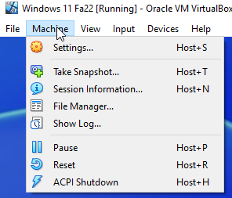
In your Windows Virtual Machine at the top in the
- Machine Settings Network Attached To: Bridged Adapter.
- The adapter showing in Name: should be the adapter that connects to your network.
- Click OK to save the changes.

Change Network Location to Private
Do this lab between your Virtual Machine and your local machine.
Start with your Windows Virtual Machine.
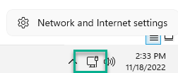
- Right Click the Network Icon in the system tray Click Network and Internet settings.
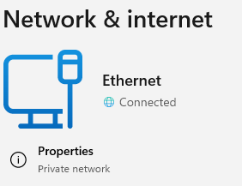
- Click Properties. (Yours will likely say Public network.)

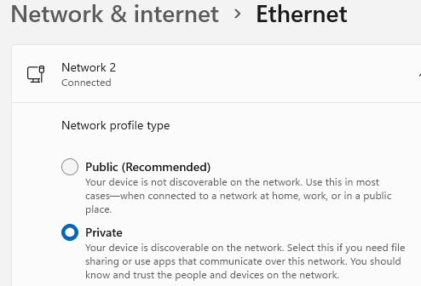
- Scroll to the top Click Private. There isn’t an OK button to click, the setting is changed.

How to Set Up Remote Desktop for First Use
The host or server computer is the computer that is serving up the Remote Desktop service for client computers.
To prepare your host computer, configure the Remote Desktop service. Here are the steps needed:
- Click Start, Click Settings. Type in and Click on Remote Desktop Settings.
- Click Enable Remote Desktop to On.
- Insert a screenshot:
Click or tap here to enter text.
- Click Ok.
- Verify that Windows Firewall is set to allow Remote Desktop activity to this computer. To do that, open Control Panel in Classic view and click Windows Firewall. The Windows Firewall window appears. In the left pane, click Allow an app or feature through Windows Firewall.
- The Allowed apps window appears. Scroll down to Remote Desktop and verify it is checked. Click OK to apply any changes.
- You are now ready to test Remote Desktop.

Using Remote Desktop
Try to use Remote Desktop from another computer somewhere on your local network. On the client computer, you can start Remote Desktop to remote into your host computer by using the command mstsc (which stands for Microsoft Terminal Services Client). Follow these steps to use Remote Desktop:
- Click Start, type Remote Desktop. Click Remote Desktop Connection.
- Enter the IP address or the host name of the computer to which you want to connect
NOTE: If you plan to transfer files from one computer to the other, click Show Options for Windows 10 or Options for Windows 7, and then click the Local Resources tab, Click More. Check Drives. Click OK. Click Connect to make the connection. If a warning box appears, click Connect again. If another warning box appears, click Yes. This will allow drives and other devices to be shared using the Remote Desktop Connection.
- A Windows security box appears, which is displayed by the remote computer. Sign in with a user name and password for the remote computer. If a warning box appears saying the remote computer might not be secure, click Yes to continue the connection.
- The desktop of the remote computer appears with a toolbar at the top of the screen. Click Restore Down to show both the remote desktop and the local desktop on the same screen.
- Insert a screenshot:
Click or tap here to enter text.
- The desktop of the remote computer is available on your local computer.
- When you click in the remote desktop’s window, you can work with the remote computer just as if you were sitting in front of it.
- To close the connection to the remote computer, sign out from the remote computer or close the desktop window.
Notes: Even though a Windows client operating system normally allows more than one user to be signed in at the same time, this is not the case with Remote Desktop. When a Remote Desktop session is opened, all local users on the remote computer must sign out after receiving a warning.

For Your Information Only: Remote Desktop from Outside Your Network
This section gives information on how to setup Remote Desktop from outside your network. This is not a part of the assignment.
If you wish to remote into your computer from outside the network, you need to configure your host computer for static IP addressing. Here are the steps needed:
- Configure the computer for static IP addressing.
- If your computer is behind a firewall, configure the router for port forwarding and allow incoming traffic on port 3389. Forward that traffic to the IP address of your desktop computer.
- Outside your network, use the Remote Desktop Connection to connect to the Public IP address of your home router. You can find this IP address at home by going to www.whatismyip.com

Assignment Submission
Attach this completed document to the assignment in Blackboard.

