Advanced Port Scanner

Objectives
The goal of this lab is to set up and use Advanced Port Scanner to scan your network for host devices and open ports. This is a good way to take a quick look at what is on a network.

Activity Background
Time required: 45 minutes
This lab may be done on a physical or virtual machine.

Activity
- Go to https://www.advanced-port-scanner.com.
- Download and install Advanced Port Scanner. Accept all default installation choices.
- Start Advanced Port Scanner. After Advanced Port Scanner loads, it will load all the IP addresses on your computer.
- Go to the command prompt. Type ipconfig /all.
- Insert a screenshot showing your local network settings.
Click or tap here to enter text.
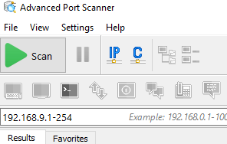
- In Advanced Port Scanner, remove all networks except your local network.
- Click the Scan button to scan your network. As the scanning progresses, the lower pane shows network devices and machines that the utility discovers.
- Insert a screenshot showing the completed scan of your network.
Click or tap here to enter text.
- Click the Expand All button.
- Insert a screenshot showing the open ports and shares on your devices.
Click or tap here to enter text.
- Go to File, Print. Choose the Microsoft Print to PDF printer. Click Print. Save the pdf somewhere you can locate it again.

Review Questions
- What network layers does the Advanced Port Scanner give you information on?
Click or tap here to enter text.
- What information does Advanced Port Scanner provide about your network?
Click or tap here to enter text.
- As a Network technician in the field, how might you use this utility?
Click or tap here to enter text.
- You used the Advanced Port Scanner print function earlier. How can this be useful?
Click or tap here to enter text.

Assignment Submission
- Attach this completed document.
- Attach your pdf report.
- Submit in Blackboard.

