Wi-Fi Analyzer
Time required: 15 minutes

Lab Description
Wi-Fi Analyzer is a free application that can be downloaded and installed on a Windows device. The application can be used to detect and analyze the different available Wi-Fi access points. The application can be downloaded through the Microsoft Store.
In this task, the use of a Wi-Fi Analyzer application will be demonstrated.
- Open the Windows Store search for and install Wi-Fi Analyzer.
- You should see something like the example screenshot.
- Insert a screenshot:
Click or tap here to enter text.
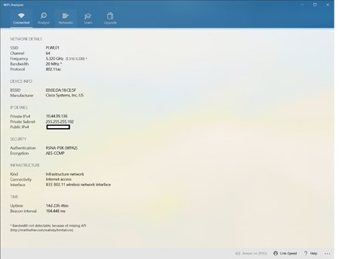
Note: Using the Wi-Fi Analyzer application, specific information can be gathered about the connected Wi-Fi network. A Network Administrator can use this information to troubleshoot connectivity-related issues on the network.
- In the Networks tab of the Wi-Fi Analyzer, the different available Wi-Fi Networks that are available are displayed. A Network Administrator can use this information to determine how further Wi-Fi Access Points can be setup if needed and the range of the available Access Points.
- Insert a screenshot:
Click or tap here to enter text.
- Click the Analyze menu of the Wi-Fi Analyzer. More information on the Wi-Fi connection can be gathered. This information includes which frequency and channel the device is connected to on the Wi-Fi Access Point.
- Insert a screenshot:
Click or tap here to enter text.
- Close the Wi-Fi Analyzer application.

Assignment Submission
- Attach this completed document to the assignment in Blackboard.

