Programming and Problem Solving Final Assignment.
Contents
Programming and Problem Solving Final Assignment. 1
Introduction to MATLAB 1
Vectors and Matrices 2
MATLAB Programming 3
GUI App 5

 No AI use

Introduction to MATLAB
These are done interactively at the Command Window. Insert a screenshot showing the results below the assignment.
NOTE: Choose 3 of the following:
- There are 1.6093 kilometers in a mile. Create a variable to store the number of miles. Convert this to kilometers, and store in another variable.

- The following assignment statements either contain at least one error or could be improved in some way. Assume that radius is a variable that has been initialized. First, identify the problem, and then fix and/or improve them:
  - 33 = number
  - my variable = 11.11;
  - area = 3.14 * radius^2;
  - x = 2 * 3.14 * radius;

- Create two variables x and y and store numbers in them. Write an expression that would be true if the value of x is greater than five or if the value of y is less than ten, but not if both of those are true.

- A company manufactures a part for which there is a desired weight. There is a tolerance of N percent, meaning that the range between minus and plus N% of the desired weight is acceptable.
  - Create a variable that stores a weight, and another variable for N (e.g., set it to 2).
  - Create variables that store the minimum and maximum values in the acceptable range of weights for this part.

Vectors and Matrices
You can do these interactively or in a script. Insert a screenshot showing the results below the assignment.
NOTE: Choose 3 of the following:
- Create a vector in three different ways: using just square brackets, using the colon operator, and using linspace;
vec =
5 7 9 11

- Create a variable myend, which stores a random integer in the inclusive range from 5 to 9. Using the colon operator, create a vector that iterates from 1 to myend in steps of 3.

- Using the colon operator and the transpose operator, create a column vector myvec that has the values -1 to 1 in steps of 0.5.

- Generate a 2 x 4 matrix variable mat. Replace the first row with 1:4. Replace the third column (you decide with which values).

- Why would the following code produce an error message? Explain what each statement does or attempts to do.
mat = [ 1 : 3 ; 4 : 6 ];
mat ( : , 2 ) = [ 3 7 11]’

- Create a vector x which consists of 20 equally spaced points in the range from -π to +π. Create a y vector which is sin(x).

- Create a 3 x 5 matrix with random integers ranging from -10 to +10. Perform each of the following.
- Find the maximum value in each column.
- Find the maximum value in each row.
- Find the maximum value in the entire matrix.
- Subtract 3 from each element.
- Count how many are positive.

MATLAB Programming
Attach the script file. Insert a screenshot showing the successful run of the program below the assignment.
NOTE: Choose 3 of the following:
- Write a script that will prompt the user for a number and print it twice, once with three decimal places, and then with one decimal place.

- A power company charges 6.6 cents per kilowatt-hour (KWH) for providing electricity. Write a script “power_charge” that uses a function to calculate and return the charge for the month.
  - Prompt the user for the number of KWH used in a given month.
  - Create a power_calc function that takes in the KWH and returns the charge for the month.
  - Print the charge for the month in dollars, in the following format. (The conversion is 100 cents in one dollar.)
Example run:
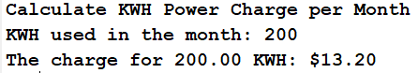
- Write a script that gets values from the user for the x and y coordinate of a point. Plot this using a large red circle.
Example run:
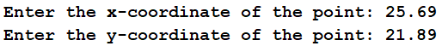
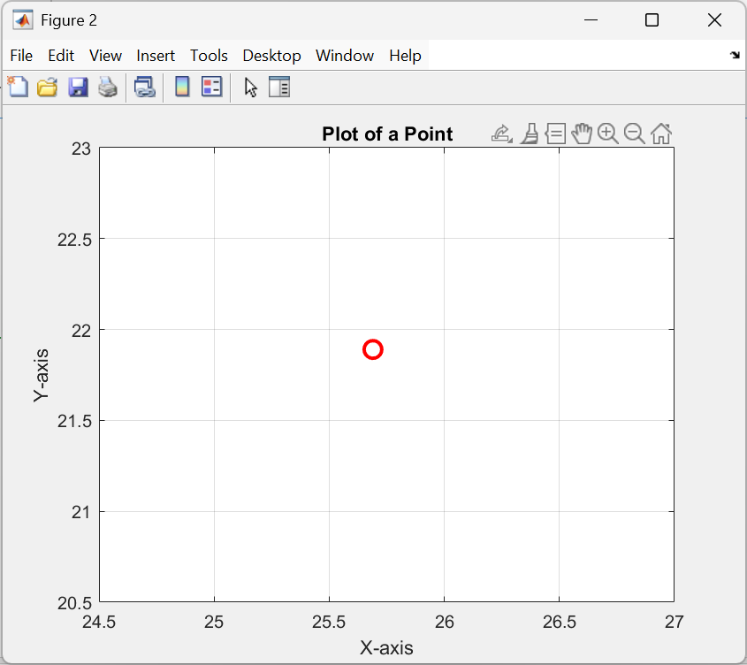
- Write a program with a function that converts inches to feet. Note that 12 inches = 1 foot.

GUI App
NOTE: Choose 1 of the following:
- Create a GUI App version of the app from the previous assignment. A power company charges 6.6 cents per kilowatt-hour (KWH) for providing electricity. Write a script “power_charge” that uses a function to calculate and return the charge for the month.
  - Prompt the user for the number of KWH used in a given month.
  - Create a power_calc function that takes in the KWH and returns the charge for the month.
  - Print the charge for the month in dollars, in the following format. (The conversion is 100 cents in one dollar.)

- Create a GUI app that generates a random number within a specified range.
- Input fields for minimum and maximum values.
- Button to generate the number.
- Display area for the random number.

