Getting Started with Packet Tracer
Contents
Getting Started with Packet Tracer 1
Lab Description 1
Install Packet Tracer 1
Tutorial: Build a Simple Network 2
Connect the Devices 3
Set Static IP Addresses 4
Verify Connectivity 4
Assignment Submission 5

Time required: 60 minutes

Lab Description
The Cisco Networking Academy website provides many useful tools for advancing your networking education. One of those tools is a network simulator called Packet Tracer.
In this project, you download and install Packet Tracer, take a tour of the simulator interface, and create a very basic network using simulated devices in Packet Tracer. This version of Packet Tracer is free to the public. In later projects, we’ll return to Packet Tracer to build more complex networks and even learn some basic Cisco IOS commands. Cisco IOS (Internetworking Operating Systems) is the operating system used on Cisco networking devices, such as routers and switches (with minor variations in the specific IOS for each different type of device). Many other manufacturers of networking devices use the same or similar commands, and those that use different commands typically use very similar functions, even if they call it something a little different.

Install Packet Tracer
To get the Packet Tracer download, you must first sign up for the free Introduction to Packet Tracer online course on the Cisco Networking Academy website.
Complete the following steps to create your account:
- In your browser, navigate to https://skillsforall.com/course/getting-started-cisco-packet-tracer?userLang=en-US
- If the course is not listed on this page, do a search for packet tracer site:netacad.com and follow links to “Download Packet Tracer” or “Introduction to Packet Tracer” to find the current Packet Tracer introduction course. Enter your name, email, and text verification to enroll in the course.
- Open the confirmation email and confirm your email address.
You’re ready to download and install Packet Tracer.
- Inside the course, check the Student Resources to find the link to download Packet Tracer. Download the correct version for your computer, and then install Packet Tracer. Note that the download might not complete in the MS Edge browser; if you encounter a problem, try Google Chrome instead. When the installation is complete, run Cisco Packet Tracer.
- When Packet Tracer opens, sign in with your Networking Academy account that you just created. If you see a Windows Security Alert, allow access through your firewall.
- Cisco Packet Tracer opens.

Tutorial: Build a Simple Network
- Open Packet Tracer.
- Save the Packet Tracer file as GettingStarted.
- Add one 2960 switch to the workspace. Go to the lower left of Packet Tracer. Drag 2960 to the workspace.
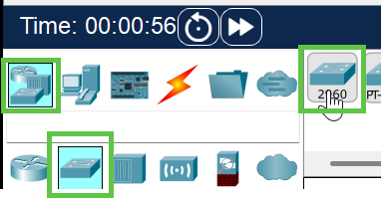
- Add two PC’s to the workspace.
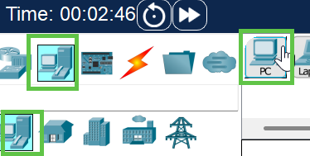
Final result:
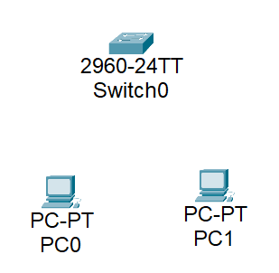

Connect the Devices
- Select a Copper Straight-Through (Ethernet) cable.
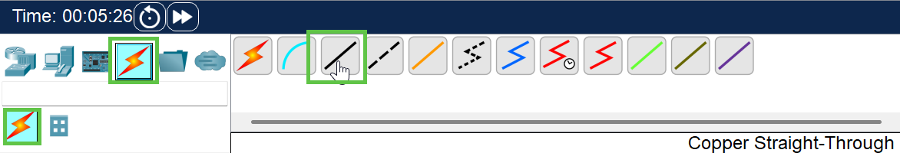
- Click PC0 Click FastEthernet0.
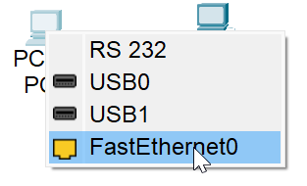
- Click Switch0 Click FastEthernet0/1
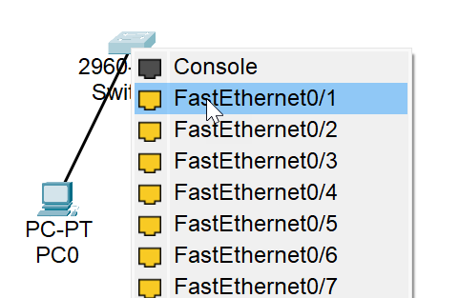
- Repeat the same process to connect PC1 to Switch0. Use the next available switch port.
- Final result:
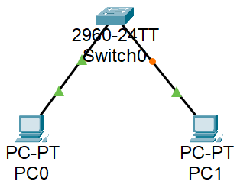

Set Static IP Addresses
We do not have a DHCP server, we will set static IP addresses for our network. A DHCP server hands out IP addressing information automatically to clients.
Device | Interface | IP Address | Subnet Mask
PC-A | NIC | 192.168.1.10 | 255.255.255.0
PC-B | NIC | 192.168.1.11 | 255.255.255.0
- Click PC0. That will bring up the configuration screen.
- Click the Desktop Tab IP Configuration.
  - IPV4 Address: 192.168.1.10
  - The Subnet Mask should automatically fill in as 255.255.255.0
- Close the configuration screen.
- Repeat for PC1. Substitute the address from the above table.

Verify Connectivity
Use the Command Prompt to verify the PC settings and connectivity.
- Click PC0 Desktop Command Prompt.
- To confirm your IP settings type: ipconfig /all Press Enter
- Insert a screenshot.
Click or tap here to enter text.
- Type: ping 192.168.1.10 Press Enter.
- You should see 4 successful replies.
- Insert a screenshot.
Click or tap here to enter text.
- If your results were not successful, go back and check the IP Configuration of each PC.

Assignment Submission
Attach to the assignment in Blackboard:
- This completed document
- Packet Tracer file

