Packet Tracer SOHO Network
Contents
Packet Tracer SOHO Network 1
Objectives 1
Materials Required 1
Activity Background 1
Part 1: Download And Install Packet Tracer 2
Part 2: Build a SOHO Network in Packet Tracer 2
Test Connectivity 7
Review Questions 8
Assignment Submission 8

Objectives
The goal of this lab is to implement a wired and wireless network with a SOHO (Small Office Home Office) router in Packet Tracer. After completing this lab, you will be able to:
- Set up a SOHO network in Cisco Packet Tracer

Materials Required
This lab requires the following:
- Computer with Windows
- Internet access

Activity Background
Cisco Packet Tracer simulates many functions of a network and can be useful to help you learn and practice networking skills. In this lab, you install Packet Tracer and use it to build and configure a small wired and wireless network that uses a SOHO router and cable modem for Internet connectivity.
NOTES: When loading a Packet Tracer file, it may take a minute for everything to connect. Sometimes a device may not get a DHCP address. Switch the IP Configuration from DHCP to Static then back to DHCP.
Time Required: 60 Minutes

Part 1: Download And Install Packet Tracer
To get the Packet Tracer download, you must first sign up for the free Introduction to Packet Tracer online course on the Cisco Networking Academy website. Complete the following steps to create your account, download, and install Packet Tracer:
- In your browser, navigate to www.netacad.com/courses/packet-tracer. Enroll in the course.
- Open the confirmation email and confirm your email address. Configure your account and save this information in a safe place. You will need this information again.
- Click Courses and select the Getting Started with Packet Tracer course.
- Inside the course Module 1: Download and Use Packet Tracer Download Cisco Packet Tracer. Download the latest version for your computer OS.
- Install Packet Tracer.
- When the installation is complete, run Cisco Packet Tracer.
- When Packet Tracer opens, sign in with your Networking Academy account that you created earlier. If you see a Windows Security Alert, allow access through your firewall. Cisco Packet Tracer opens.
Take a few moments to explore the Packet Tracer menus and features.
Note: The web is an excellent source of information about Packet Tracer. For example, you can search youtube.com on “how to use packet tracer” for a quick tutorial.

Part 2: Build a SOHO Network in Packet Tracer
Follow these steps to build a network in Packet Tracer:
To add a device to your network, select a category of devices in the bottom-left portion of the window, and then press and drag a device to the workspace. Follow these steps to add devices to your network, arranging the devices as shown in Figure 7-14. Do not worry about configuring any of the devices yet.
- Select End Devices.
  - Press and drag a PC to the workspace.
  - Press and drag a Laptop to the workspace.
  - Press and drag a Printer to the workspace.
  - Press and drag a Smartphone to the workspace.
  - Press and drag a Tablet to the workspace.
- Select Network Devices select Wireless Device.
  - Press and drag the WRT300N wireless router to the workspace.
  - Select WAN Emulation, then press and drag PT-Cloud to the workspace.
    - Click Cloud-PT. Click Config, set the Display Name as ISP.
  - Select WAN Emulation, and then press and drag a Cable-Modem-PT to the workspace.
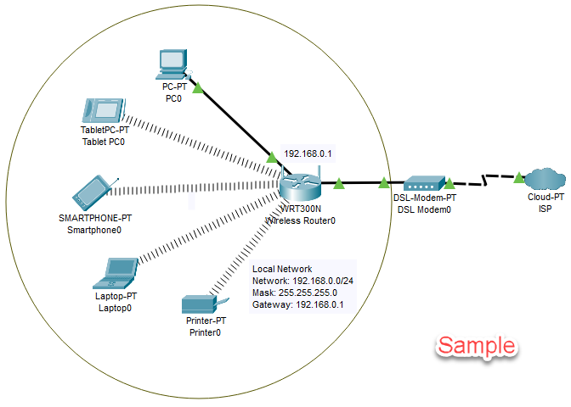
Figure 7-14 Arrangement of devices in Packet Tracer
NOTE: To delete a device from the workspace, select the Delete icon in the menu bar. Your pointer changes to an ×. Then click the device you want to delete. To return to the Select function, click the Select icon in the menu bar.
You’re now ready to use Ethernet cable to connect devices in your network.
- To connect a cable, you first select the type of cable you want. Then click the first device in the connection and select its port.
- Click the second device and select its port. The cable connects the two devices. If both devices are turned on, they will attempt to automatically establish connectivity.
- In the categories of devices in the bottom-left portion of the window, select Connections (the lightning bolt icon). In the list of cable types, press and drag a Copper Straight-Through cable (a black solid line) to the Wireless Router. Select the first port on the Wireless Router, then click the PC and select the FastEthernet port. The Ethernet cable connects the Wireless Router and PC.
- Connect the Internet port on the wireless router to Port1 on the Cable-Modem-PT.
- Use a Coaxial cable to connect Port0 on the Cable-Modem to Coaxial7 on the Cloud-PT.
- To configure the Wireless Router, Click to open its configuration window.
  - Click GUI to see the web-based utility on the WRT300N wireless router.
  - Select the GUI Setup tab, and notice that the local IP address of the router is 192.168.0.1. Also notice that DHCP is enabled, so devices on your network can be assigned dynamic IP addresses.
  - Insert a screenshot.
Click or tap here to enter text.
  - What is the range of IP addresses to be assigned?
Click or tap here to enter text.
- To secure the wireless network, select the GUI Wireless tab, select Wireless Security, and set the Security Mode to WPA2 Personal.
- Set a Passphrase.
- Save your settings.
- Insert a screenshot.
Click or tap here to enter text.
  - Click Basic Wireless Settings. Change the SSID to something of your choosing.
  - Insert a screenshot.
Click or tap here to enter text.
  - Save your settings.
  - To secure the router, select the GUI Administration tab. Change the Router Password. Change the Password to Password01.
  - Insert a screenshot.
Click or tap here to enter text.
  - Save your settings.
By default, end devices are set for static IP addresses and have not yet been assigned IP addresses. To change the setting to DHCP, follow these steps:
- TabletPC
  - Click the TabletPC to open the configuration window.
  - Set to DHCP.
  - Click Wireless0.
  - Set the SSID to your SSID.
  - Set the WPA-PSK Pass Phrase to the passphrase you created earlier.
  - Insert a screenshot.
Click or tap here to enter text.
  - Close the configuration window.
- Smartphone
  - Click the Smartphone to open the configuration window.
  - Set to DHCP.
  - Click Wireless0.
  - Set the SSID to your SSID.
  - Set the WPA-PSK Pass Phrase to your passphrase.
  - Insert a screenshot.
Click or tap here to enter text.
  - Close the configuration window.
- Laptop
The Laptop has to be configured to use a wireless card.
  - Scroll down in the Physical Device View.
  - Click the Power Button to turn off the laptop.
  - Drag the ethernet module from the laptop to the module column.
  - Drag the WPC300N module to the bottom right of the screen. Drop it right below Customize Icon in Logical View.
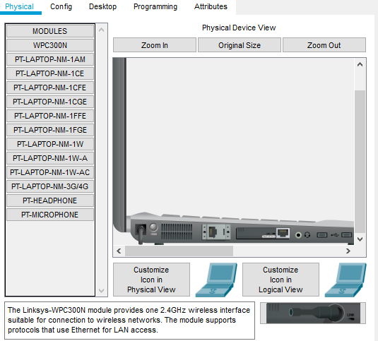
  - Click the Power Button to turn on the laptop.
  - Click the Config tab. Set to DHCP.
  - Click Wireless0.
  - Set the SSID to the SSID you created earlier.
  - Set the WPA2-PSK Pass Phrase to the passphrase you created earlier.
  - Insert a screenshot.
Click or tap here to enter text.
  - Close the configuration window.
- Printer
The Printer has to be configured to use a wireless card. It is the same process as the laptop.
  - Scroll down in the Physical Device View.
  - Click the Power Button to turn off the printer.
  - Drag the ethernet module from the printer to the module column.
  - Replace it with the WPC300N module.
  - Click the Power Button to turn on the printer.
  - Click the Config tab. Set to DHCP.
  - Click Wireless0.
  - Set the SSID to the SSID you created earlier.
  - Set the WPA2-PSK Pass Phrase to the passphrase you created earlier.
  - Insert a screenshot.
Click or tap here to enter text.
  - Close the configuration window.
- PC
  - Click the PC Desktop tab IP Configuration.
  - Choose DHCP.

Test Connectivity
- To test connectivity from the PC to your router, open the PC’s configuration window, Click Desktop, and then click Command Prompt.
  - Determine the IP address of the PC using a command line utility.
  - Insert a screenshot.
Click or tap here to enter text.
  - Test connectivity to the router using a command line utility.
  - Insert a screenshot.
Click or tap here to enter text.
- Click the Laptop.
  - Determine the IP address of the Laptop using a command line utility.
  - Insert a screenshot.
Click or tap here to enter text.
  - Test connectivity to the PC using a command line utility.
  - Insert a screenshot.
  - Click or tap here to enter text.
- Insert a screenshot of your completed network.
Click or tap here to enter text.
- Click File, click Save as, and save the Packet Tracer file in a safe place.

Review Questions
- What layer does a switch operate at?
Click or tap here to enter text.
- Does an end device require an IP address in order to establish network connectivity with a switch? Please explain why.
Click or tap here to enter text.
- What layer does Wireless Router operate at?
Click or tap here to enter text.
- What is the exact TCP/IP command is used to test for connectivity between a device with an IP address of 192.168.1.101 and another device that has an IP address of 192.168.1.102?
Click or tap here to enter text.

Assignment Submission
Attach this completed document and your Packet Tracer file and submit the assignment in BlackBoard.

