Windows Server Part 3 - Users and Groups
Activities
Windows Server Part 3 - Users and Groups 1
Figure It Out 1
Activity 3-1: Disabling, Renaming, and Enabling an Account 2
Activity 3-2: Moving an Account 3
Activity 3-3: Changing an Account’s Password 3
Activity 3-4: Copying and Deleting an Account 4
Activity 3-5: Creating an OU Structure 5
Activity 3-6: Creating Domain Local and Global Security Groups 6
Assignment Submission 9

How to Create Screenshots: Please use the Windows Snip and Sketch Tool or the Snipping Tool. Paste a screenshot of just the program you are working on. If you are snipping a virtual machine, make sure your focus is outside the virtual machine before you snip.
- Press and hold down the Windows key & Shift, then type S. This brings up the on-screen snipping tool.
- Click and Drag your mouse around whatever you want to snip.
- Release the mouse button. This places the snip into the Windows Clipboard.
- Go into Word or wherever you want to paste the snip. Hold down CTRL, then type V to paste the snip.

Figure It Out
There will be times in any assignment where you may miss a step or the instructions are not quite correct or as clear as they could be. Research and figure out what is needed to complete the assignment. Explain what you did and why. I am looking for evidence of understanding. Directions in IT are not always complete or accurate. They need interpretation and research. Take the concepts of that we are learning and figure out an answer.
- Google it
- Watch the videos
- Read the book
- Ask for help

Activity 3-1: Disabling, Renaming, and Enabling an Account
Time Required: Approximately 5 minutes
Objective: Practice disabling, renaming, and then enabling an account.
Description: In this activity, you learn how to disable an account, rename the account, and then enable that account.
- Logon to Server1.
- Access Active Directory Users and Computers, or if it is closed, open it.
- Browse to find the account, Sales1, you created in the previous activity.
- Right-click the account and click Disable Account.
- Click OK when you see the informational dialog box that verifies you have disabled the account. The account icon will have a down arrow inside a white circle to show that it is disabled. No one can use the account until you enable it.
- Insert a screenshot:
Click or tap here to enter text.
- To rename the account Right-Click Rename. Enter a new name Sales2 press Enter.
- When you see the Rename User dialog box, change the First name and the Last name boxes to reflect the new name. Change the User logon name, sales2. Click OK.
- Make sure the account is now listed as Sales2 in the Sales OU.
- Time to enable Sales2.
- Right Click Sales2 Enable Account.
- Insert a screenshot:
Click or tap here to enter text.

Activity 3-2: Moving an Account
Time Required: Approximately 5 minutes
Objective: Practice moving an account.
Description: If your organization uses OUs to reflect different departments, then you might need to move accounts between OUs as people are transferred to different departments. In this activity, you move the account you renamed to a different OU.
- Open Active Directory Users and Computers.
- Right-click the account you renamed, Sales2.
- Click Move.
- In the Move dialog box, find the Accounting OU, and click it. Click OK.
- In the tree of the left pane, click the OU to which you moved the account and verify that the account is moved (see the middle pane).
- Insert a screenshot:
Click or tap here to enter text.
- Drag Sales2 back to the Sales OU.
- Leave the Active Directory Users and Computers MMC console window open for the next activity.

Activity 3-3: Changing an Account’s Password
Time Required: Approximately 5 minutes
Objective: Practice changing an account’s password.
Description: One of the most common account management tasks is resetting passwords. In this activity, you learn how to reset the password for a user.
- Open Active Directory Users and Computers.
- Open the Sales OU, if it is not already open, so that you can see the account you created and renamed.
- Right-click the account for which you want to reset the password, Sales2.
- Click Reset Password.
- Insert a screenshot:
Click or tap here to enter text.
- Enter the new password Password02 and then confirm it.
- Ensure that the box is checked for User must change password at next logon. Checking this box enables you to force the user to change the password by Microsoft and often a requirement of financial auditors who scrutinize networks that handle financial information. Notice that you can also unlock an account that has been locked. You might need to unlock an account when a user has unsuccessfully tried to sign in too many times and the account goes into a locked status for a prespecified interval.
- Click OK in the Reset Password dialog box. Click OK in the information message box.
- Logon to Win 11 with Sales2 change the password to Password01
- Notice that you couldn’t go back to a previous password because you had already used it.
- Change your Password to Password03
- Restart Win11.
- Leave Active Directory Users and Computers open for the next activity.

Activity 3-4: Copying and Deleting an Account
Time Required: Approximately 5 minutes
Objective: Practice deleting an account.
Description: In this project, you delete the account that you renamed.
- Logon to Server1.
- Open Active Directory Users and Computers.
- Before we delete Sales2, we are going to copy it.
- Right Click Sales2 Copy
- Enter user information for Sales1.
- Password: Password01
- Check: User must change password at next logon
- Logon to Win11 as Sales 1 -> Change the password to Password04
- Restart Win11.
- Open the Sales OU, if it is not already open, so that you can see both Sales1 and Sales2.
- Right-click the account you want to delete, Sales2, and click Delete.
- Insert a screenshot:
Click or tap here to enter text.
- Click Yes to verify that you want to delete this account.
- Leave the MMC console window for Active Directory Users and Computers open for the next activity.
- Right Click Sales1 Reset Password Password01

Activity 3-5: Creating an OU Structure
Time Required: 10 minutes
Objective: Create OUs to reflect a company’s departmental structure.
Required Tools and Equipment: Server1
Description: You have been asked to finish creating the OU structure for a business with five main departments: Accounting, Administration, Sales, Research, and Operations. You create an OU structure based on these requirements, using Active Directory Administrative Center for this task.
- Log on to Server1 as your administrator account, if necessary.
- Open Active Directory Users and Computers.
- In the left pane, right-click the Employees OU, which was created earlier, point to New, and click Organizational Unit.
- In the Name text box, type Administration. Leave the other settings at their defaults and click OK.
- Repeat Steps 3 and 4 to create the Research and Operations OUs. When finished, click the domain node in the left pane to display the folders and OUs in the middle pane, if necessary. You should have Accounting, Administration, Operations, Research, and Sales.
- Insert a screenshot:
Click or tap here to enter text.
- Close Active Directory Users and Computers. If you’re continuing to the next activity, stay logged on; otherwise, log off or shut down Server1.

Activity 3-6: Creating Domain Local and Global Security Groups
Time Required: Approximately 15 minutes
Objective: Create a domain local and a global security group and make the global group a member of the domain local group.
A domain local group is the main security principal recommended for assigning rights and permissions to domain resources. Although both global and universal groups can also be used for this purpose, Microsoft best practices recommend using these groups to aggregate users with similar access or rights requirements. Global and universal groups should then be added as members of domain local groups, which are added to a resource’s DACL. The process can be summarized with the abbreviations AGDLP and AGGUDLP. In single-domain environments or when users from only one domain are assigned access to a resource, use AGDLP:
- Accounts are made members of
- Global groups, which are made members of
- Domain Local groups, which are assigned
- Permissions to resources
Description: In this activity, assume that you have been asked to set up groups to manage access for the managers in an Active Directory that has four domains. You will practice beginning the setup by creating a domain local group that will be used to manage resources and a global group of accounts. Last, you will add the global group to the domain local group. Use the administrator level account you created earlier.
Users >> Global >> Domain Local >> Resources
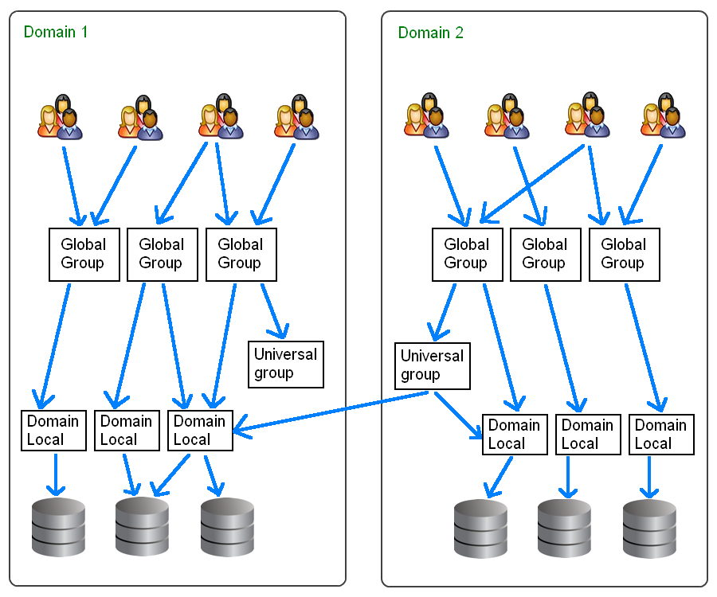

- Open Active Directory Users and Computers that you have been using.
- In the Sales OU, create a new user named: Sales2
- Enter user information for Sales2.
  - Password: Password02
  - Check: User must change password at next logon
- In the tree in the left pane, display the contents under the domain, business.local
- Create 2 new users in the Administration OU, Administration1 and Administration2.
  - Use Test as their last names.
  - Password: Password02
  - Ensure the box is checked for User must change password at next logon.
- Insert a screenshot showing these two users in the Administration OU:
- Click or tap here to enter text.
- Repeat the previous steps for Accounting, Research, and Operations.
- In the Sales OU, Right Click New Group.
- In the Group name box, enter DL_Sales
- Click Domain local under Group scope. Click Security (if it is not already selected) under Group type.
- Click OK. Look for the group you just created in the right pane within the Sales OU.
- Click the Create a new group in the current container icon on the button bar (with two heads).
- In the Group name box, type G_Sales
- Ensure Global is selected under Group scope and that Security is selected under Group type.
- Click OK. Look for the group you just created in the right pane.
- Use the previous instructions to create groups for Accounting, Administration, Research, and Operations
- In the Sales OU, Double-click G_Sales.
- Click the Members tab. Notice that no members are currently associated with this group.
- Click the Add button.
- Click the Advanced button in the Select Users, Contacts, Computers, Service Accounts, or Groups dialog box.
- Click Find Now.
- Click Sales1, then hold down the CTRL key and click Sales2. Click OK.
- Make sure that the users you selected are shown in the Select Users, Contacts, Computers, Service Accounts, or Groups dialog box. Click OK.
- Be sure that both accounts are shown in the global group’s Properties box on the Members tab.
- Insert a screenshot:
Click or tap here to enter text.
- Click OK.
- Do this same process for the other OU’s.
- Add each Global Group to the corresponding Domain Local Group.
- Double Click DL_Sales. Show the Member tab.
- Insert a screenshot:
Click or tap here to enter text.

Assignment Submission
Attach this completed document to the assignment in Blackboard.

