Week 10 Linux Projects - Working with the BASH Shell
Activities
Week 10 Linux Projects - Working with the BASH Shell 1
Update Kali Linux 1
Project 7-1: Redirect stdout and stderr to a File 2
Project 7-2: Redirect stdout and stdin using pipe metacharacters 4
Project 7-3: Create and Use a Shell Script 6
Project 7-4: Shell Scripts with Decisions and Loops 8
Project 7.5: Backup Script with Input 9
Decisions 10
Positional Parameters 10
Project 7.6: Backup Script 11
Assignment Submission 12

How to Create Screenshots: Please use the Windows Snip and Sketch Tool or the Snipping Tool. Paste a screenshot of just the program you are working on. If you are snipping a virtual machine, make sure your focus is outside the virtual machine before you snip.
- Press and hold down the Windows key & Shift, then Type S. This brings up the on-screen snipping tool.
- Click and Drag your mouse around whatever you want to snip.
- Release the mouse button. This places the snip into the Windows Clipboard.
Go into Word or wherever you want to paste the snip. Hold down CTRL, then Type V to paste the snip.

Update Kali Linux
In Kali Linux in the terminal.
sudo apt update
sudo apt dist-upgrade -y

Project 7-1: Redirect stdout and stderr to a File
Time required: 30 minutes
In this hands-on project, you use the shell to redirect the stdout and stderr to a file and take stderr from a file.
- Log in to the terminal as user.
- Type touch sample1 sample2 and press Enter to create two new files named sample1 and sample2 in your home directory.
- Verify their creation by typing ls Press Enter.
- Type ls -l sample1 sample2 sample3 and press Enter.
- Is there any stdout displayed on the terminal screen? Is there any stderr displayed on the terminal screen? Why?
Click or tap here to enter text.
- Type ls -l sample1 sample2 sample3 > file and press Enter.
- Is there any stdout displayed on the terminal screen? Is there any stderr displayed on the terminal screen? Why?
Click or tap here to enter text.
- Type cat file and press Enter.
- What are the contents of the file and why?
Click or tap here to enter text.
- Type ls -l sample1 sample2 sample3 > file and press Enter.
- Is there any Standard Output displayed on the terminal screen? Is there any Standard Error displayed on the terminal screen? Why?
Click or tap here to enter text.
- Type cat file and press Enter.
- What are the contents of the file and why? Were the previous contents retained? Why?
Click or tap here to enter text.
- Type ls -l sample1 sample2 sample3 > file 2> file2 and press Enter.
- Is there any stdout displayed on the terminal screen? Is there any stderr displayed on the terminal screen? Why?
Click or tap here to enter text.
- Type cat file and press Enter.
- What are the contents of the file and why?
Click or tap here to enter text.
- Insert a screenshot.
Click or tap here to enter text.
- Type cat file2 and press Enter.
- What are the contents of file2 and why?
Click or tap here to enter text.
- Insert a screenshot.
Click or tap here to enter text.
- Type ls -l sample1 sample2 sample3 > file 2>&1 and press Enter.
- Is there any stdout displayed on the terminal screen? Is there any stderr displayed on the terminal screen? Why?
Click or tap here to enter text.
- Type cat file and press Enter.
- What are the contents of the file and why?
Click or tap here to enter text.
- Type ls -l sample1 sample2 sample3 >&2 2> file2 and press Enter.
- Is there any stdout displayed on the terminal screen? Is there any stderr displayed on the terminal screen? Why?
Click or tap here to enter text.
- Type cat file2 and press Enter.
- What are the contents of file2 and why?
Click or tap here to enter text.
- Insert a screenshot.
Click or tap here to enter text.
- Type date >> file and press Enter.
- Type cat file and press Enter.
- What are the contents of the file and why?
Click or tap here to enter text.
- Type date >> file and press Enter.
- Type cat file and press Enter.
- What are the contents of the file and why? Can you tell when each date command was run?
Click or tap here to enter text.
- Type exit and press Enter to log out of your shell.

Project 7-2: Redirect stdout and stdin using pipe metacharacters
Time required: 20 minutes
In this hands-on project, you redirect stdout and stdin using pipe metacharacters.
- Log in to the terminal as user.
- Type cat /etc/services and press Enter to view the /etc/services file.
- Type cat /etc/services | less and press Enter to perform the same task page-by-page.
- Explain what the | (pipe) metacharacter does in the previous command. How is this different from the less /etc/services command?
Click or tap here to enter text.
- Type cat /etc/services | grep -i NFS and press Enter.
- How many lines are displayed? Why did you not need to specify a filename with the grep command?
Click or tap here to enter text.
- Type cat /etc/services | grep -i NFS | tr n N and press Enter.
- Explain the output on the terminal screen.
Click or tap here to enter text.
- Type cat /etc/services | grep NFS | tr n N | sort -r and press Enter.
- Explain the output on the terminal screen.
Click or tap here to enter text.
- Type cat /etc/services | grep ntp | tr n N | sort -r | tee file and press Enter.
- Explain the output on the terminal screen.
Click or tap here to enter text.
- Type cat file and press Enter.
- What are the contents? Why? What does the tee command do in the pipe above?
Click or tap here to enter text.
- Type cat /etc/services | grep NFS | tr n N | sort -r | tee file | wc -l
Press Enter.
- Explain the output on the terminal screen.
Click or tap here to enter text.
- Type cat file and press Enter.
- What are the contents and why?
Click or tap here to enter text.
- Type cat /etc/services | grep NFS | tr F f | sort -r | sed /udp/d | sed /tcp/s/mount/MOUNT/g and press Enter.
- Explain the output on the terminal screen. Can this output be obtained with the grep and tr commands instead of sed?
Click or tap here to enter text.
- Type cat /etc/hosts
- Type cat /etc/hosts | awk ' /localhost/ {print $1, $3}’ and press Enter.
- Explain the output on the terminal screen.
Click or tap here to enter text.
- Type exit and press Enter to log out of your shell.

Project 7-3: Create and Use a Shell Script
Time required: 15 minutes
In this hands-on project, you create a basic shell script and execute it on the system.
- Log in to the terminal as user
Of course, the first script is going to be Hello World!
- Use your favorite Linux text editor to open a new file for editing called hello_world.sh in your home directory.
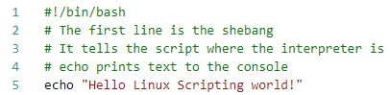
- Type bash hello_world.sh press Enter.
- Insert a screenshot of your script results.
Click or tap here to enter text.
- Use your favorite Linux text editor to open a new file for editing called myscript.sh in your home directory.
- Enter the following text into the myscript.sh file.
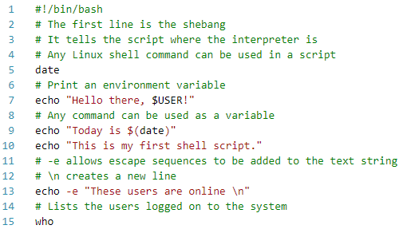
- Type ls -l myscript.sh press Enter.
- What permissions does the myscript.sh file have?
Click or tap here to enter text.
- Type bash myscript.sh and press Enter.
- Insert a screenshot of your script results.
Click or tap here to enter text.
- Type ./myscript.sh and press Enter.
- What error message did you receive and why?
Click or tap here to enter text.
- Type chmod 744 myscript.sh press Enter.
- Type ./myscript.sh and press Enter.
- Did the script execute? Why?
Click or tap here to enter text.
- Type ls -l myscript.sh press Enter.
- Look at the permissions for the myscript.sh. What changed?
Click or tap here to enter text.
- Type exit and press Enter to log out of your shell.
Escape sequence | Description
\\ | backslash
\a | ASCII beep
\b | backspace
\c | Prevents new line
\n\ | Starts a new line
\t | Horizontal tab

Project 7-4: Shell Scripts with Decisions and Loops
Time required: 45 minutes
In this hands-on project, you create a shell script that uses decision and loop constructs to analyze user input.
- Log in to the terminal as user.
- Open a new text file for editing called input.sh in your home directory.
- Why is it good form to use a .sh extension for shell scripts?
Click or tap here to enter text.
- Enter the following script including comments.
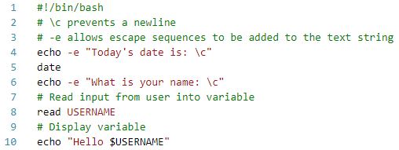
- Type chmod 744 input.sh press Enter.
- Execute the script.
- Insert a screenshot.
Click or tap here to enter text.

Project 7.5: Backup Script with Input
- Change directories to Documents.
- Use your favorite Linux text editor to create a few files.
- Change back to your home directory.
- Create the following script.
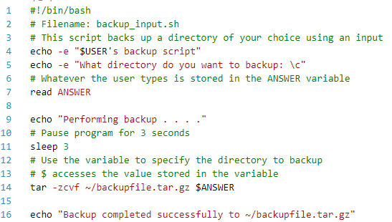
- Type chmod 755 backup_input.sh press Enter.
- Execute the script.
You can use a relative path or absolute path. This example will use a relative path which assumes you are in your home directory.
- Enter ./Code for the directory to backup.
- Insert a screenshot.
Click or tap here to enter text.

Decisions
Decision constructs are the most common type of construct used in shell scripts. They alter the flow of a program based on whether a command in the program completed successfully or based on a decision that the user makes in response to a question posed by the program.
The most common type of decision construct, the if construct, has the following syntax:
if <this is true>
then
<do these commands>
elif <this is true>
then
<do these commands>
else
<do these commands>
fi
Some common rules govern if constructs:
- elif (else if) and else statements are optional.
- You can have an unlimited number of elif statements.
- The <do these commands> section can consist of multiple commands, one per line.
- The <do these commands> section is typically indented from the left side of the text file for readability but does not need to be.
- The end of the statement must be a backward if (fi).
- The <this is true> part of the if syntax shown earlier can be a command or a test statement:
  - Commands return true if they perform their function properly.
  - Test statements are enclosed within square brackets [ ] or prefixed by the word “test” and used to test certain conditions on the system.

Positional Parameters
A shell script can take arguments when it is executed on the command line; these arguments are called positional parameters and may be referenced using special variables within the shell script itself. The special variable $1 refers to the contents of the first argument, $2 refers to the contents of the second argument, $3 refers to the contents of the third argument, and so on. If there are more than nine arguments, then you can use curly braces to indicate the appropriate positional parameter; for example, ${10} refers to the contents of the tenth argument. The special variable $0 refers to the command itself.

Project 7.6: Backup Script
The following script uses a command line argument to choose the directory to backup.
- Create the following script.
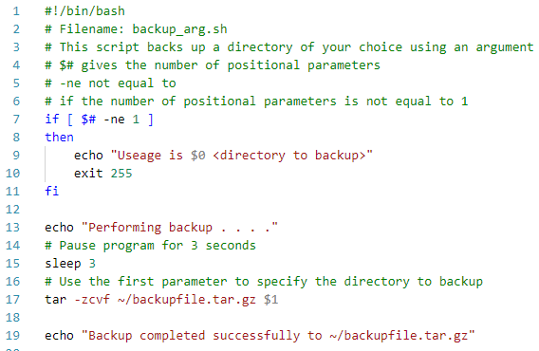
- Type chmod 755 backup_arg.sh press Enter.
- What permissions does 755 give?
Click or tap here to enter text.
- Type ./backup_arg.sh press Enter. Note the error that you receive because you did not specify a positional parameter.
- Type ./backup_arg.sh Documents press Enter. This will create a backup of the Documents directory within the backupfile.tar.gz file in your home directory.
- Type ls -f and press Enter.
- Insert a screenshot.
Click or tap here to enter text.
- Type exit and press Enter to log out of your shell.

Assignment Submission
Attach this completed document to the assignment in BlackBoard.

