Week 6 Linux Projects - Chapter 4 Linux Filesystem Management
Activities
Week 6 Linux Projects - Chapter 4 Linux Filesystem Management 1
Update Kali Linux 1
Project 4-6: System Information 1
Project 4-7: Permissions 2
Project 4-9: Change Ownership 6
Assignment Submission 7

Update Kali Linux
In Kali Linux in the terminal.
sudo apt update
sudo apt dist-upgrade -y

Project 4-6: System Information
There are some utilities that will give a look at the system and system resources.
- At the terminal: top
- Paste a screenshot.
Click or tap here to enter text.
- Describe 3 items of interest.
Click or tap here to enter text.
- Type q to quit.
We will be installing some programs
- Type: sudo apt update
- Type: htop
- You will receive a message that Command htop not found. Yes, you want to install it.
- Type: htop to run the program.
- Paste a screenshot.
Click or tap here to enter text.
- Describe 3 items of interest.
Click or tap here to enter text.
- Type q to quit.
- Same installation routing with btop
- Resize your terminal if necessary.
- Paste a screenshot.
Click or tap here to enter text.
- Describe 3 items of interest.
Click or tap here to enter text.
- Type q to quit.

Project 4-7: Permissions
Time required: 30 minutes
In this hands-on project, you apply and modify access permissions on files and directories and test their effects.
Linux access permissions regulate the level of access users and groups have to files and directories. There are three basic permissions:

- Read (r): Allows viewing and reading the content of a file or listing the contents of a directory.
- Write (w): Permits modifying or deleting a file, and for directories, it allows creating, deleting, and renaming files within the directory.
- Execute (x): For files, it allows executing or running the file as a program. For directories, it enables accessing the contents of the directory.
Permissions are assigned to three categories:
- Owner (u): The user who owns the file or directory.
- Group (g): A group of users to which the file or directory belongs.
- Others (o): All other users who are neither the owner nor in the group.
Combining these elements, permissions are represented by a three-digit octal number. For instance, "chmod 755" means the owner has read, write, and execute permissions, the group has read and execute permissions, and others have read and execute permissions.
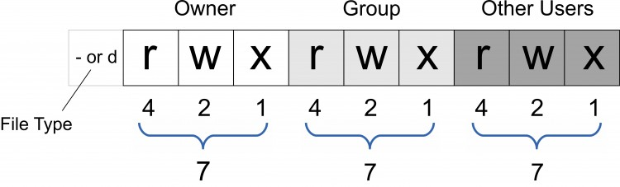
- Log in using the user name of user and the password of Password01
We will need another user later in these tutorials. -m adds the home directory.
- sudo useradd -m user1
- Add or change a password on a user account
- sudo passwd user1
- Use Password01
- touch permsample
chmod is a command in Unix and Unix-like operating systems used to change the permissions of files and directories. It stands for change mode The command allows users to modify the read, write, and execute permissions for the owner, group, and others.
chmod 777 grants full read, write, and execute permissions to the owner, group, and others for a file or directory in Unix-like operating systems. It provides unrestricted access, allowing anyone to perform any operation on the file or directory. It's a powerful setting but should be used cautiously due to security implications.
- chmod 777 permsample
- ls -l
- Who has permissions to this file?
Click or tap here to enter text.
- chmod 000 permsample
ls -l is used to list detailed information about files and directories in a long format. The output includes various details such as permissions, ownership, file size, modification date, and the name of each file or directory.
- Column 1: File type and permissions (e.g., -rw-r--r--).
- Column 2: Number of hard links to the file or directory.
- Column 3: Owner of the file or directory.
- Column 4: Group associated with the file or directory.
- Column 5: Size of the file in bytes.
- Column 6-8: Date and time of the last modification.
- Column 9: Name of the file or directory.Type ls –l and press Enter.
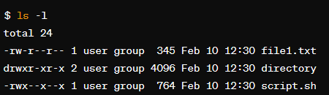
- file1.txt is a regular file with read and write permissions for the owner and read-only permissions for others.
- directory is a directory with read, write, and execute permissions for the owner, and read and execute permissions for others.
- script.sh is an executable script with read, write, and execute permissions for the owner, and execute permissions for others.
- ls -l
- Who has permissions to this file? What does chmod 000 do?
Click or tap here to enter text.
Try removing the file
- rm permsample
- Were you able to delete this file? Why?
Click or tap here to enter text.
- Change to the root folder
- cd /
- Show the present working directory.
- pwd
- What directory are you in?
Click or tap here to enter text.
- ls –F
- What directories do you see?
Click or tap here to enter text.
- Type ls –l and press Enter to view the owner, group owner, and permissions on the foruser1 directory created earlier.
- Who is the owner and group owner?
Click or tap here to enter text.
- If you were logged in as the user user1, in which category would you be placed (user, group, other)?
Click or tap here to enter text.
- What permissions do you have as this category (read, write, execute)?
Click or tap here to enter text.
- cd /home/user
- cp /etc/hosts hosts
- Type ls at the command prompt and press Enter to ensure that a copy of the hosts file was made in your current directory.
su – Switch users
- su user1
- ls
- Were you able to see the contents of the directory? Why?
Click or tap here to enter text.
- su user
- Were you successful? Why?
Click or tap here to enter text.
- Type nano hosts at the command prompt to open the hosts file in the nano editor. Delete the first line of this file and save your changes.
- Were you successful? Why? Exit the nano editor.
Click or tap here to enter text.
- Type exit and press Enter to log out of your shell.

Project 4-9: Change Ownership
Time required: 15 minutes
In this hands-on project, you view and change file and directory ownership using the chown and chgrp commands.
- Login with user and the password of Password01.
- Change to /home/user cd ~
- At the command prompt, type touch ownersample and press Enter.
- Type mkdir ownerdir at the command prompt and press Enter.
- Type ls –l at the command prompt and press Enter to verify that the file ownersample and directory ownerdir were created and that user is the owner and group owner of each.
- Type chgrp sys owner* and press Enter to change the group ownership to the sys group for both ownersample and ownerdir.
- Why were you successful?
Click or tap here to enter text.
- Type sudo chown user1 owner* and press Enter to change the ownership to the user1 user for both ownersample and ownerdir.
- Why were you successful?
Click or tap here to enter text.
- At the command prompt, type sudo chown user owner* and press Enter to change the ownership and group ownership back to the root user for both ownersample and ownerdir.
- Type mv ownersample ownerdir and press Enter.
- Type ls –lR at the command prompt and press Enter to note that the ownersample file now exists within the ownerdir directory and that both are owned by root.
- Type chown -R user1 ownerdir and press Enter.
- Type ls –l at the command prompt and press Enter.
- Who owns the ownerdir directory and ownersample file? Why?
Click or tap here to enter text.
- Type rm -R ownerdir and press Enter.
- Why were you able to delete this directory without being the owner of it?
Click or tap here to enter text.
- Type poweroff to shut down Kali.

Assignment Submission
Submit this completed document in Blackboard.

