Week 13 Windows Server Activities - Odds and Ends
Activities
Week 13 Windows Server Activities - Odds and Ends 1
Activity 14-1: Enable the Active Directory Recycle Bin 1
Activity 14-2: Create a Shortcut on the All Users Desktop 3
Activity 14-3: Enable Remote Access Through the Administrator Remote Desktop 5
Activity 14-4: Installing and Using the Remote Server Administration Tools for Windows 6
Activity 14-5: Installing Software with Group Policy 6
Activity 14-6: Windows Security 8
Assignment Submission 9

How to Create Screenshots: Please use the Windows Snip and Sketch Tool or the Snipping Tool. Paste a screenshot of just the program you are working on. If you are snipping a virtual machine, make sure your focus is outside the virtual machine before you snip.
- Press and hold down the Windows key & Shift, then type S. This brings up the on-screen snipping tool.
- Click and Drag your mouse around whatever you want to snip.
- Release the mouse button. This places the snip into the Windows Clipboard.
- Go into Word or wherever you want to paste the snip. Hold down CTRL, then type V to paste the snip.

Activity 14-1: Enable the Active Directory Recycle Bin
Time Required: 10 minutes
Objective: Enable the Active Directory Recycle Bin
Required Tools and Equipment: Server1
Description: Enable the Active Directory Recycle Bin. This allows easy recovery of deleted Active Directory Objects.
- Logon to Server1 as your administrator account, and open Server Manager.
- Go to Tools, Active Directory Administrative Center.
- Click on the domain object MyDomain (local). On the right side of the screen, Click Enable Recycle Bin …
- Click OK to confirm that you want to enable the Recycle Bin. Close the window.
- Open Active Directory Users and Computers. Create an OU called TestOU.
- Create a user called TestUser20 as the first name. Use testuser20 as the user logon name.
- Open an Administrator PowerShell prompt.
- Type the following command, and press enter. This command should show the user and any deleted objects.
get-adobject -filter {displayname -eq "testuser20"} -includedeletedobjects
- This should show the user.
- Insert a screenshot of the result:
Click or tap here to enter text.
- Delete that user.
- Type the following command press enter. This command should show the deleted user.
get-adobject -filter {displayname -eq "testuser20"} -includedeletedobjects
- You should see the user listed showing Deleted: Yes.
- Insert a screenshot of the result:
Click or tap here to enter text.
- To restore the user, use the following command.
(Get-ADObject -SearchBase (get-addomain).deletedobjectscontainer -IncludeDeletedObjects -filter "samaccountname -eq 'testuser20' ") | Restore-ADObject
- Insert a screenshot of the restored user in Active Directory:
Click or tap here to enter text.

Activity 14-2: Create a Shortcut on the All Users Desktop
Time Required: 10 minutes
Objective: Create a Shortcut on the Public Desktop.
Required Tools and Equipment: Server1 and Win11
Description: Use Group Policy Preferences to deploy a shutdown and logoff shortcut to everyone’s desktop. Any shortcuts or files in the c:\public\desktop folder shows up on everyone’s desktop.
- Logon to Server1 as your administrator account. Open Group Policy Management.
- At the domain object level, create and link a GPO named Desktop Shortcuts.
- Open Computer Configuration Preferences , Windows Settings Shortcuts.
- Right Click Shortcuts, Click New Shortcut.
- Use the following settings on the General tab.
  - Name: Shutdown
  - Location: All Users Desktop
  - Target: Type in c:\windows\system32\shutdown.exe
  - Arguments: -s -t 0
There is a space between -s -t and 0 (zero)
  - Icon file path: On the right, Click the button with the 3 dots ...
- Click the Common tab.
  - Select Remove this item when it is no longer applied.
- Click OK.
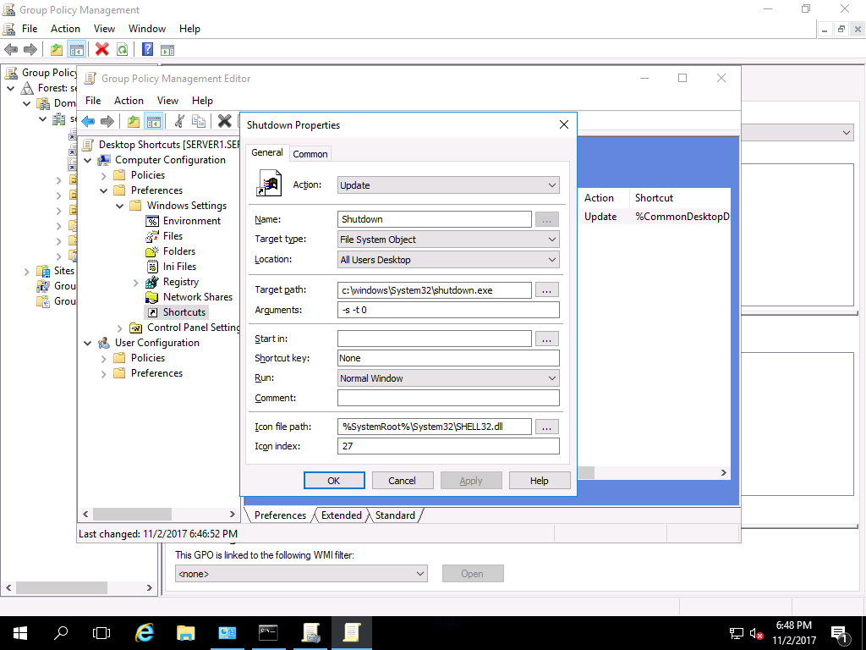
- Insert a screenshot of the General tab of the Shutdown shortcut:
- Click or tap here to enter text.
- Create a Sign Out shortcut using the same process. Use shutdown -l (Lower case L) for the arguments. Use a different icon.
- Insert a screenshot of the General tab of the Sign Out shortcut:
- Click or tap here to enter text.
- Close the Group Policy Editor.
- Optimize the Group Policy by going to the Details tab, and choosing GPO Status, User configuration settings disabled.
- Insert a screenshot:
Click or tap here to enter text.
- Close the Group Policy Management console.
- On Server1, use gpupdate to make sure both of your shortcuts show up. Test them both.
- Insert a screenshot of the server desktop showing both shortcuts:
Click or tap here to enter text.
- Logon to Win11. If the shortcuts don’t show up, use gpupdate to update group policy.
- Insert a screenshot showing both shortcuts on your Win11 desktop.
Click or tap here to enter text.

Activity 14-3: Enable Remote Access Through the Administrator Remote Desktop
Time Required: Approximately 10 minutes
Objective: Windows Server allows 2 simultaneous administrative connections through Remote Desktop. Enable access to Windows Server through Remote Desktop.
Description: In this activity, you configure Windows Server to be accessed from Windows workstations, such as Windows 10, through Administrator Remote Desktop using NLA.
- Start Server1. Open Server Manager, if it is not open.
- In the left pane, click Local Server.
- In the right pane, click the setting for Remote Desktop. Click Enabled.
- In the System Properties dialog box with the Remote tab displayed, ensure that Allow remote connections for this computer is selected as well as Allow connections only from computers running Remote Desktop with Network Level Authentication (recommended), if it is not already selected.
- Click OK in the Remote Desktop Users dialog box.
- Click OK in the System Properties dialog box.
- Sign in to Win11.
- Use your administrator credentials with the Remote Desktop Connection to connect to Server1.
- Insert a screenshot showing the Server1 desktop from Win11:
Click or tap here to enter text.

Activity 14-4: Installing and Using the Remote Server Administration Tools for Windows
Time Required: Approximately 15 minutes
Objective: Learn how to use the Remote Server Administration Tools capability for Windows
Description: Many of the MMC snap-ins can be implemented using the Remote Server Administration Tools capability. In this activity, you learn how to download and install the Remote Server Administration Tools for Windows. As an administrator, you will normally have two accounts, one for administration, and one for normal work that is at the user level.
- Start Server1 and Win11.
- Login to Win11 as your domain administrator account.
- Click Start, Click Settings. Type in Optional Features. Click Add a feature.
- Type RSAT. Click RSAT: Active Directory Domain Services and Lightweight Directory Services Tools. Click Install.
- Click Start, go to Windows Administrative Tools. Right Click Active Directory Users and Computers, Click More, Click Run as Administrator. Type in your domain administrator credentials.
- Insert a screenshot showing Active Directory Users and Computers connected to and showing your domain.
Click or tap here to enter text.

Activity 14-5: Installing Software with Group Policy
Time Required: Approximately 15 minutes
Objective: Learn where to set up software installation in a Group Policy.
Description: Simple software can be installed by GPO. For more advanced deployments, you would need something like Microsoft System Management Server or a third-party software. In this activity, you view where to configure software to be published or assigned. You will install 7-Zip to Win11.
- On Server1, go to http://www.7-zip.org/download.html and download the .msi (alternative MSI installer) 7-Zip for 64-bit Windows x64 (Intel 64 or AMD64).
- Create a folder under the C: called ClientApps.
- Move the 7-zip installation file you downloaded earlier to the ClientApps folder.
- Set the Share permission to Everyone Full Control.
- Set the Security permission to System and Administrators Full Control, and Users Read & execute (This includes list folder contents and Read.)
- In Active Directory Users and Computers, make sure you have a Workstations OU. Make sure Win11 is in it.
- Open the Group Policy Management console. Create a GPO called Install 7-Zip in the Workstations OU.
- Open Active Directory Users and Computers and confirm that Win11 is in the Workstations OU.
- Go back to Group Policy Management. Under Computer Configuration Policies in the tree, click Software Settings.
- In the right pane, right-click Software installation, and then click Properties.
- Make sure that the General tab is displayed in the Software installation Properties dialog box. Notice that you can use the Default package location box to specify the location of the software that users will install, which can be on this server or on a different server in the network. Also, among the New packages parameters, there are options to Publish or Assign software.
- Click each of the Advanced, File Extensions, and Categories tabs to view the properties that can be configured on these tabs. Click Cancel.
- Right Click Software Installation, Click New, Package.
- Browse to the Network \\server1\ClientApps and click the file you downloaded earlier.
- Insert a screenshot:
Click or tap here to enter text.
- Click Open.
- Keep the default choice of Assigned. Click OK.
- Right Click on the newly created software package and choose Properties.
- Go to the Deployment tab. Select Uninstall this application when . . .
- Insert a screenshot:
Click or tap here to enter text.
- Click OK.
- Close the Group Policy Editor.
- Click the Details tab of the Install 7-Zip GPO and change the GPO status to User configuration settings disabled. You are installing to a computer, you do not need the User configuration policies.
- Insert a screenshot:
Click or tap here to enter text.
- Click the Settings tab. You should see the details of the Assigned Application.
- Insert a screenshot:
Click or tap here to enter text.
- Start Win11. Logon as any user. Use gpupdate /force to update group policies. Restart Win11.
- If you go to File Explorer, and Right Click on any folder, you should see 7-Zip in the context menu. If not, you may need to restart Win11 again.
- Insert a screenshot:
Click or tap here to enter text.

Activity 14-6: Windows Security
Time Required: Approximately 5 minutes
Objective: Use the Windows Security GUI.
Description: In this activity, you learn how to use Windows Security.
- Start Server1. Click Start, type in and click Windows Security.
- Click Virus & threat protection.
- Notice the Current threats. The last scan is listed.
- Click Scan options: Quick, Full, and Custom. Go back to Virus & threat protection.
- Scroll down to Virus & threat protection settings, Click Manage settings. Note the various settings in this window. Make sure that real-time protection is turned on.
- Go back to Virus & threat protection. Scroll down to Virus & protection updates.
- Click Check for updates. You can use the Update definitions button on this tab to get the latest updates for Windows Security, including new virus definitions.
- Insert a screenshot:
Click or tap here to enter text.
- Close Windows Security.

Assignment Submission
Attach this completed file to the assignment in Blackboard.

