Week 2 Windows Server Activities – Windows 11 Client
Activities
Week 2 Windows Server Activities – Windows 11 Client 1
Activity 2-1: Install Windows 11 1
Download Windows 11 Enterprise Evaluation 1
Create a Windows 11 Virtual Machine 2
Itall Windows 11 Enterprise 5
Configure Windows 11 6
VirtualBox NAT Network Troubleshooting 7
Activity 2-2: Windows Update 8
Assignment Submission 8

How to Create Screenshots: Please use the Windows Snip and Sketch Tool or the Snipping Tool. Paste a screenshot of just the program you are working on. If you are snipping a virtual machine, make sure your focus is outside the virtual machine before you snip.
- Press and hold down the Windows key & Shift, then type S. This brings up the on-screen snipping tool.
- Click and Drag your mouse around whatever you want to snip.
- Release the mouse button. This places the snip into the Windows Clipboard.
- Go into Word or wherever you want to paste the snip. Hold down CTRL, then type V to paste the snip.

Activity 2-1: Install Windows 11
Time required: 60 minutes

Download Windows 11 Enterprise Evaluation
DANGER!! Will Robinson!!!!
When downloading this ISO:
- DO NOT OPEN IT.
- DO NOT TOUCH IT!
You can wipe the hard drive of your computer if you don’t pay attention. It has happened before with other students.
- Download the evaluation copy of Windows 11 Enterprise.
https://www.microsoft.com/en-us/evalcenter/evaluate-windows-11-enterprise
- Download the ISO – Enterprise. You will need to Register.
- Download the ISO to a folder on your hard drive where you can find it.

Create a Windows 11 Virtual Machine
- Start VirtualBox.
- Click New.
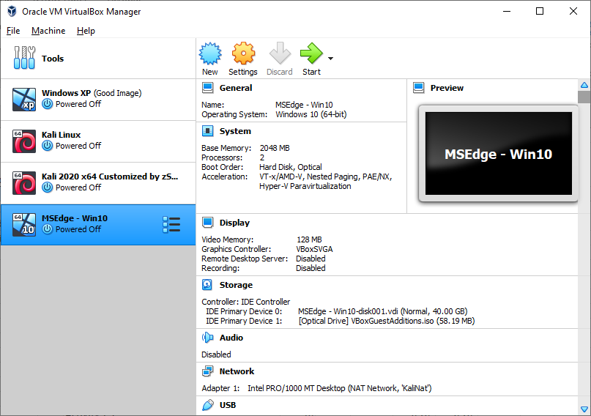
- Name and operating system: Enter Windows 11 for the Name. The Version should automatically be Windows 11 (64-bit). Click Next.
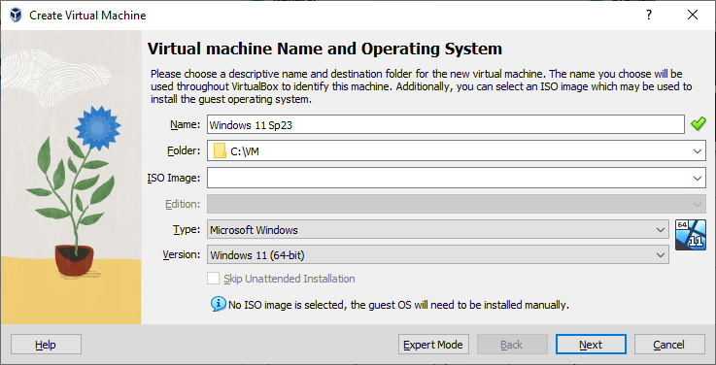

- Memory Size: Accept default size of 4096 MB. Click Next.
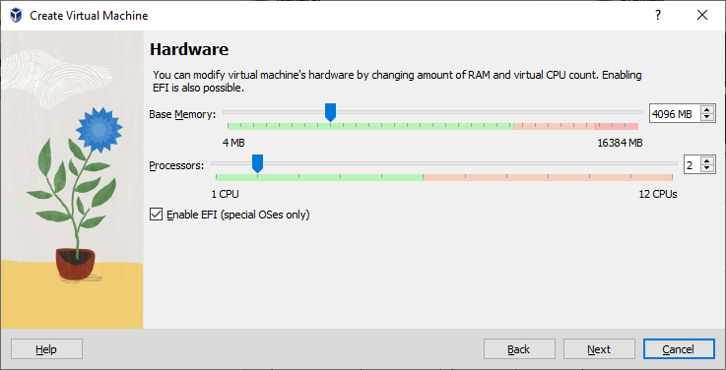
- Accept the default File size of 80 GB. Click Create.
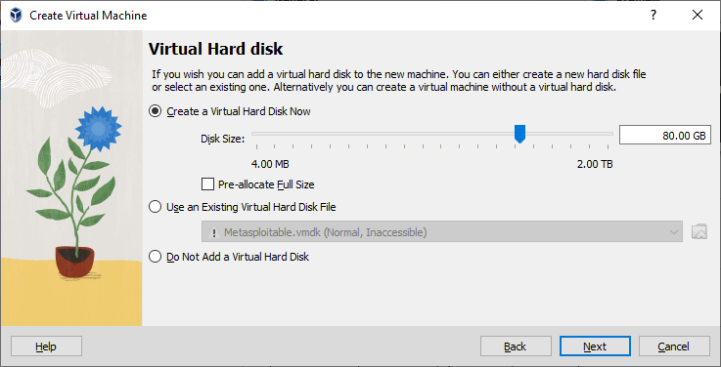
- Click Finish.
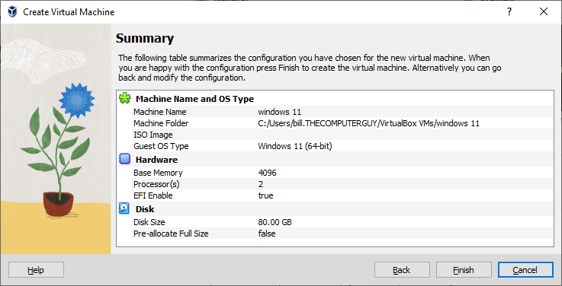

Itall Windows 11 Enterprise
- Click Start on your new virtual machine.
- Click the drop-down menu next to DVD Select Other Browse for your Windows 11 ISO file.
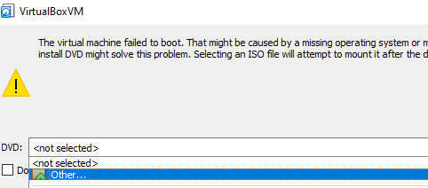
- Click Start (You will be asked to press any key to boot from CD or DVD.) Press any key on your keyboard. Your virtual machine will boot from the ISO and start setup.
- The Windows 11 installation screen should appear.
- Click Next Install now.
- Accept the license terms Click Next.
- Click Custom: Install Windows only (advanced).
- Click Disk 0 Unallocated Space Click Next.
- Windows will install. This may take some time. Windows will reboot. Work on other homework while the installation does its thing.
- After Windows 11 boots up Go to the Devices menu Optical Drives Remove disk from virtual drive.
- After a bit Windows will reboot again.

Configure Windows 11
NOTE: These configuration steps can change without notice.
- When the installation is complete, the screen will say Is this the right country or region? Click Yes.
- Is this the right keyboard layout or input method? Click Yes.
- Want to add a second keyboard layout? Click Skip.
- Let’s set things up for your work or school: Click Sign-in options.
- Sign-in options Domain join instead
- Enter your name Type in User for the username. Click Next.
- Create a super memorable password: Use Password01. Click Next.
- Confirm your password. Click Next.
- Make up security answers. Click Next.
- Choose privacy settings for your device: You can turn them all off if you wish. Click Accept.
- Right Click Start (Power User menu) Click System. This will bring up the System Properties. Click Rename this PC.
- Change the computer name to Win11 Click Restart Now.
- Log in to Win11. At the top of the Virtual machine window go to the Devices menu Choose Insert Guest Additions CD image.
- Open File Explorer Click the VirtualBox Guest Editions CD Drive Double Click VBoxWindowsAdditions Install and agree with default settings.
- Accept all prompts. Restart when prompted.
- Click Start Type and choose Control Panel Type and choose Network and Sharing Center.
- Click Ethernet. Click Properties, Click Internet Protocol Version 4, Click Properties.
- Win10 Network Settings:
IP Address: 10.10.1.20
Subnet Mask: 255.255.255.0
Default Gateway: 10.10.1.1
DNS: 8.8.8.8
- Google how to set the time zone to Mountain Time.
- In VirtualBox on your VM. Go to Settings Network Choose the NatNetwork we created earlier.
- Insert a screenshot of your VM running on your desktop.
Click or tap here to enter text.
Video walkthrough: VirtualBox User Created NAT

VirtualBox NAT Network Troubleshooting
There can be issues using a user created NAT network in VirtualBox. Here are some steps that may help resolve issues.
- Delete and recreate the NAT Network.
If that doesn’t work, try this.
- Delete the NAT Network you are working on.
- Run the following command at a command prompt to list the DHCP servers (NAT networks).
cd "c:\Program Files\Oracle\VirtualBox"
vboxmanage list dhcpservers
NOTE: NatNetwork is the default name for the first NAT network created. Replace that name with the name of the network you wish to remove.
cd "c:\Program Files\Oracle\VirtualBox"
Vboxmanage.exe dhcpserver remove --network=”NatNetwork”
- Create the NAT network again.
- Switch the VM to the Bridged Adapter.
- Set the VM to the new NAT Network.

Activity 2-2: Windows Update
Time Required: Approximately 15 minutes
Objective: Use Server Manager to start Windows Update.
Description: Plan to regularly update Windows Server 2022 to keep the operating system secure and to obtain the latest service pack when it becomes available. In this activity, you use Server Manager to access Windows Update and then check to see if there are updates waiting to be installed. The default setting for Windows Update is to automatically download updates, but to not install them until you initiate the installation. This is so that updating the operating system is not occurring automatically while users are active. In this way, you can install updates during a scheduled time when users are not on the server. For this activity, the server should already be connected to the Internet.
- Logon to Server1.
- Open Server Manager.
- Click Local Server in the left pane.
- Click the link to the right of Windows Update, which is Download updates only, using Microsoft Update.
- In the Settings window under Update & security, check to see if there are updates waiting to be installed and if there are, click the Install now button. (Alternatively, if there are no updates waiting to be installed, click the Check for updates button and then if updates are downloaded, click the Install now button.)
- Insert a screenshot for each updated server:
Click or tap here to enter text.

Assignment Submission
Attach this completed document to the assignment in BlackBoard.

