Week 4 PowerShell
Contents
Week 4 PowerShell 1
Tutorial 1: Functions 1
Tutorial 2: Getting Started Scripts 2
Tutorial 3: Get Objects Methods and Properties 3
Tutorial 4: Manage Processes 4
Tutorial 5: Using Windows PowerShell 4
Tutorial 6: Cmdlets 5
Assignment Submission 6

Time required: 90 minutes
NOTE: Perform this lab on Server1.

Tutorial 1: Functions
A PowerShell function is a reusable block of code that performs a specific task or set of tasks. Functions are used to encapsulate a series of commands and can accept input parameters and return output. They help in organizing and simplifying scripts by breaking them into smaller, manageable pieces. In essence, a PowerShell function is like a mini-program within a PowerShell script, designed to perform a specific function or operation.

Create a file named square_number_function.ps1
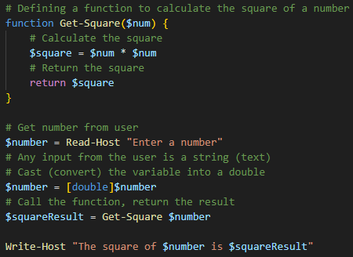
Example run:

Tutorial 2: Getting Started Scripts
Let’s run a few PowerShell commands to get started.
Create a file named sample_script.ps1
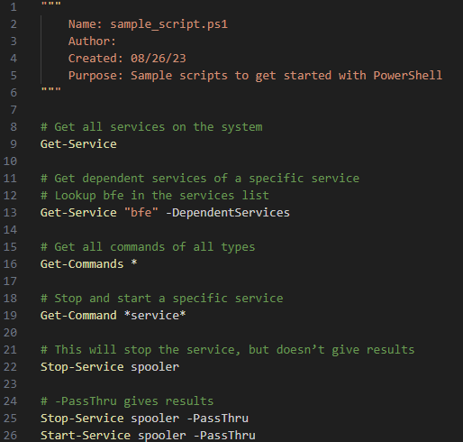

Tutorial 3: Get Objects Methods and Properties
Create a PowerShell program named get_object_methods_properties.ps1
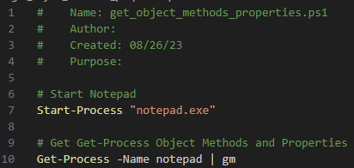

Tutorial 4: Manage Processes
Create a PowerShell Program named manage_processes.ps1
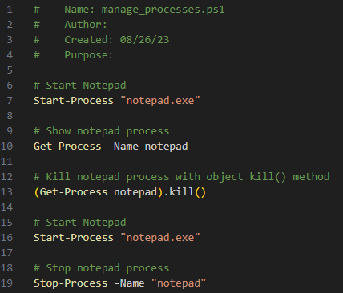

Tutorial 5: Using Windows PowerShell
Time Required: Approximately 15 minutes
Objective: Use traditional Command Prompt commands and cmdlets in Windows PowerShell.
Description: Learning how to use Windows PowerShell can be an important way to expand your server administration toolbox. In this activity, you take several traditional commands and cmdlets for a test drive.
- Click Start Type PowerShell Right Click Windows PowerShell ISE Click Run as Administrator.
- To view the files in the current folder dir Enter.
- Insert a screenshot of one screen of the listing.
Click or tap here to enter text.
- To change to the \Users directory, enter cd c:\users press Enter.
- Type dir press Enter.
- Insert a screenshot.
Click or tap here to enter text.
- Type Get-Command | more and press Enter. You see the commands one screen at a time. Press the Spacebar to advance to the next screen. Repeat this step until you’ve viewed all the screens. (Note that you can also press q to exit back to the command line, if you decide not to view all the screens of commands.)
- Press the up arrow and notice that the last command you entered is placed on the command line so that you can repeat the command. Press the up arrow again and you’ll see the second to-last command you entered. Press Enter to run that command.
- Type Get-Process press Enter to view the processes running on the server.
- Start Google Chrome.
- Type Get-Process -name chrome press Enter. You will see several chrome processes.
- Insert a screenshot.
Click or tap here to enter text.

Tutorial 6: Cmdlets
In this Hands-On Project, you work with common Windows PowerShell administrative cmdlets.
- On your Windows Server 2022 host, open the Google Chrome Web browser.
- Right-click the Start menu and choose Windows PowerShell (Admin) to open Windows PowerShell.
- At the prompt, type Get-Process | more and press enter. Note that there are many processes with a ProcessName of chrome that comprise the Google Chrome Web browser.
- Insert a screenshot.
Click or tap here to enter text.
- Press q to quit the more command.
- Type Stop-Process -name chrome and press enter. Note that the Google Chrome Web browser app was closed.
- Type Get-Service | ogv and press enter. Note that the App Readiness service is called AppReadiness and is not started by default. Close the GridView window.
- Type Start-Service -name AppReadiness and press enter to start the service.
- Type Stop-Service -name AppReadiness and press enter to stop the App Readiness service.
- At the prompt, type Test-NetConnection and press enter to test your network connectivity to internetbeacon.msedge.net.
- Insert a screenshot.
Click or tap here to enter text.
- Execute the following commands at the command prompt, in turn. For each one, note the network configuration information displayed.
- Get-NetIPConfiguration
- Insert a screenshot.
Click or tap here to enter text.
- Get-NetAdapter
- Insert a screenshot.
Click or tap here to enter text.

Assignment Submission
- Attach the program files.
- Attach this completed document.
- Submit in Blackboard.

