Week 4 PowerShell
Contents
Week 4 PowerShell 1
Get Help on a Command 1
Tutorial 1: System Information 1
Tutorial 2: Working with the File System 4
Assignment Submission 5

Time required: 60 minutes
NOTE: Perform this lab on Server1.

Get Help on a Command
You are trying to figure out how to automate gathering information from Event Logs. A good place to start is with PowerShell’s help system.
# How to get help on a command
Get-Help Get-EventLog -ShowWindow
A help window will popup. Click Settings Click a Check Mark in all Help Sections. Click OK.
Look through the information displayed. You will find examples of these commands. Run both.
# List all event logs
Get-EventLog –list

# List 20 most recent entries from the system log
Get-EventLog -LogName System -Newest 20

Tutorial 1: System Information
Windows Management Interface (WMI) is a comprehensive management framework provided by Microsoft for managing components and services in a Windows environment. It allows you to access and manipulate system settings, configurations, and information programmatically, making it a valuable tool for system administrators, including those involved in Information Technology and Cybersecurity.
In the following tutorial, we get information about our server using PowerShell and WMI.
This script is designed to retrieve and display various system information using Windows Management Instrumentation (WMI) objects. It provides details about the operating system, BIOS, processor, memory, and disk space.
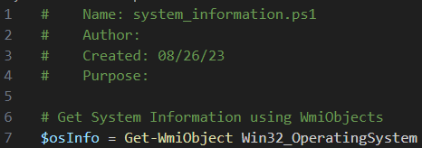
This line uses the Get-WmiObject cmdlet to retrieve information about the operating system and stores it in the variable $osInfo. It specifically queries the Win32_OperatingSystem class.
This line retrieves information about the BIOS (Basic Input/Output System) and stores the BIOS version in the variable $biosInfo.
This line collects information about the computer's processor and stores it in the variable $cpuInfo. It queries the Win32_Processor class.
This line fetches information about physical memory (RAM) and calculates the total capacity by summing up the values. The result is stored in the variable $memoryInfo. It queries the Win32_PhysicalMemory class and uses Measure-Object to calculate the sum of the Capacity property.
This line retrieves information about logical disks (hard drives) with a drive type of 3 (which represents local disk drives) and stores the results in the variable $diskInfo. It queries the Win32_LogicalDisk class with a filter to select only local disk drives.
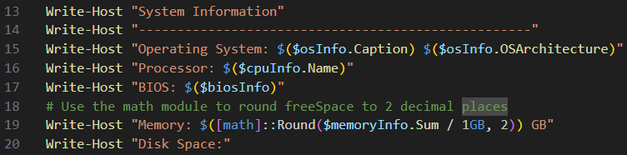
These lines use Write-Host to display specific system information obtained earlier in the script. It includes details about the operating system name and architecture, processor name, BIOS version, and memory capacity (converted from bytes to gigabytes).
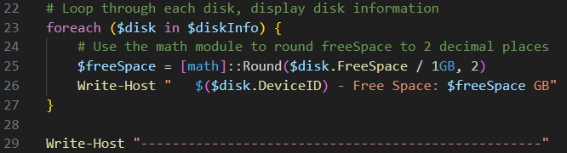
This section iterates through each logical disk stored in $diskInfo using a foreach loop. For each disk, it calculates and displays the free space in gigabytes (GB) by dividing the free space in bytes by 1GB. The result is rounded to two decimal places.
Example run:
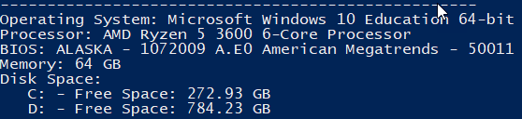

Tutorial 2: Working with the File System
In this Hands-On Project, you work with PowerShell providers.
- Right-click the Start menu and choose Windows PowerShell (Admin) to open Windows PowerShell.
- At the prompt, type Get-PSProvider and press enter to view the available PowerShell providers.
- Insert a screenshot:
Click or tap here to enter text.
- Type Get-PSDrive and press enter to view the expanded list of PowerShell providers. Note that the filesystem provider is available for each drive letter on the system, and that registry provider is available for HKEY_CURRENT_USER and HKEY_LOCAL_MACHINE.
- Insert a screenshot:
Click or tap here to enter text.
Each PowerShell provider treats each item that it works with as an object.
- At the prompt, type gci | Get-Member and press enter to view the properties available for the objects within the current directory of the filesystem provider. Note that there is a PSIscontainer property that indicates that the object is a subdirectory.
- Type gci | Where-Object {$_.psiscontainer} and press enter to view only directories.
- Insert a screenshot:
Click or tap here to enter text.
- Following this, type gci | Where-Object {!$_.psiscontainer} and press enter to view only non-directories (i.e., files).
- Insert a screenshot:
Click or tap here to enter text.
Within the filesystem provider, you can create, edit, and remove objects, such as files and directories. Execute the following commands at the command prompt, in turn. For each one, interpret the output (referencing the aliases and cmdlets within this module, as necessary).
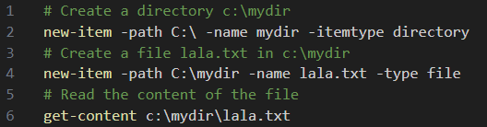
- Insert a screenshot of the result:
Click or tap here to enter text.
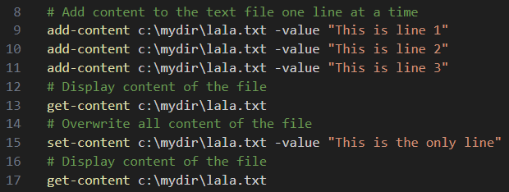
- Insert a screenshot of the result:
Click or tap here to enter text.
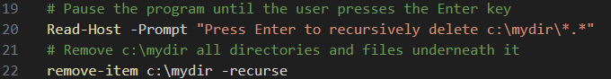
- Insert a screenshot of the result:
Click or tap here to enter text.

Assignment Submission
- Attach the program files.
- Attach this completed document.
- Submit in Blackboard.

