Packet Tracer Routing
Contents
Packet Tracer Routing 1
Objectives 1
Activity Background 1
Part 1: Download And Install Packet Tracer 1
Assemble Network 2
Configure Laptop 2
Connect the Devices 4
Configure Routers 4
Configure PC’s 5
Test Routing 6
Review Questions 7
Assignment Submission 8

Time Required: 60 Minutes

Objectives
The goal of this lab is to implement a wired and wireless network with a SOHO router in Packet Tracer. After completing this lab, you will be able to:
- Set up a small routed network in Cisco Packet Tracer

Activity Background
Cisco Packet Tracer simulates many functions of a network and can be useful to help you learn and practice networking skills. In this lab, you install Packet Tracer and use it to build and configure a small wired routed network.

Part 1: Download And Install Packet Tracer
Follow these steps to download and install Packet Tracer:
To get the Packet Tracer download, you must first sign up for the free Introduction to Packet Tracer online course on the Cisco Networking Academy website. Complete the following steps to create your account, download, and install Packet Tracer:
- In your browser, navigate to www.netacad.com/courses/packet-tracer. Enroll in the course.
- Open the confirmation email and confirm your email address. Configure your account and save this information in a safe place. You will need this information again.
- Click Courses and select the Introduction to Packet Tracer course.
- Inside the course, click Student Resources, and then click Download and install the latest version of Packet Tracer. Download the latest version for your computer. Install Packet Tracer.
- When the installation is complete, run Cisco Packet Tracer.
- When Packet Tracer opens, sign in with your Networking Academy account that you created earlier. If you see a Windows Security Alert, allow access through your firewall. Cisco Packet Tracer opens.

Assemble Network
- In Packet Tracer, place a router, two switches, two PC’s, one laptop, and one Access Point as shown.
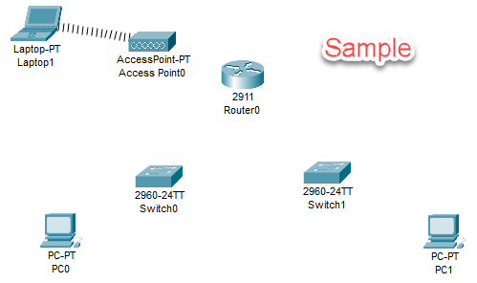

Configure Laptop
Configure the Laptop with a wireless card.
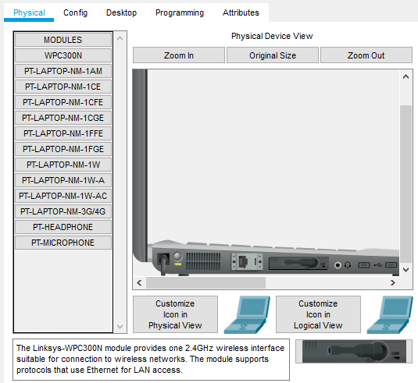
- Click the Laptop.
- Scroll down in the Physical Device View to the bottom of the laptop.
- Click the Power Button to turn off the laptop.
- Drag the ethernet module from the laptop to the module column.
- Drag the WPC300N module to the bottom right of the screen. Drop it where the ethernet module was.
- Click the Power Button to turn on the laptop.
- Click the Desktop tab IP Configuration.
- IP Configuration Static
  - IPv4 Address: 172.16.1.10
  - Subnet Mask: 255.255.0.0
  - Default Gateway: 172.16.1.1

Connect the Devices
Connect the devices as shown below using copper straight cable. Connect to the ports shown.

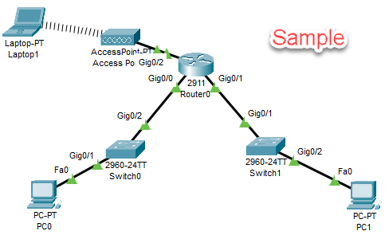

Configure Routers
This following diagram shows the IP addressing configuration of our network.
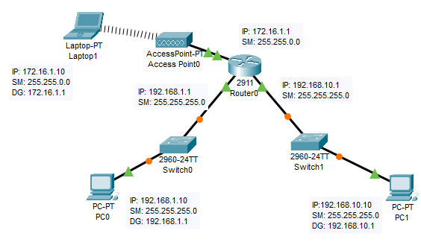
- Click Router0. That will bring up the settings where we will configure the IP addresses of the router interfaces.
- Click the Config tab. Click GigabitEthernet0/0.
- Click the On box to enable the port.
- We will enter a standard private Class C network with 254 hosts.
  - IPv4 Address: 192.168.1.1
  - Subnet mask: 255.255.255.0
- Click GigabitEthernet0/1.
  - Click the Config Tab.
  - Click the On box to enable the port.
  - We will enter another standard private Class C network with 254 hosts.
    - IPv4 Address: 192.168.10.1
    - Subnet mask: 255.255.255.0
- Click GigabitEthernet0/2.
  - Click the Config Tab.
  - Click the On box to enable the port.
  - We will enter a standard private Class B network with 65534 hosts.
    - IPv4 Address: 172.16.1.1
    - Subnet mask: 255.255.0.0
- Close the Router0 window.
- The switches are layer 2 devices, and need no configuring. They communicate by MAC addresses.

Configure PC’s
- Click PC0. Click the Desktop tab.
- Click Static. Enter the following IP addressing information. Note that the Default Gateway address matches the IP address of the router interface we are connected to.
  - IPv4 Address: 192.168.1.10
  - Subnet Mask: 255.255.255.0
  - Default Gateway: 192.168.1.1
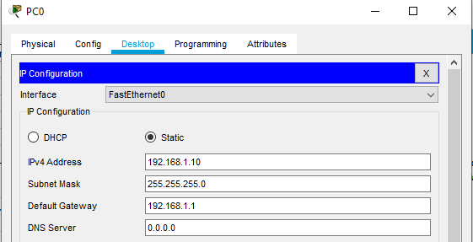
- Close the Window.
- Click PC1. Click the Desktop tab.
- Click Static. Enter the following IP addressing information. Note that the Default Gateway address matches the IP address of the router interface we are connected to.
  - IPv4 Address: 192.168.10.10
  - Subnet Mask: 255.255.255.0
  - Default Gateway: 192.168.10.1
- Click the X to the right of IP Configuration to go back to the Desktop.

Test Routing
- On the Laptop, go to the Desktop.
- Click the Command Prompt.
- Type ping 192.168.10.1. You should see 4 successful replies from the router interface.
- Insert a screenshot.
Click or tap here to enter text.
- Type ping 192.168.1.1. You should see 4 successful replies from the other router interface.
- Type ping 192.168.1.10. You should see 4 successful replies from PC0. Be patient, it may take a ping or two to get the ping crossing the router.
- Close the Window.
- Click PC0. Go to the Desktop tab. Click Command line.
- Type ping 172.16.1.10. You should see 4 successful replies from Laptop.
- Insert a screenshot.
Click or tap here to enter text.
- Drag the PC0 windows to the left of the Packet Tracer Program. Click Simulation. Click the Play button.
- At the PC0 command prompt, type ping 192.168.10.10.
- You should see a simulation of the packets going back and forth.
- Delete the Sample screenshot below. Insert a screenshot from your PacketTracer.
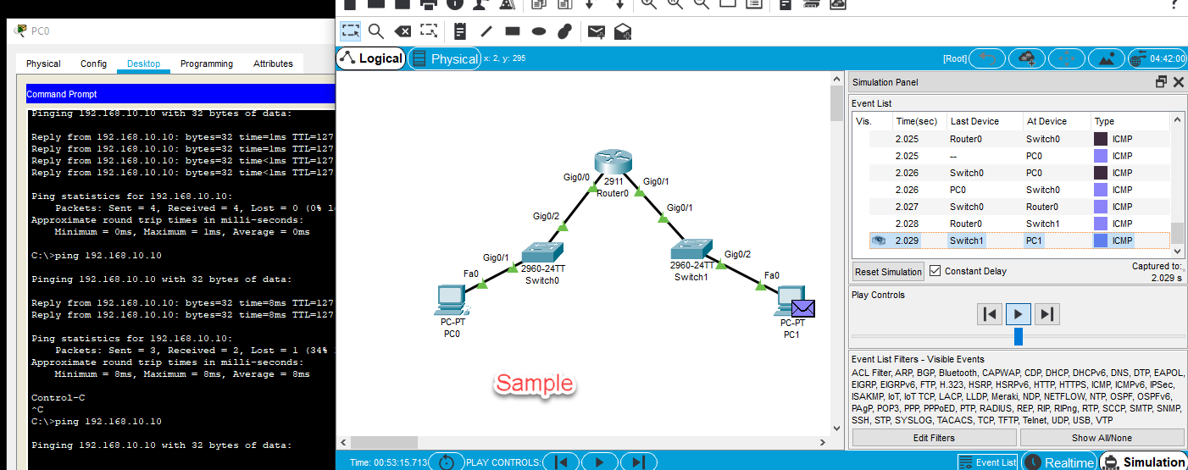

Review Questions
- What layer does a router operate at?
Click or tap here to enter text.
- What is the purpose of the default gateway in a network?
Click or tap here to enter text.
- Which device moves the packet from one network to the other network?
Click or tap here to enter text.
- Describe how an operating system determines from the IP address and subnet mask where to send a packet.
Click or tap here to enter text.

Assignment Submission
Attach this completed document and the Packet Tracer file in BlackBoard and submit.

